A Bottom-up Evaluation of the Master Innovation and Development Plan for Toronto’s Quayside

Part 1: Addressing Existing Barriers

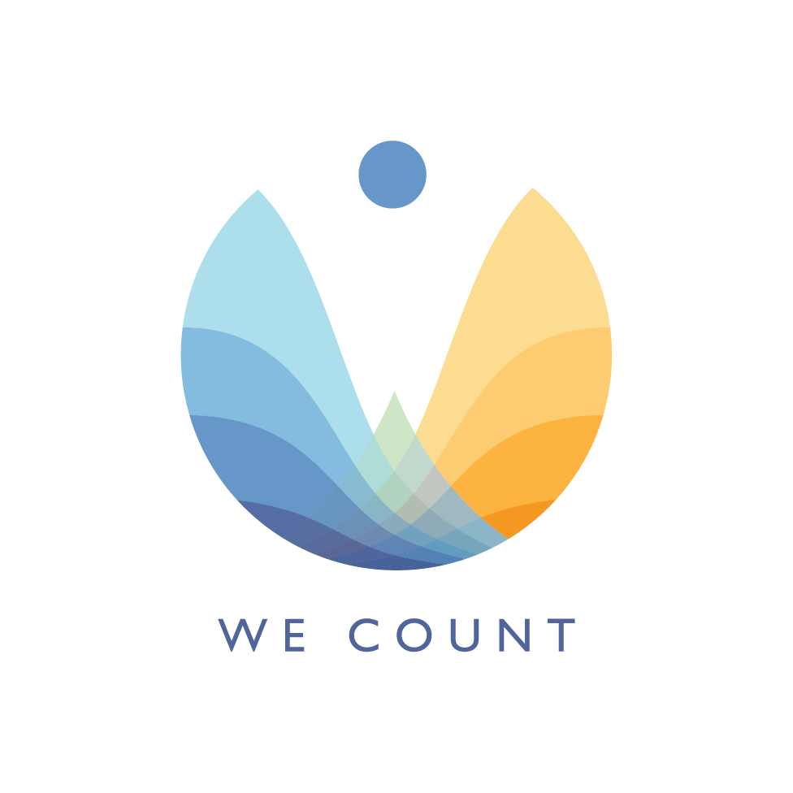September 12, 2019

1 Executive Summary 1

2 Introduction 2

3 Evaluation Approach and Process 5

3.1 Consultation Process 6

3.2 Co-creation Day 7

4 Stories 7

4.1 James Goes Out on His Own 7

4.2 Human Factor 11

4.3 Getting Around 19

4.4 The Way Home 23

4.5 Smart City: Bringing Back Civilized to Civilization 29

4.6 Grades and Shades of Inclusion 37

4.7 Into the Chaos 44

5 Evaluation of MIDP 49

5.1 A New Type of Community 51

5.2 MIDP Definition of Accessibility 52

5.2.1 Expert contributors' definition of accessibility. 53

5.3 Designing with those who can't use the design 54

5.3.1 Persistent Technological Fails 55

5.3.2 Economic and Social Marginalization 57

6 Findings 58

6.1 Our Themes 58

6.2 MIDP Chapter 1—Mobility 59

6.2.1 Theme: Accessible Amenities 59

6.2.2 Theme: Accessibility: Policy 61

6.2.3 Theme: Accessibility: Transit 63

6.2.4 Theme: Equitable Access to Transit 65

6.2.5 Theme: Integration with Metro 65

6.2.6 Theme: Streetscape Design: Transit 68

6.2.7 Theme: Streetscape design 70

6.3 MIDP Chapter 2—Public Realm 80

6.3.1 Theme: Accessibility Standards 81

6.3.2 Theme: Accessible Amenities 82

6.3.3 Theme: Community Building 83

6.3.4 Theme: Environmental Design 87

6.3.5 Theme: Green Spaces 88

6.3.6 Theme: Governance 90

6.3.7 Theme: Governance: Commercial Spaces 91

6.3.8 Theme: Governance: Community Spaces 97

6.3.9 Theme: Governance: Public Spaces 98

6.3.10 Theme: Streetscape Design 103

6.3.11 Theme: Streetscape Barriers—Temporary 115

6.3.12 Theme: Spirituality and Culture 117

6.3.13 Theme: Social Supports 118

6.4 Chapter 3—Building and Housing 121

6.4.1 Theme: accessibility governance/ accessibility 121

6.4.2 Theme: Accessibility Standards 124

6.4.3 Theme: Building design 129

6.4.4 Theme: Rents governance: equity 133

6.4.5 Theme: Governance: commercial spaces 134

6.4.6 Theme: governance: Public spaces 138

6.4.7 Theme: Governance: rented space 143

6.5 Chapter 4—Sustainability 144

6.5.1 Theme: Accessibility Governance 145

6.5.2 Theme: Disaster management/Sustainability 146

6.5.3 Theme: Environmental control 147

6.5.4 Theme: Green Spaces 149

6.5.5 Theme: Sustainability: environment 151

6.5.6 Theme: Logistics/ Building & Housing and Sustainability 153

6.6 Chapter 5—Digital Innovation 153

6.6.1 Theme: Green Spaces 153

6.6.2 Theme: Accessibility Standards 156

6.6.3 Theme: ICT Accessibility 157

6.6.4 Theme: Interface/Product Design 165

6.7 Summary Table of Questions and Evaluation Findings 168

7 Conclusion 177

8 Bibliography 179

# Executive Summary

This report is an independent evaluation of Sidewalk Labs’ Master Innovation and Development Plan for Toronto’s Quayside and was undertaken as part of a project called, We Count. This evaluation focuses on inclusion and accessibility concerns developed from stories written by diverse individuals. Individuals at the edges of our communities are often the most vulnerable to risks and design failures when we re-design spaces, services and policies. Individuals that have difficulty using or can’t use our current designs, also have the most compelling uses of new systems. It is incumbent on an inclusive society to think about the full spectrum of needs. If time and resources constrain the needs to be considered, considering previously excluded voices will garner the greatest innovation and sustainability. Individuals that experience our designs from the edges are valuable evaluators; they provide unexplored perspectives for surfacing fail points. For this reason, we have employed a bottom-up evaluation that focuses on the experience of individuals at the edges of our current community designs in evaluating the Master Innovation and Development Plan (MIDP). Our approach to the evaluation is a co-design approach that uses narrative analysis to generate questions with which we can evaluate the MDIP.

Our goal is to contribute to the evaluation of the MIDP using criteria based on diverse community members and their real experiences. The MIDP is a complex document that includes guiding accessibility principles to address and highlight the commitment of Sidewalk Labs to inclusion and accessibility. In our evaluation we consider these principles but also look for evidence of the principles in each of the chapters of the MIDP for implementations/enactments of the principles.

New sociotechnical practices, such as those proposed in the MIDP, come with both opportunities and risks. They have the potential to address existing barriers, but may also introduce new barriers, or amplify and automate existing barriers. This report is the first part of a two-part evaluation. In this first part we address whether the MIDP will address existing barriers and whether it has the potential to deliver on its commitment to create a more inclusive and accessible community. In the coming months we will complete a second part which addresses how the MIDP plans to mitigate new risks to accessibility and inclusion.

IDRC engaged seven content experts with diverse experience to be story leads in a co-creation exercise that would document individual experiences in daily activities. The stories created from these real experiences would be used to generate questions with which to review and evaluate the MIDP. The evaluation process followed three phases:

1. Consultation Process with content experts
2. Story Co-creation with content experts and collaborators
3. Question generation and evaluation (discussed in section 5 Evaluation of MIDP)

From the seven stories, over 100 questions were developed. The questions were refined and combined until the number of questions was at 76. Answers to each of these questions were then sought within the MIDP, sometimes in multiple chapters (resulting in 86 evaluations). In the findings section, each evaluation question is presented along with the story excerpt from which it was generated, the relevant sections of the MIDP and the degree of support for the issue/concern raised by the question that was found. The results were as follows:

| Degree of Support | Total |
| --- | --- |
| Partially Supported | 45 |
| Not Supported | 17 |
| Fully Supported | 14 |
| Grand Total | 76 |

While the MIDP shows regard and planning for accessibility and inclusion, there are still many areas where there is not enough information about the plans for enacting this commitment. In some areas, there is no information to address the evaluation questions at all. A summary of the evaluation question, the relevant sections of the MIDP and the degree of support is provided in section 6.7.

# Introduction

New technologies, such as those in a smart community, have the potential to address challenges but will also introduce new barriers. This report is a discussion of how current barriers are addressed within the MIDP. A follow-up report that addresses new barriers, particularly those that come in the unseen world of data collection, data analysis, algorithms, profiling and surveillance will be prepared in the coming months.

Historically, design has been for a mythical average or a perceived majority voice leading to exclusion of those who aren’t average or among the majority. Addressing the needs of individuals that are currently excluded from our designs provides the greatest opportunity to create more innovative designs and improve the design for all users. A design that can flex to meet the needs of the many minorities will have the capacity to address the needs of the changing majority and to better respond to the inevitably changing context.

Individuals at the margins of our communities are often the most vulnerable to the risks and failures of designs, when we re-design spaces, services and policies. Sidewalk Labs has committed to inclusive design and to creating a community that is inclusive. Edge scenarios are an excellent tool for evaluating design; they engage multiple perspectives for understanding the range of possible fail points and the contingencies not considered in the design. For this reason we engage a bottom-up evaluation based on the narratives of individuals at the edges of our current communities in evaluating the Master Innovation and Development Plan (MIDP).

The MIDP is the detailed proposal for the development of the Quayside neighbourhood and IDEA District as envisioned by Sidewalk Labs. The neighbourhoods proposed would connect Toronto's downtown to the eastern waterfront and area of land currently undeveloped and in transition from a more industrial past.

The MIDP is the proposed response to a consultation process—as planned out in their Sidewalk Labs public engagement plan released in February 2018—with diverse Toronto communities and stakeholder groups, started in June 2018. Alongside Waterfront Toronto, Sidewalk Labs designed a consultation process including public roundtables, community programming engaging often forgotten populations, co-design days and hackathons and the 307 work space (pp. 70-71).

The Inclusive Design and Research Centre (IDRC) was one of the stakeholders that collaborated with Sidewalk Labs and Waterfront Toronto in developing an inclusive and community-centred consultation around issues of accessibility for the smart community. As a collaborator that guided and enabled several co-design sessions and accessibility events with Sidewalk Labs[1], IDRC and members of the We Count team are particularly committed to insuring that accessibility and inclusion are well-represented in the MIDP, in a way that addresses the concerns of currently marginalized members of the Toronto community.

While IDRC has facilitated the development of accessibility guidelines and feedback from disability and accessibility communities, the evaluation by the We Count team is independent of that consultation. The methodology the We Count team developed for the evaluation of the MIDP started from, and centered on, the experiences and lives of people with diverse needs and members of the disability community[2]. It is an approach based on the co-creation of narratives of real experiences of diverse people who represent excluded or minority voices. These voices reflect the entangled and intersecting facets of systemically marginalized identities. The facets of difference include disability, gender, sexuality, race, immigrant status, indigeneity, age and socio-economic status.

Seven expert contributors were selected and underwent an orientation on August 28th, 2019 to introduce them to the MIDP, the evaluation process and their role as content creators. During that orientation they were provided with printed and digital templates of guiding questions, as well as with tablets to record five experiences of their lives moving through the city using paper, voice recordings, pictures and videos.

The expert contributors spent two weeks recording their experiences in their preferred formats—including reflecting on how those experiences and their lives would relate to living in a smart city—following which they met with the full We Count team and volunteers for a co-creation day, on September 12th, 2019.

During the co-creation day, each expert contributor worked in collaboration with volunteers and other members of the We Count team to develop their stories, based on the experiences they collected (See pp. 7-49 for the full, finished stories from our expert contributors). The co-created stories are as unique as each expert contributor and vary immensely in format, insights and narrative styles. The experiences and stories from our expert contributors are the core of our evaluation of the MIDP.

Throughout the process we strived to adhere to the common values of inclusive design and disability justice. We wanted to clearly distinguish the engagement from token forms of unremunerated consultation that disabled people[3] are frequently asked to participate in. The We Count team and the IDRC are committed in this assessment to following principles of compensated and meaningful co-design. Meaningful co-design goes beyond consultation for the sake of consultation, it is an understanding of disability perspectives as inherently valuable and desirable in all our communities, present and future. Disability justice views disability not as a prior lesser state that will be erased via a more accessible environment, or as a state detached from the embodied, concrete, lived reality of disability. Disability and ableism are linked to other forms of exclusion and discrimination, especially racism, colonialism, class-based discrimination, transphobia and homophobia.

Inclusive design recognizes that in many plans, disability is often relegated to the edges of the edges of our communities. Disabled people’s needs are very different from each other. This means that these needs are often the smallest minority and complicated by other forms of exclusion. Inclusive design asserts that the perspectives at these extreme edges are the most important consideration in design. Inclusive design attends to three dimensions: 1) recognizing that we are all diverse, that our designs need to serve this diversity in an integrated system, and that we need to own and govern the knowledge of our personal diversity; 2) that our planning process needs to engage the full range of individuals impacted by the design as co-designers, especially people who are currently excluded, this means that the processes themselves need to be co-designed by the full diversity of perspectives; and 3) that design is intervening in a complex adaptive system and needs to strive to benefit the system as a whole, today and in the future.

Engagement of disabled people's experiences and perspectives in co-designing all aspects of the design, from planning to governance and sustainability, will result in beneficial and substantial changes to overall infrastructures. In part, because we understand that designing with individuals that view our communities from the periphery means better access and inclusion for all.

Meaningful participation of individuals on the edges of our society in planning processes, leads to valuing diversity and catalyzing the expertise of people who contribute previously unconsidered perspectives.

# Evaluation Approach and Process

A bottom-up evaluation approach was undertaken with the goal of evaluating the MIDP from the perspective of individuals with lived experience of disability and marginalization. IDRC engaged content experts with this experience to be story leads in a co-creation exercise that would document individual experiences in daily activities. The stories created from these real experiences of diverse individuals would be used to generate questions with which to review and evaluate the MIDP. The evaluation process followed three phases:

1. Consultation Process with content experts
2. Story Co-creation with content experts and collaborators
3. Question generation and evaluation (discussed in section 5 Evaluation of MIDP)

## Consultation Process

The Consultation Process involved selecting 7 content experts with edge perspectives and lived experiences of disability and/or exclusion. IDRC approached individuals from their pool of collaborators as well as organizations that represented or provided support to individuals with disabilities, indigenous communities and at-risk individuals. Content experts were selected to provide a diverse range of experiences and perspectives and ranged in age from 18 to 60+. The content experts are from diverse backgrounds, cultures, disability, age, gender and socioeconomic status. Collectively, the content experts share experiences of exclusion that relate to:

* Vision
* Hearing
* Mobility
* Cognition
* Age
* Citizenship
* Gender identity
* Precarious housing
* Culture
* Socio-economic status
* Family role
* Heritage
* Animal companions
* Technology
* Dexterity
* Language

The content experts were given an orientation of the We Count Project, Quayside Project and an overview of their participation in the evaluation process. Content experts were asked to document five experiences of their choice over a two-week period (August 28th, 2019 to September 12th, 2019). Content experts were provided with a workbook and tablet to document their experiences but could choose any mode (e.g.: paper journals, online journals, voice recordings, pictures and video) for the process. Content experts were loaned iPads during the two-week period to record audio, video and photos if desired.

Content experts documented details of the experience like time of day, season, settings, goals as well as emotional and sensory details. The experts were also asked to envision their experiences in a “smart city” context.

Volunteer story co-creators responded to an invitation posted to the Inclusive Design Research Centre’s Community List, a sign-up list for people who are interested in inclusive design topics. Volunteers received training on how to be co-creators and were instructed to support but not dictate the story creation.

## Co-creation Day

The second stage was Co-creation Day. After the Consultation Process, content experts, trained volunteers and the MIDP Evaluation team collaborated with content experts to share their lived experiences, which seeded the story development. Each content expert was grouped with two volunteers/MIDP Evaluation team members to co-create stories from the lived experiences, while maintaining anonymity and confidentiality of the expert. Common themes were first identified in the five recorded lived experiences, which was then developed into a story. The Story Builder Tool, developed by Inclusive Design Research Centre, was used to capture and organize participant stories using a mixture of images, videos, audio description and text. After the stories were completed, each content expert presented their story to the entire group of content experts, trained volunteers and the MIDP Evaluation team. In total, seven stories were co-created, based on the five recorded lived experiences of each content expert in the Consultation Process.

# Stories

## 

## James Goes Out on His Own

It was a cool and sunny winter day. James was going to the store to buy Cheezies to take to his seniors’ club, but today’s trip is not like a regular day, because he has a cast on his left arm. Luckily for James, he was right-handed. It was still tricky for him to get around with his cane. But today, James was determined to go outside and get what he needed for his new seniors’ club. James was not sure what he was getting himself into with this shopping trip, but he was willing to give it a try and see what it was like shopping with a cast.

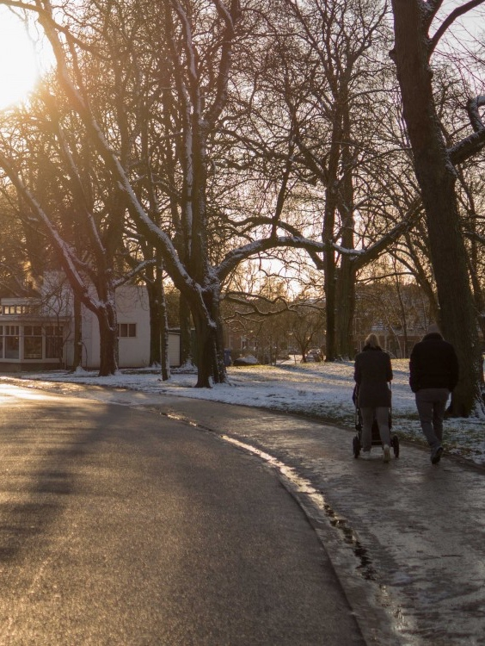

Image Creative Commons Public Domain.

James grabbed his backpack and put it over his shoulder a bit clumsily. James left his apartment, slamming his door behind him. “It drives me up the wall that I have to balance my cane and bag with this bum arm. That stupid driver! If he had just waited until I had sat down before moving, none of this would have happened. I wouldn’t have fallen and broken my arm.” Unfortunately, it happened all the time that the bus driver would drive off in a rush. James wished that there was a signal to let the driver know when he was safely seated.

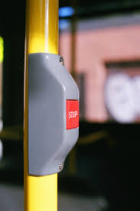

The image is released free of copyrights under Creative Commons Public Domain.

After walking for a block, James began to calm down. He felt like he belonged because this was his neighborhood. He saw people that he knew and started to feel better. He felt that he was getting all the garbage out of his mind. James arrived at the store in a better mood. He enjoyed coming to the store because he knew what it was all about. He could go out and get what he wanted all by himself and he liked that experience. It was so nice that the store was near James’ home. He could go whenever he wanted.

James always felt that he could be independent at this store because it had a railing on both sides of the entrance, so he felt secure on the step and he knew where his favourite foods were. However, today, James is buying Cheezies, which is something new and he doesn’t know where to find it. James looked for a friendly face and spotted his favourite cashier. He asked her for help and she was happy to help him to buy Cheezies. The cashier even helped James put the Cheezies in his bag. It’s hard to manage a zipper with one hand and keep his cane from falling.

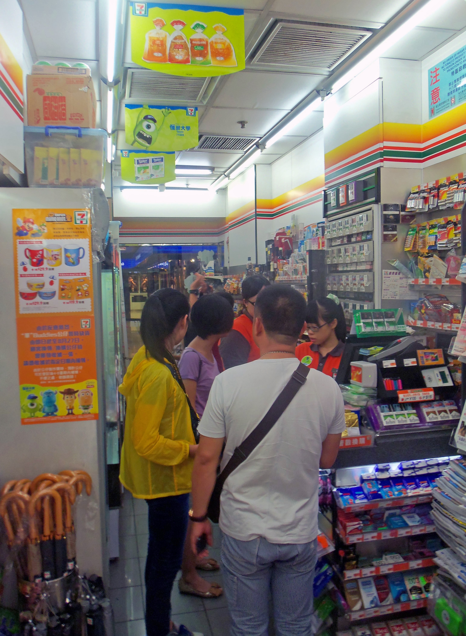

Image by [Daniel Case](https://www.flickr.com/people/8272478@N04/). Creative Commons Public Domain.

On the way home, James glances at his watch and realizes that he’s running late. “Oh no, I booked Wheel-Trans for 1:00” James had to be at the front of his building on time because Wheel-Trans would not wait and if he missed it, he wouldn’t get to go. James hurried home but had to be careful because it was winter and the sidewalks could be slippery. “It’s not the ice you see that you have to worry about,” James muttered to himself. James arrived at the front of his building, “made it!” James felt relief. Despite the blue sky, it’s chilly, so James decides to wait in the foyer. “Ah, that’s better.” James let the warmth from the heater take the chill off.

James keeps a close out the door as he waits and waits and waits. James glances at his watch and waits some more. Finally, at 1:40, Wheel-Trans arrived. “I wish I could take the bus like I used to, but it just isn’t safe anymore.” James felt anger at the driver for being so late. Still, he smiled anyway and was polite because he might get the driver again and he relies on the driver and doesn’t want to get in his bad books.

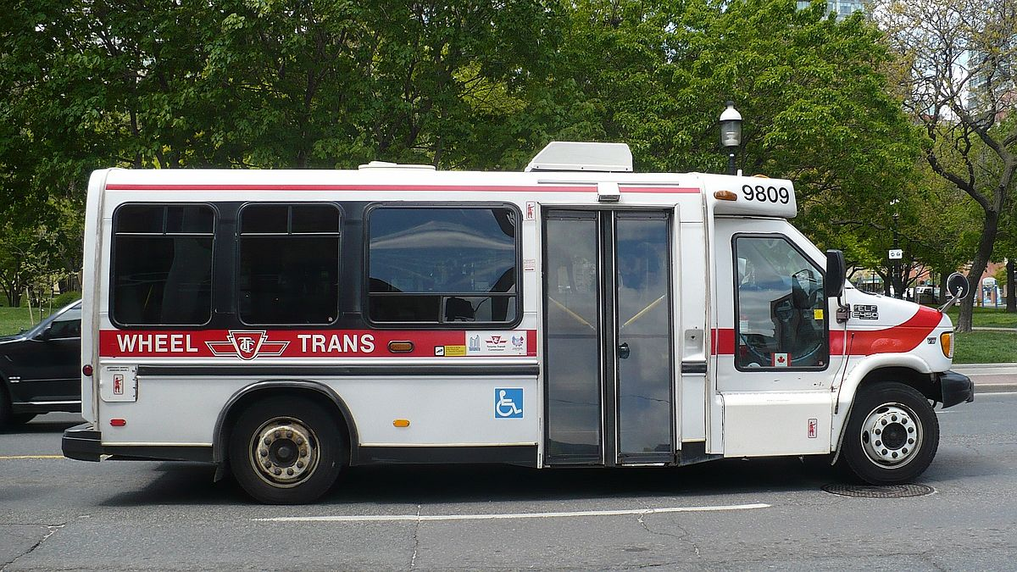

Image Wikimedia Commons.

Safely on his way to the senior’s club at the community centre, James lets the frustration of the wait go and begins to feel excited about getting out. James had been to the seniors’ club a few times and he liked going, but he still felt like the new person and, so he is a little nervous too. Today is the first time James is going to the club without Anib, his support worker. James thought Anib was the friendliest person he had ever met. Anib knew James’ interests and helped him find the seniors club to join. Anib also gave James the support that he would need to get to the club, meet the coordinator and feel comfortable getting to know the other members. Anib helped him find his way around and know where things are.

James had really missed people since he retired from his job and he missed his responsibilities of helping out and giving back to the community. He was an expert at what he did and had enjoyed every minute of it. This senior’s club was a chance for James to meet new people and to have a new responsibility and a role. This week, James is part of the food committee and has the job of helping to organize the snacks.

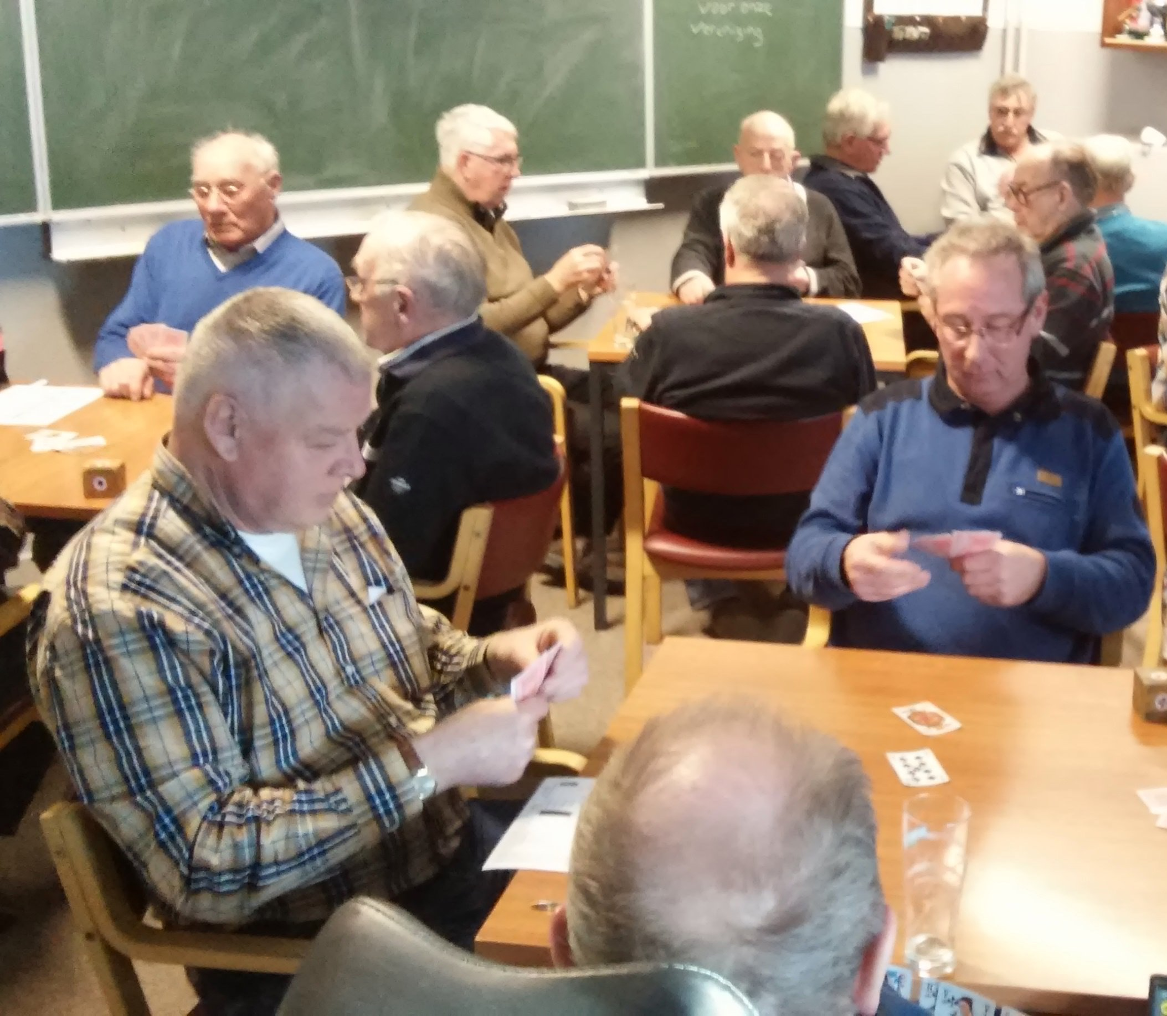

Image by [**Joop van Dijk**](https://www.flickr.com/photos/joopvandijk/). Creative Commons Public Domain.

It was great that the seniors had their own space within a larger community centre. They had a room just for them and for their things but could see all the different activities around them, kids and parents, newcomers learning English, young people exercising. There was a lot going on all the time, but, in their space, things were slower- paced and quieter. The room was just for them and everything that they needed was in that one spot.

When James arrived at the senior’s club, he began to set up the food table and along came Wally. Inwardly, James sighed. Wally was never happy unless he was telling people what to do. “Don’t put the Cheezies in the chip bowl. “Wally sniped. James wanted to say, “Cheezies, chips what’s the difference?” but talking to Wally was like talking to a wall. “Perfect name,” thought James, he didn’t feel safe with Wally and wondered why Wally couldn’t be friendly.

James looked for the Cheezie bowl but had no idea which bowl would keep him out of trouble with Wally, so he turned to the activity’s coordinator, Mary, who was always willing to help people who need help. Mary helped James with the bowl and thought about the problem of James’ discomfort with Wally and Wally’s need to have everything just so. Mary knew from her meetings with Anib that James was a good listener and enjoyed hearing about everyone’s day. Mary asked James to lead the group in sharing their stories from the past week. James was good at making everyone feel comfortable and listened well. He made people feel heard. Even Wally was willing to share his stories. James and Wally realized that they had some things in common.

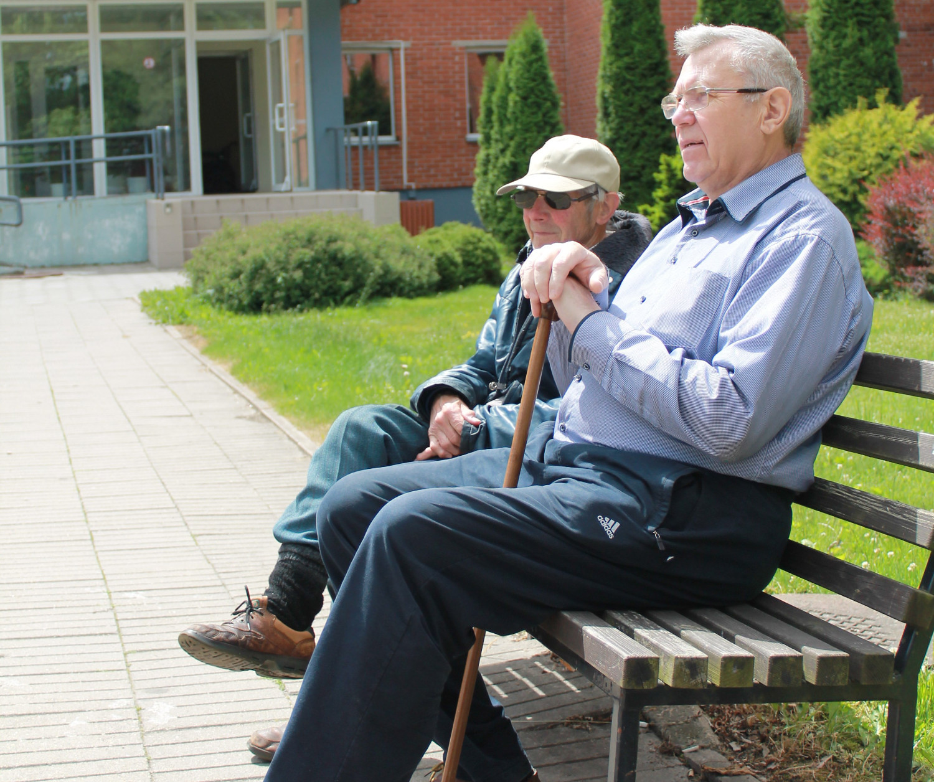

Image by [Senior Guidance](https://www.flickr.com/photos/146515428@N03/). Creative Commons Public Domain.

After story-sharing, Mary suggested that James and Wally work together to label the cupboards and the things inside so that everyone would know where everything goes and what each thing is for. James is really good at drawing and he uses pictures to help label the bowls and Wally prints neatly, so he writes all of the words.

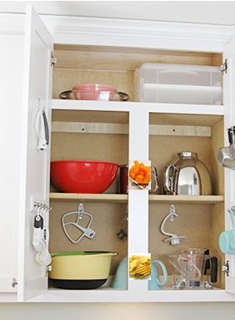 Image modified from <https://www.twotwentyone.net/quick-easy-organization-tricks/>

From that day on, everyone could know which bowl was for Cheezies and which was for chips.

## 

## Human Factor

I was driving into the parking lot and parked in a designated wheelchair parking. When I went to pay, I realized it was rather difficult due to the non-adjustable parking meter. From my angel seated in my wheelchair, the glare from the lights above me made it difficult for me to see the screen. The number to call for assistance went straight to voicemail. I left a voicemail with my license plate and cellphone number and stated that the machine was not reading my credit card. Digital options were simply not working and I desperately needed a more human connection for assistance.

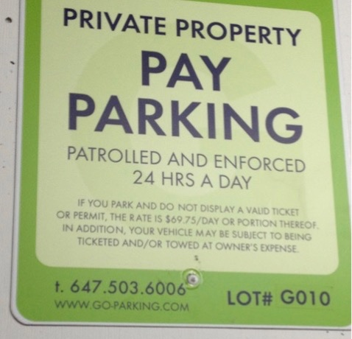

Image by the story lead.

Parking payment method. Showing where to insert credit card or change for payment method on parking meter.

Image by the story lead.

I walked into the grocery store using the specific entrance and as I was perusing the aisles, I found that there were several staff hovering over me when all I wanted was for someone to just say “I am here if you need me.” Once I was done getting everything I needed, I found my way to the accessible cashier lane, only to find it unstaffed. So, then I went into a regular line, where a customer offered to assist me by taking the groceries out of my bag from the back of my chair onto the conveyor belt. The card reader was also not adjustable. It could not be moved and it was out of my reach, so it was impossible to be able to hide my personal information when I reached over. This was yet another awkward instance where I felt I did not have autonomy.

Shows non-portable card reader which glare from above lights.


Image by the story lead.

No staff assisted me; it was simply other shoppers that offered to help. Common empathy of the average person rather than the attentiveness of staff has been a recurring theme of my shopping experience. Without the kindness of strangers, I often find that advocating for myself in what are monitored public spaces increases the feeling of “invisibility.” Once I was finished, I decided to head into the Mall to use the accessible washroom. I found it to not be so accessible after all, as it was, in fact, also being used as a non-gendered and family washroom. The support handles were not adjustable and the automatic door was not working, making it much harder to open. There were many other non-accessible features of the washroom, such as a greatly elevated mirror that started at my forehead, as well as a hand dryer that blew into my face. The toilet seat was significantly lower than my wheelchair, which made it difficult to transfer over, as well as the support bar being too high.

Toilet seat is significantly lower than wheelchair.

Image by the story lead.

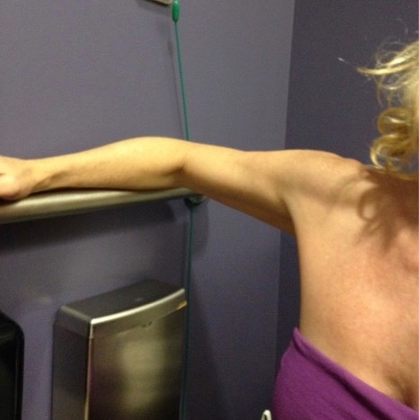

Image by the story lead.

Heading back to the grocery store, I started to realize that mall closure had already begun unannounced. I noticed that the accordion gate between the grocery store and the Mall had been closed, so I looked for a security guard to ask for assistance. I communicated that I needed passage through the grocery store to get to where I parked.

Entrance between mall and grocery store blocked by accordion gate.

Image by the story lead.

He said my only option was to leave through a different exit. This was concerning to me because it was a longer route and I was very tired at this point. I can see through the now-closed barricade, other shoppers still using the store on the other side. The solution was simple. I explained to the guard that I needed to go through that exit to get to my vehicle. However, he was resistant. Another customer noticed me on the other side of the gate and approached customer service on my behalf. She was refused by customer service to address the situation. She came over to speak to me and we discussed the unexpected early mall closure, which had left me feeling unwelcome and devalued as a customer. When she couldn’t find staff to help, she resorted to simply opening the gate herself and letting me through. No special knowledge was required, just compassion. Had this been a digitally timed locking device, this would not have been possible.

I exited the Mall using the grocery store entrance and made my way to my parking space. There was a car double-parked between the designated wheelchair permitted spots. I was unable to leave until another compassionate person came along and offered to move my van so that I could open my automated door and extend the ramp for my wheelchair.

Car double parked between two designated wheelchair accessible spots.

Image by the story lead.

Accessibility ramp being lowered to demonstrate appropriate space needed in between vans in parking spaces.

Image by the story lead.

Throughout my day, I encountered several instances where getting around was difficult. Barriers to access are a common experience in my daily life and I am appreciative of the awareness and assistance of others when available. This proves that the human factor must remain in designing. When ignored, it can affect all aspects of a person’s physical, emotional, psychological and social interactions.

## 

## Getting Around

**Starting My Day**

I begin my day by waking up. My first prayer of the day is that my scheduled PSW shows up, which is unusual; most days, I am left in bed until I can find someone to help me out. Today, she shows up.

**Walking My Dog**

Now that I am out of bed and in my wheelchair and ready to go, I have to take my baby out. My baby’s name is Juba and he walks on four legs. So, I put my baby in his bag and took him to the park for about 45 mins. We head back home, where I am going to leave Juba in a climatized environment as I’ll be gone for most of the day. I wish there were a way to access the thermostat in case it warms up or cools down during the day while Juba is at home. It would also be great to have a camera to watch him and maybe access to a community dog walker. 

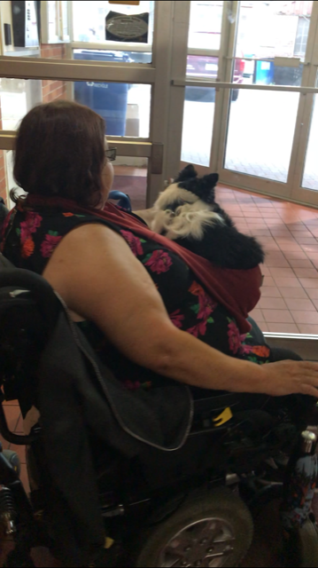

Image by the story lead.

**Getting to Work**

Back out ago, hoping wheel trans will be on time to get me to work. GREAT! Wheel trans is here and I’m off to work. Sometimes wheel trans doesn’t even show up, or it can be up to one hour late, which means I get to work late and I’ll be late for everything else during that day. It’s a good thing that my work can make accommodation for your tardiness. If the Wheeltrans doesn’t show up, I should call the cap, which is very expensive and it can add to a defect for my budget at the end of the month. Everything in Toronto is very expensive.

**At Work—Morning**

Today at work, my morning is about giving a workshop on cultural competency, colonization and history of Canada, all the way to treat and reconciliation and working with indigenous individuals and how this history ties into the trauma of today. Most of the individuals in the workshop this morning are police and security. Many of these individuals live in that new smart city, so it’s good for them to hear what the true history of this country is and the genocide that was enacted by the government that still is in power today. When Christopher Columbus got lost and we as indigenous people found him, life changed forever for us. Pre Columbus, indigenous people had an amazing simple life, living by the instructions given by the creator to live in harmony with all of our relatives, including those that grow on earth, walk on four legs, fly, crawl and swim. How people survived the cultural genocide with our languages and traditions still intact speaks to our resilience. How important it is for those who live in that smart city to understand how to interact and work with indigenous people and this should include all cultures and helping to understand newcomers as well.

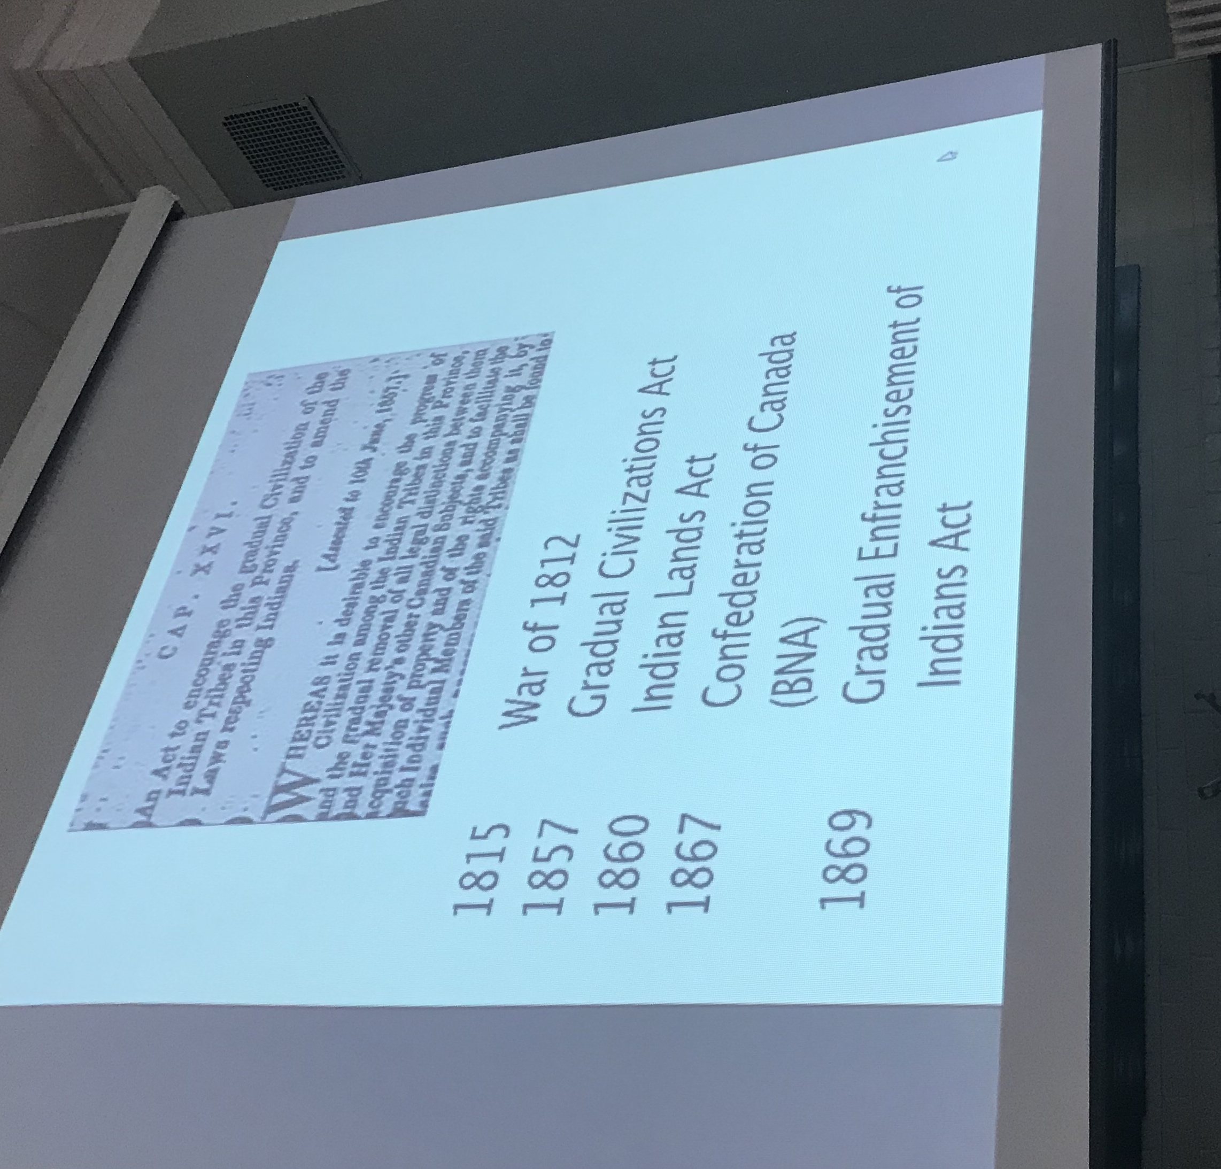

Image by the story lead.

**At Work—Afternoon**

After I have done that for the morning, I had my lunch and I’m going to go to the afternoon where I work with the individuals. My work with individuals is around self-determination and how to survive in today’s world, helping them to understand the social norms and orientation to the rules. Many of the people I work with are women fleeing the violence by their significant partner or family members of the missing and murdered indigenous women. For my clients’ survival, it is absolutely important to know about social norms and surviving in today’s world of the dominant culture, i.e. relationship to white privilege.

**Self-Care**

What a busy day I have had! And now I have to go to the park and rejuvenate myself. I have brought my medicine that I am going to burn and my hand drum to recreate the heartbeat of mother earth. So, I can connect with my ancestors and not take home the emotions of fear after a hard day of work. You don’t have to take home the other people’s trauma. Today is one of those good days when no one in the park complains to me about my behaviour. Some days people in the neighbourhood ask me to leave the park because they say that it is loud and they can’t stand the smell of my medicine burning and, on some days, they literally attack my (physically)—White privilege.

Hand drumming in the park



Image by the story lead.

Smudging in the park

Video by the story lead: <https://stories.cities.inclusivedesign.ca/uploads/eaa18a50-d64a-11e9-878e-13cc3403c489.mp4>

**End of My Day**

Now it’s time to go home and wouldn’t you know it starts to rain. I hated it when it rains when I go home because I leave south of Gardiner and it’s well known that during a rainstorm, it floods under the Gardiner, creating headaches for those ones of us trying to get home. Because of Toronto’s lack of infrastructure, the swear floods and the water seeps up to the street and in some case create power outages and increase pollution in water. When the swear overflows seeps up to the sidewalks and overflows over the manholes and flooding, the union station and cars are stuck there. I’m worried about my dog drinking this water and being affected by it. I’m also worried about a power outage and if I can get to my unit.

Luckily, I get home and the power is on. So, I take the elevator to my condo and take Jubo for a walk.

## 

## The Way Home

A person  crossing a city street with the CN Tower at the back. 

The image is registered trademarks of Airbnb, Inc.

My story is a story about finding a sense of place in Toronto. My journey as a queer refugee newcomer in Canada would lead me to new and unfamiliar spaces and through moments when I felt completely alone and times when I felt at home with people I’d only just met. These experiences shaped who I am in a place that I knew nothing about at one point.

The most important experiences for me were the ones that transpired in ordinary, everyday moments, in transitional spaces and in quiet and small ways. The growing pains and struggles that came with these experiences would become an important part of my journey. They brought me to my community. They brought me home.

A close up of a colorful background with a pair of feet in the centre.

Image modified. Original image by Joshua Coleman. <https://www.joshstyle.com/home>

**A Desire to Belong**

As a newcomer in Toronto, it was challenging to navigate the city layered with very different cultures, social norms and unspoken collective agreements shared between strangers. After landing here, I began to notice these differences, often with a debilitating level of acuteness and self-consciousness. In my culture, you are expected to seek out and utilize local knowledge when you are trying to navigate through a new or unfamiliar space; a sense of community is present even in public spaces and shared between strangers.

Here, in moments when I felt lost or confused and wanted to reach out to someone, I encountered apathy and occasionally even hostility. I come from a city that is far more complex and harder to navigate compared to Toronto. I have gotten lost several times while commuting, walking or driving in my city, but each time I was able to find my way with the help of strangers, which eased my anxiety.

 Drawing of a lost person crossing a city street.

Image created by the story lead.

As a newcomer in Toronto, I felt more isolated with each passing day knowing I was on my own if I were to get lost. It took me a while to process and understand the information in maps, signs, schedules and way finders. Often, it overwhelmed me when I was experiencing confusion and anxiety. Language spoken feels more valuable than language read in such situations. The attitudes I encountered reminded me that I was far away from home.

A group of people around each other crosing their hands.



Image by K.O. from Weclid Inc. https://weclikd.blog

**Searching...**

It took me a few years to familiarize myself with this landscape and find spaces where I could connect meaningfully with people. I started working as a community facilitator and through my practice, I began to connect with people through art and storytelling. Whether it was through poetry, artmaking, craft or performance—the presence of art and artists in my everyday life, public spaces and within communities I am a part of making me feel accepted and comfortable to express who I am. I felt new spaces open up for me. I didn’t feel so lost anymore.

A sweeter lying on green grass.



Image by the story lead.

**Kinship**

Since coming out as queer woman, I had to learn, unlearn and relearn what kinship and family meant to me. As I think about this, my mind travels back to three years ago when I injured my shoulder in a bike collision. I developed chronic pain for which I sought out every kind of treatment I could find. With failing treatments, I had to come to terms with the reality of living with this pain. The permanent sensation of pain reminded me again that I was alone. The family that provided me with care and comfort when I was sick or in pain wasn’t here with me. All around me, I saw people who didn’t have to live with pain every day and a culture that glorified physical fitness. The emotional experience of the pain was, at times, worse than the physical one. But my pain also gave me the tools to manage my pain in new and unfamiliar ways.

A person walking in a boardwalk in a forest during the day.


Image by the story lead.

In the following years, I sought and found alternative forms of care and healing. The only time I was able to forget about my pain was when I was walking in parks surrounded by old-growth trees, hiking in forests, sitting by the lake, feeding birds and studying trees. I felt myself growing closer and closer to my natural environment. Being near trees, whether in a park or backyard garden, soothed my pain, calmed my nerves and let me connect with something outside of myself. The kinship I developed with trees, birds and animals not only healed me but made my connection to this place even stronger.

Drawing of a front of a house, in the middle of second floor there is a balcony with the siluet of a women with flowers around her.

Image created by the story lead.

**Putting Down Roots...**

My new life in this now familiar place needed a place that I could call home, one that I would be sharing with my partner. I try to forget how frustrating and arduous it was to look for a home as a young, queer POC (person of colour) couple. For a few months in the process, we had to live with the possibility of being forced to move to an area that was remote—disconnected from our support systems and friends. Luckily, we found a home in a tiny attic studio in a neighbourhood that we love.

Looking back at these experiences, I can see how much I have grown in this city and how much the city has grown on me. My story is one of the many, many stories of the people from my newcomer, QTBIPOC community. It is what drives me to help others feel at home wherever they are.

## Smart City: Bringing Back Civilized to Civilization

Since the beginning of our time, my ancestors walked this land. I have always felt great comfort knowing that where my footsteps, my ancestors have also stepped in the same place, long ago. At one time, we had full access to our land, water and all that resided in and on it. We had access to all of our medicines, to our language, to our culture and ceremonies. We could stand on the water’s edge and drink directly from the shores; we had all that we needed to survive and thrive in our communities following the seasons, the sun, the moon and the stars. We travelled freely along with the lands surrounded by its comforts and bounty and were a greater part of that community, helping anyone in need and being part of that village.



Image by Natasha G from [Pixabay](https://ocaduniversity.sharepoint.com/teams/Team_MIDPEvaluation/Shared%20Documents/General/Image%20by%20%3ca%20href=%22https:/pixabay.com/users/NatashaG-363234/?utm_source=link-attribution&amp;utm_medium=referral&amp;utm_campaign=image&amp;utm_content=527995%22%3eNatasha%20G%3c/a%3e%20from%20%3ca%20href=%22https://pixabay.com/?utm_source=link-attribution&amp;utm_medium=referral&amp;utm_campaign=image&amp;utm_content=527995%22%3ePixabay%3c/a%3e).

Since the colonization of man, the connection to the earth has suffered. Where I was once able to put my feet in the water, I now have to stand on a pier looking over. Huge condo developments deny my access to it and it has become a commodity that has been privatized and commercialized. All the plant medicines have been replaced and colonized as well by plants and seeds from other lands. Concrete laying over these plants, the seeds have since gone to sleep. Where we were able to view the travels of the sun, the moon and the constellations, the buildings have grown taller and taller, fighting for real estate space in the sky, blocking out our access to it. Large trees have been replaced by much smaller ones and our access to green space has been denied.

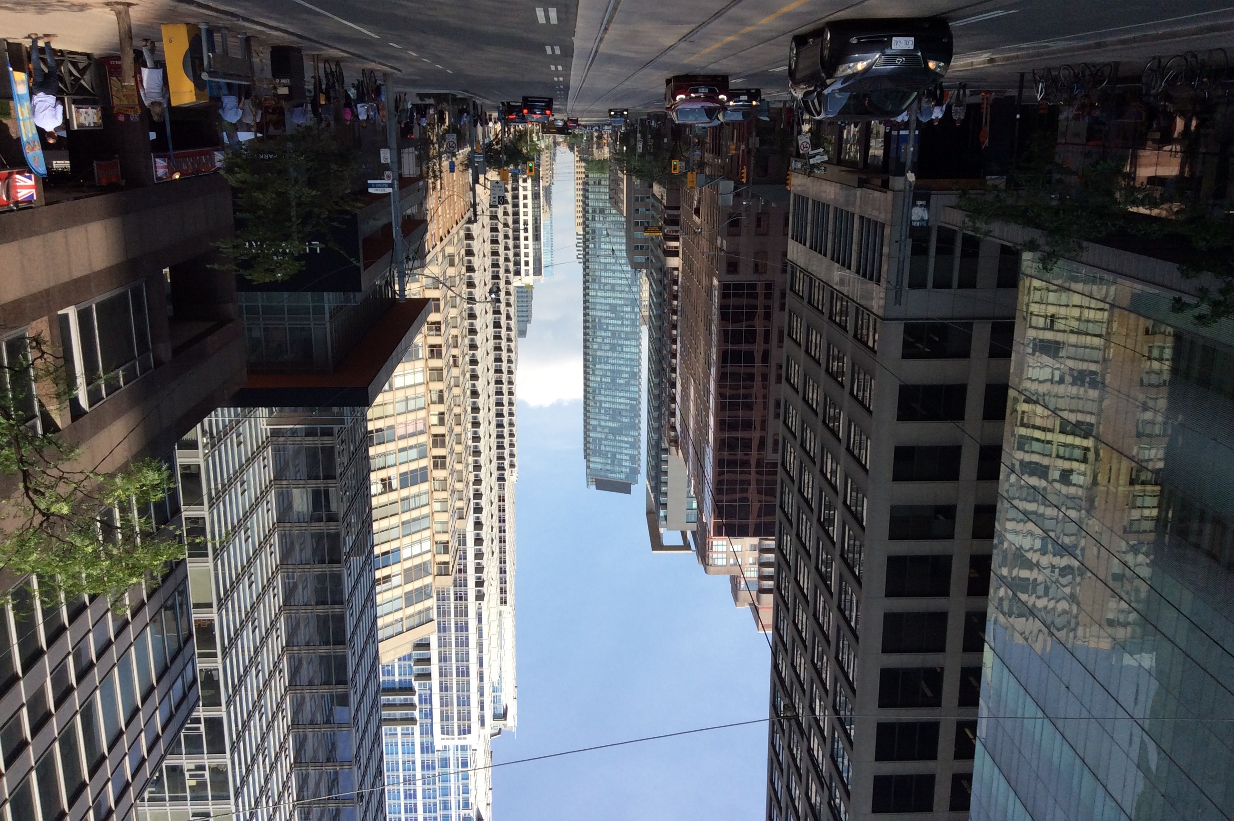

Image by the story lead.

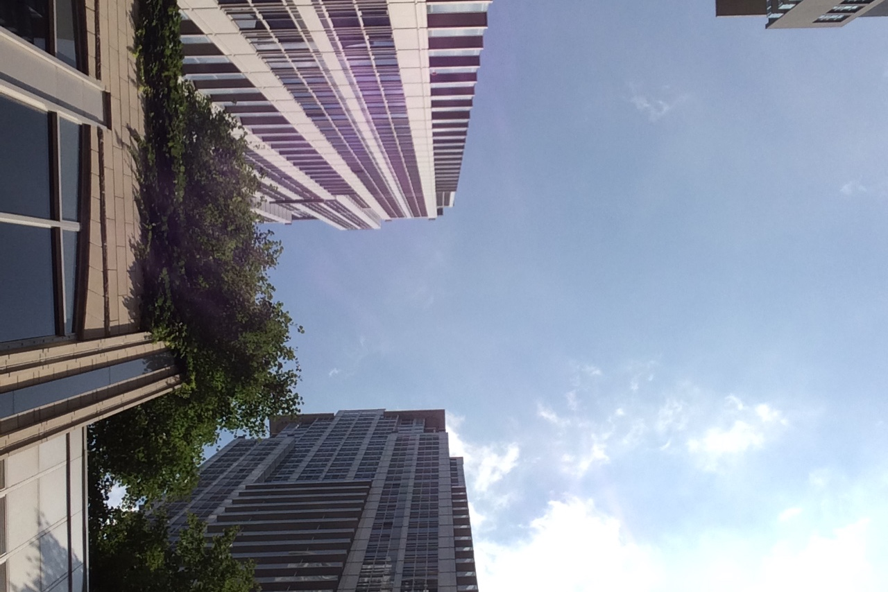

Image by the story lead.

Losing access to our land and to the rhythm of the seasons has removed all empathy and compassion from us, as a whole, so that what we have done to the land, we are now doing to the people. We have become focused on the development and economic growth at the detriment of the fringed society, where we are made to feel invisible and unheard. When I walked through my neighbourhood, old storefronts that were once family-owned, are now replaced with larger brand-named stores that could afford the high rental rates. Cultural centers, Free Clinics and public access buildings were being relocated and replaced by Starbucks, Tim Hortons, Urban Outfitters and other corporate entities, removed all the individuality that made up our neighbourhood affecting single mothers, refugees, All homeless, those with addictions and mental health affected communities. Access to Shelters, food banks, walk-in clinics being replaced by private practices in a tiered healthcare system, shelters are moved to the suburbs, further denying basic human needs to the people that make up my community so that they have no choice but to move away. The green spaces that I enjoyed with my children growing up, became parking lots and then became condo developments, which only the rich can afford, making me feel like a stranger in my own neighbourhood.

All that I have witnessed in my community is a direct result of colonization. The taking over of lands replacing inaccessible resources to those who cannot afford and gentrifying spaces, making them inaccessible causes those that are affected by these changes to suffer as a result. As a single mother with three children, I cannot afford to move out of our one-bedroom apartment and with all the development makes affordable housing a pipe dream.

Elder Jay Mason told me once that there is nothing civilized about civilization and long after he is gone, I can see this for my own eyes. In the presence of urban development, I see humanity’s fragmentation, further marginalizing the most vulnerable and weak. Much like cement is paved over nature, I see the same happening to people.

As I walk the streets, I see directly how the homeless are affected, how police presence is more prominent. How a homeless man is bullied because he had alcohol open in a park, gets a 300 dollar ticket and a six-month ban from the park (his home) while they look the other way at all the public drinking that is available and even encouraged at street festivals and beer gardens, throughout the city. Buildings and public spaces are designed to make it impossible for those that are homeless to find a place to sleep or segmented benches, making laying down impossible.

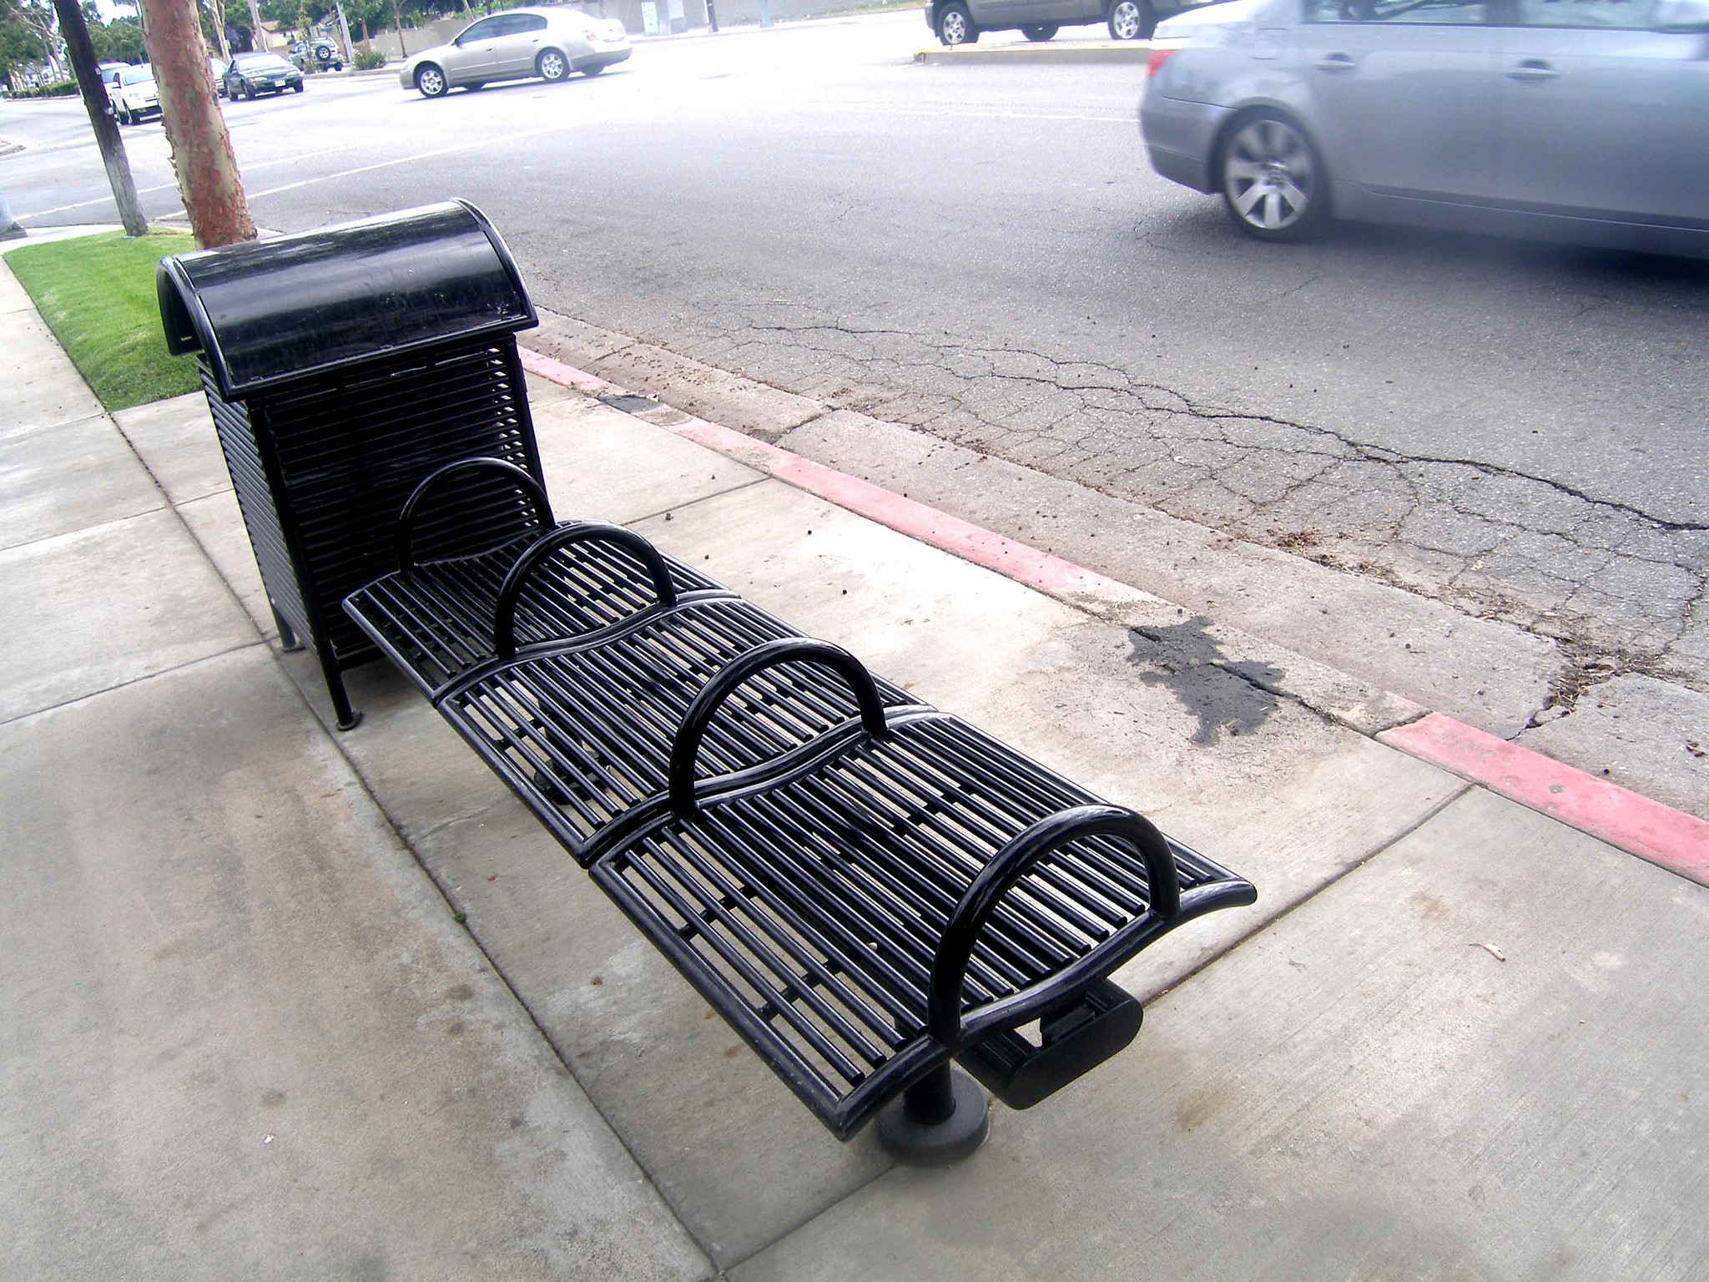

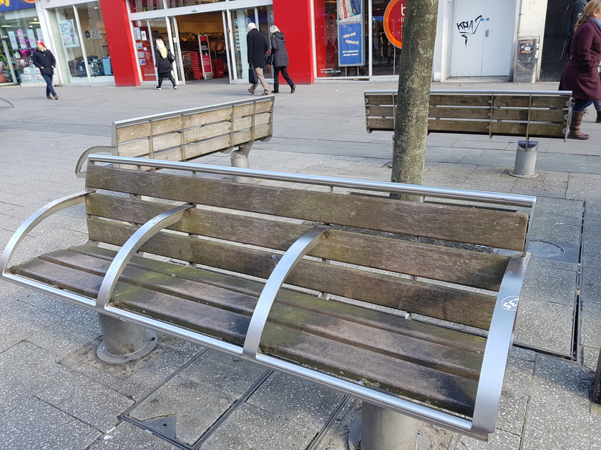

Image by [Laurie Avocado](https://www.flickr.com/photos/auntylaurie/2528899062). Creative Commons Public Domain.

Police involvement is based on personal biases and even Indigenous police have been assimilated to the point where they are enforcing colonial laws against their own people for simply being visible. This makes me concerned, not only for our community that once was, but for the future of my children, that they will be scrutinized by the families and the children they grew up with are now afraid of them because of their socio-economic status.

Police involvement is based on personal biases and even Indigenous police have been assimilated to the point where they are enforcing colonial laws against their own people for simply being visible. This makes me concerned, not only for our community that once was but for the future of my children, that they will be scrutinized by the families and the children they grew up with are now afraid of them because of their socio-economic status.

In one of my travels, I came across a dandelion growing in the crack of the sidewalk and it reminded me of the resiliency of mother nature. How resilient our plant medicines are that even though we have long paved over them, the seeds have been asleep and are now waking up. It reminded me of the resiliency of humans and how we strive for that connection and although we may only be a plant creeping up from a crack, underneath that sidewalk, our roots are connected to each other. Where the government has failed to help the people, I have seen the roots in the community grow and reach out to help each other.

A wild plant with flower groing on a rural street.

Image by the story lead.

Where again, those without monetary gain are usually the most charitable to others in their community. Where government programs have failed, grassroots programs have thrived with people leading their own patrols, policing their own communities, opening their doors, feeding the people and being that village. I have seen the outpour of kindness and generosity from those who have nothing because it is in their nature to give because they know what it feels to live without.

Thinking back to the uncivilized nature of civilization makes me wonder how can we improve the urban environment to include all. I am reminded of my traditional background and how I look towards how we survived without the amenities that now give us comfort. How when we think of a smart city, my idea of “smart” doesn’t involve electronic apps, or billboards with information, surveillance cameras everywhere and constant light and sound pollution. That all of these mess with our circadian rhythm, turning us into insomniacs and further harms those like my sons with autism, who have sensitivities to lights and sounds causing stress, overthinking and mental health issues due to constant information overload.

A smart city for me would focus on sustainable living practices for all that improve our everyday living and the communities we live in.

Incorporating more green spaces that are not only accessible to all but also are affordable to all. Using rammed earth, strawbale, adobe, cobb, in our structures to reduce our strain on the environment. Making Internal walls out of recycled products like pop cans, plastic water and glass bottles so that they don’t end up in landfills. I think about how this type of housing would benefit all of my friends on the street and make affordable housing more accessible. How this type of thinking can benefit the design of a smart city which would create accessible homes for low income as well as for those that can afford the market rate. A tiered building system so that each apartment can grow their own food with passive solar windows and outdoor patios that encourage the owners to grow their own foods. Not only is affordable housing important, but it is also essential to change our ways of thinking so that different economic brackets can live side by side without stigma and judgement. That a smart city would embrace all public access. I dream that our public transportation would be tied into our tax system so that it would be free for all, or that it would be geared to income. So that it would be more equitable for people like me don’t have to pick between putting money on a presto card or feeding my children that week, just so that I can go to work to support my family. The idea of an equitable society is a truly smart city, where it is accessible to your needs and not based on your socio-economic status. I see a community being supported like all aspects of the medicine wheel. That it would support the mental, emotional, physical, spiritual aspects that holistically support our well-being.

All of those aspects of human conditioning can be healed through greenspace. Removing contained gardens and making them accessible to the people so that all Schools and buildings have greenhouses, where children can learn how to grow their own food and lunch and breakfast programs in the school, can benefit from it. As well as nurturing the child’s connection to nature. All green spaces contained lush gardens that can provide nourishment as well as stimulation to the senses. I see a community of food gardens, Healing gardens, fruit trees, edible flowers making food accessible to all. This is the way to moving towards a smart city and bringing the idea of civilized, back to civilization.

## Grades and Shades of Inclusion

**Introduction**



Image by Cultured Stone. [Stream Stone Spring](https://www.culturedstone.com/products/stream-stone#spring).

Inclusiveness is like a precious stone. When someone comes across a precious stone, there are a number of different reactions they may have. This story will present some of those reactions as scenarios and describe how it relates to accessibility and inclusiveness.

**Scenario #1: Neglecting To Be Inclusive**



Image by [Pezibear](https://pixabay.com/photos/desert-sand-landscape-sun-sunset-790640/). Pixabay License.

One way of reacting to the precious stone is outright dismissing it.

The Story: In this scenario, the stone is completely ignored. Even though it has a shine, its own appeal and characteristics, none of those are taken into account. The stone receives no attention and no value.

Impact on Accessibility: There are two different degrees of impact on accessibility: partial and total. Total neglect involves no action toward accessibility. This creates stigma and discrimination towards accessibility. It also reinforces the blind spots that society may have about accessibility, making the issue even more challenging to resolve. Partial neglect occurs when you take some steps towards accessibility, but neglecting parts of it for different reasons. For example, a lack of funding or knowledge leads to partial neglect. Additionally, ignoring feedback on the existing solutions for accessibility also contribute to neglect.

Examples:

* A landlord that is solely interested in maximizing profit at the expense of the tenants. Despite being presented with the case for accessibility, the landlord outright dismisses these needs. Worse even, they use accessibility demands as a reason to divide tenants and make it difficult to find a solution for all.
* Using payment terminals that don’t enable a “tap” functionality leads to privacy issues. Without a tap, a user has to share their pin-number with a third party (i.e. cashier), which puts their identity and security at risk.
* Banks offer the service of a safety box, which is not designed to be accessible. Both the actual design of the infrastructure and the service itself are limiting and do not work for everyone.

**Scenario #2: Inclusiveness as a Prop**

A vase of flowers with stones inside on a table.



Image Public Domain.

Another reaction to seeing a precious stone is to think about it as a prop or decoration.

The Story: In this scenario, the stone is taken from its environment and used as a display piece. For example, this may add a certain aesthetic to someone’s home or serve as a decoration for his or her living space. In this scenario, the stone becomes part of the background; it’s not a focal point. It’s only brought up when it needs to be presented, but otherwise, it’s sidelined as an object for display.

Impact on Accessibility: Here, we see accessibility as a trend. It’s used as a real-world display piece to demonstrate compliance with legal requirements. This treatment puts more importance on the presentation of meeting accessibility (the superficial), not actually serving the core needs of accessibility (the meaningful).

Example(s):

* Elevators that are designed to be accessible, but in fact, do not meet the diverse needs of the users it's intended to serve. The placement of the control panel is placed out of the hand range; the design of the buttons is limiting, a lack of voice-activated controls, etc.
* Washrooms are not equipped with transferring devices for those in need. There is a range of unique and private, needs that are unmet in washroom designs that don’t respect or dignify the users.

**Scenario #3: Inclusiveness as a Commodity**

Image of a brick wall.

Image by story lead.

Another reaction to seeing a precious stone is to look at how you can use it to your own benefit. Essentially, the stone becomes an object of consumption.

The Story: For example, the stone can be marketed, promoted and sold. Driven by these motives, the stone is only valuable by serving the "business," not in its own right. The stone is just like any other stone, extracted from its environment and sold for its material benefit.

Impact on Accessibility: This relates to accessibility because it's often valued from a commercialized or business perspective. This puts accessibility as a risk of becoming commoditized. It downgrades the value of those with accessibility needs by dehumanizing the person. Both the uniqueness and diversity found in inclusivity are removed in favour of efficiency and scale.

Example:

* The pricing and business model for a variety of accessible products and services demonstrate the commercialization of accessibility:
  + Powerchairs that come at a price tag that is unreasonable for any individual to purchase, causing them to rely on funding or other means
  + Accessible tech and devices that are provided and serviced by organizations and
  + The extremely high price point for accessible vans and its maintenance at a specialized shops.

**Scenario #4: Core Value of Inclusiveness**

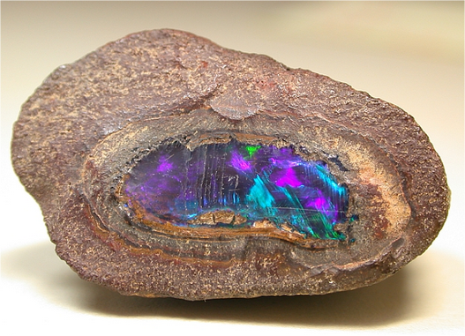

Image source: Public Domain.

Another reaction to coming across the stone is to see, understand and respect the stone for its own value.

The Story: In this scenario, the stone is appreciated for its inherent value—to know it as it is, not like your project. This means understanding all aspects of the stone-like, its history, environment, variety of characteristics, power of action and its limitations, etc.

Impact on Accessibility: When it comes to accessibility, this reaction, it respects, dignifies and empowers those served by inclusiveness. This involves seeking to understand the needs and challenges from the perspective of those who need it. Ultimately, this puts the focus on the real-life impact of accessibility and creates a habit of ongoing improvement.

Example:

* The use of ramps in public spaces is an example of taking care of people’s needs
* Closed Caption is a broad, mass example of assisting those with hearing challenges.

## Into the Chaos

**Starting the Day**

My guide dog and I start our morning with a walk by the lake. This is a favourite spot because the boardwalk is wide and the white benches and handrails stand out against the background. I enjoy the soft sound of the waves and birds and the feeling of being with nature. This is a calming space for me as I get ready for the day ahead. I have a hearing loss as well as being legally blind, so these moments of quiet are important to me.

A group of subdivision houses with stores in a comercial street



Image by story lead.

Boardwalk by the lake.



Image by story lead.

**Heading Downtown**

I am heading to downtown Toronto for a professional conference. I head to my local GO train station with my guide dog and we meet up with my human companion. I’m thankful for the portable ramp onto the accessible train car. It’s easier as the steps are hard to navigate.

When we disembark at Union Station, we make our way to the elevator. I’m not able to see the buttons on the panel, even though it has red backlighting. It is not enough contrast for me to see. I have to wait for someone else to push the button. The Braille buttons are a nice "feel good" feature for those who are sighted or blind (if the blind can find it...). Not many low vision persons know Braille.

When we get off the elevator, we are now in what I call “chaos,” with people rushing in every which direction. My companion struggles to find the sign to the street because the station has changed so much recently. The environment at Union is constantly changing due to the ongoing renovations. This makes it confusing to find our way around.

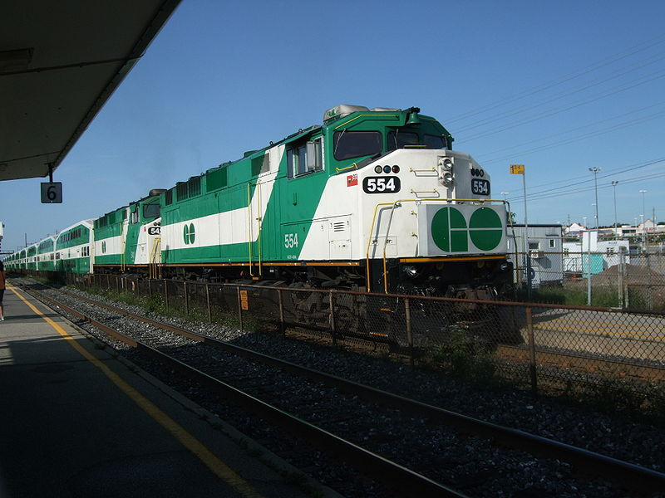

Image by Ibagli. Wikimedia Commons.

**On the Streets**

We finally make our way to street level. The constant sounds of traffic (trucks are the worst!), construction noise and people talking all blend into a cacophony of sound. It is hard to hear my companion, so a conversation is not easy. While we were waiting at an intersection for our light to turn green, a wide-bodied truck makes a right turn in front of us. My companion pulls me back a few feet to avoid contact with the truck body and wheels. What seems like numerous encounters with construction hoardings has us veering off to the right or left to walk along the temporary wood surface. These tactile changes my feet felt, combined with the construction noises, do not feel safe.

**Navigating Steps**

I arrive at the conference venue, feeling very stressed. This is not helped by the fact that I almost fell down the stairs when making my way to the correct floor amid a crowd of other conference-goers. The stairs don’t have a continuous handrail and there are no tactile markings on the floor. I don’t know where the stairs begin and end. A ramp would have been better!

**Dining Out**

After the last panel at the conference, a group of colleagues and I decide to continue the discussion at a nearby restaurant. The restaurant website indicates that it is accessible. On the way to the restaurant, I look for an area to relieve my dog. I know she has to go, but there is only concrete. All of a sudden, my dog stops smack in the middle of a sidewalk and has a poop. I always travel with (empty!) poop bags, so I pick it up. It is a while before my companion points out a garbage can and I deposit it. This is not the first time my dog has dumped on the sidewalk. (Hint to neighbourhood designers and developers: please provide obvious relief areas for service and pet animals. It could be as simple as a large square of dirt next to a curbside tree and garbage can next to it.)

The hostess at the restaurant is putting tables together to accommodate our large group. We explain to the hostess, we need a table with a bright light because of my low vision. But once we’re seated, I find it’s not bright enough for my needs. I ask if the lights can be turned up and the answer is no. The noise level of music and people talking and dishes/glasses clinking is loud and it is hard to have a conversation with anybody. We are handed menus and I put mine aside. The server comes to our table and starts talking rapidly. "Hi, my name is...? And I am your server tonight. The specials are blah blah blah ...... And comes with blah blah blah. And the soup is blah blah blah. Can I get you something to drink?"

I have no clue what the specials areas it was too noisy to hear and too fast to follow. By now, YES, I need a drink! I order my usual as it's a standard drink. My companion tells me slowly and clearly what the specials are. We order our food. When it arrives, I cannot figure it out. My companion is accustomed to telling me things like: the potatoes are at 6 o'clock, the meat is at 9 o'clock, etc. This time, however, he looked flummoxed. The menu did not describe this as a DIY (do it yourself) assembly dish. This was a lettuce wrap that I had to put together myself from a literal head of lettuce. It was definitely not "blind-friendly." The waiter came over and explained how to put it together for EACH bite. I could not see to do this, so I ended up picking away at the individual ingredients. Not enjoyable.

Meanwhile, the noise level is getting to me. If I turn the hearing aids down, it is hard to hear the people around me. If I leave the hearing aids alone, it is still difficult. I’m missing all the jokes and stories people are sharing with one another. The connections that they are making is something I am not a part of. Watching my fellow group members interact and not being able to participate makes me feel isolated. I’m not enjoying this, I’m enduring it. I can’t wait for the meal to end.

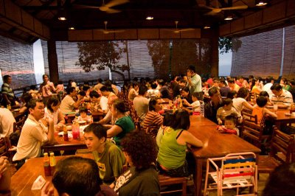

[This Photo](https://marginomarginalia.wordpress.com/category/poems/) by Unknown Author is licensed under [CC BY-NC-ND](https://creativecommons.org/licenses/by-nc-nd/3.0/)

**Using the Washroom**

I need to use the washroom before we leave. As I bump my way past tables that are too close together, I reflect that this is not a wheelchair friendly space as well as not a low vision or hard of hearing friendly. The washroom is dimly lit. The stall doors and partitions are dark and so are the walls of the room. I finally spot a white toilet and use it. The sink and soap are manageable, although finding the dark paper towels and the garbage can is a challenge. And the door to get out of the washroom is the same colour as the walls. Finally, I see the glint of a metal handle on the door and open it.

**Home Sweet Home**

When I get home, I realize how tense my shoulders are. I feel drained from the challenging day I just had. Home sweet home!

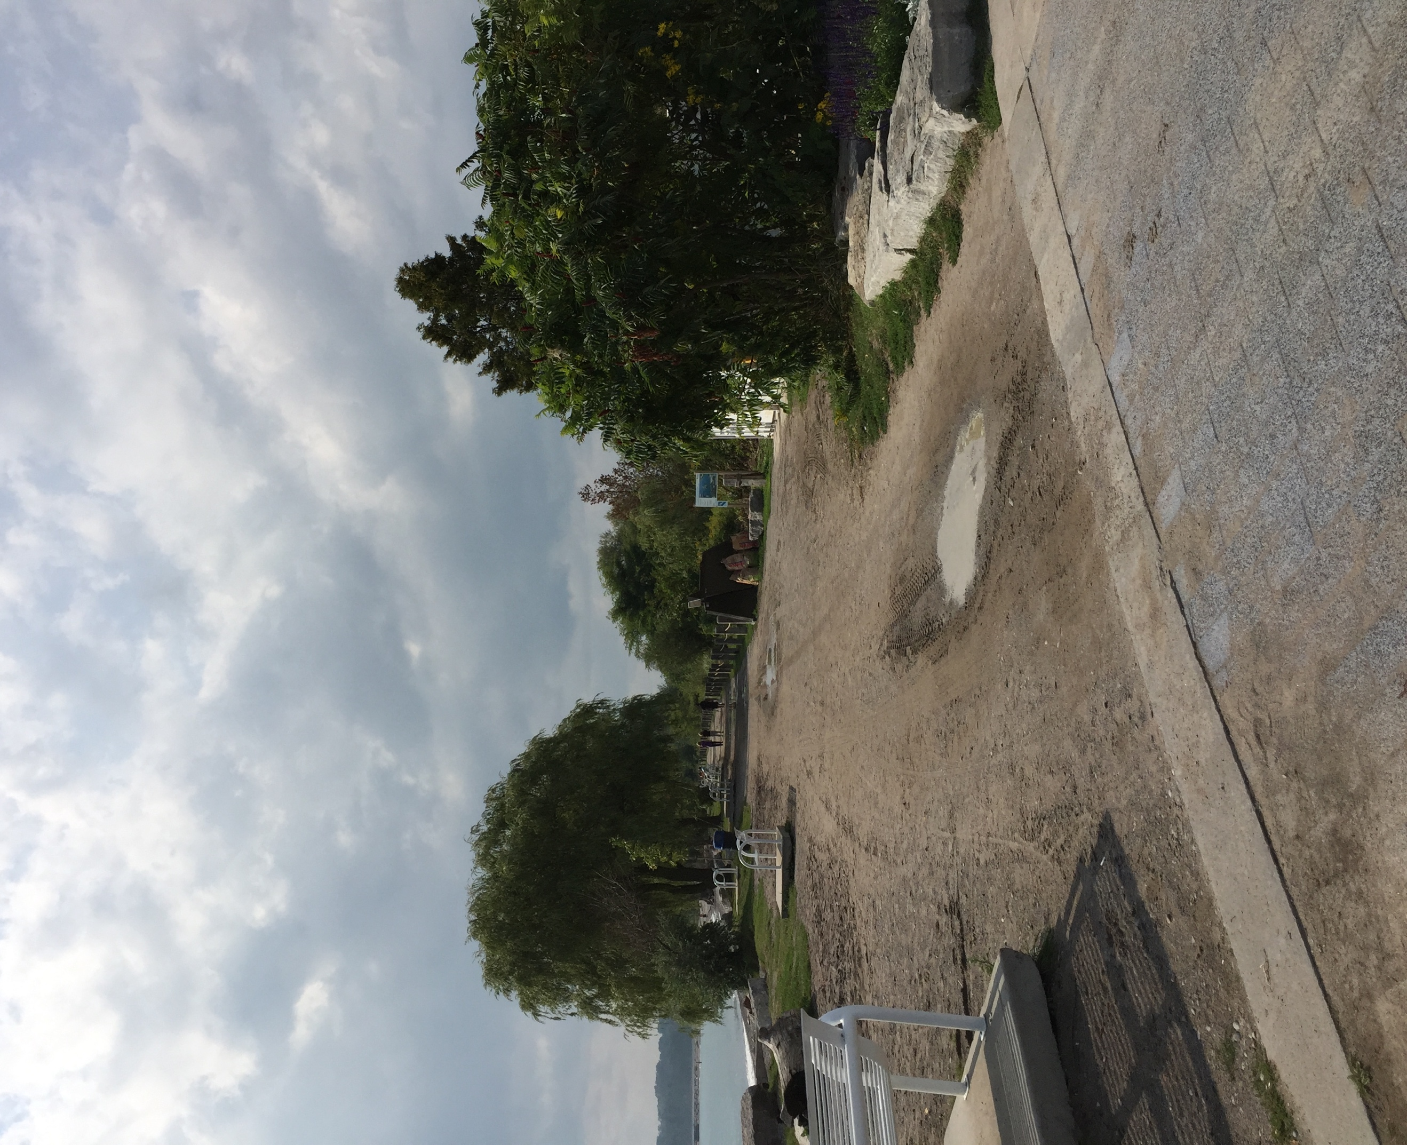

Image by story lead.

# Evaluation of MIDP

Following a final review of the stories by the expert contributors, the We Count team started work on analyzing the content of the stories. Using the stories from our expert contributors, we formulated questions to evaluate the MIDP, not only from an accessibility standpoint, but also from the perspectives of people with experience of disability and other members of the disability community. The insights of people who both depend on accessibility, and for whom accessibility either fails or is lacking made it possible to create questions that challenged the MIDP project in innovative ways.

The process of formulating questions was iterative, meant to both elicit as many questions as possible towards as full an analysis of the MIDP, and to bring out emerging areas of concerns throughout the stories. Were there shared experiences or concerns from story to story? What themes emerged within each story and in the stories overall?

Using the questions elicited from the stories, we determined six thematic groups that were of particular interest to our expert contributors in their stories:

* Stakeholder consultation
* Building, space design & sustainability
* Social support, culture & spirituality
* Governance, standards, & affordability
* ICT accessibility

The chapters of the MIDP were divided among We Count team members for analysis, with relevant questions and themes. Certain questions and themes were relevant to more than one chapter and this analysis from multiple perspectives became an important aspect of the methodology. Having multiple points of views that are equally considered valid simultaneously made it possible for the analysis to be more comprehensive. Instead of trying to impose a neutral point of view that would necessarily value one view[4] over or instead of others, incorporating multiple points of views in the analysis more accurately represents the multiplicity of experiences in the disability community and in experiences of (in)accessibility.

We presented this methodology at the 2019 DEEP (Designing Enabling Economies & Policies) on October 18th, 2019. Preparing and giving the presentation itself became part of the overall methodology of the MIDP analysis: it made it possible for us to reiterate the centrality of the stories in our analysis. In turn, this brought to the fore certain overarching aspects of accessibility as it is set out in the MIDP. Notably, the role accessibility is presented as playing in the creation of Quayside and the IDEA District overall as new types of community spaces; the concept of the user/community member Sidewalk Labs implicitly sketches in the MIDP; the focus on technology as offering solutions for accessibility and ultimately to disability; and the importance of social and economic in(ex)clusion for our expert contributors and the ways the MIDP has evaded addressing issues of meaningful participation, power differentials and indigeneity and ethnicity in their master plan.

## A New Type of Community

In the MIDP, Sidewalk Labs focuses repeatedly on the importance of community[5] for ensuring the success of Quayside and the IDEA district neighborhoods. All aspects of the proposal are dependent on the idea "that the greatest cities are built from the community up" (Vol.1, p. 21). In fact, what is proposed in the MIDP is "a new kind of community" (Vol. 1, p. 22) where digital technologies and big data are used to shape and support urban and social infrastructures, supported by an active citizenry. Digital tools and innovations are intrinsic to the development and the implementation of Quayside and the IDEA district: from an automated factory to produce mass timber and the construction of a separate and independent thermal grid, to the collection of real-time energy data and the schedulers used to manage energy consumption, the physical infrastructure of Quayside and the IDEA District will rely on the digital solutions Sidewalk will provide. It is a vision of community that attempts to merge community values and people-centric design and spaces to digital tools and efficiency; this ends up defining normative expectations about how this community will be organized and who will determine both norms and community.

After reading the MIDP it remains uncertain how disabled people and other people from marginalized communities will be included in Quayside and whether that "inclusion" will be more tokenistic or more robust. In part this may be due to "community" being determined by how the smart city will be constructed, organized and maintained, with people living there expected to comply to whatever vision of the future Sidewalk Labs has imagined will benefit their economic bottom-line the most.

In the stories co-created by our expert contributors, on the other hand, community is tied to the geography and the past:

I have always felt great comfort knowing that where my footsteps, my ancestors have also stepped in the same place, long ago (p. 29).

But community is also constructed through learning to belong with new people and in new spaces:

My journey as a queer refugee newcomer in Canada would lead me to new and unfamiliar spaces and through moments when I felt completely alone and times when I felt at home with people I’d only just met (p. 23).

As well, community is sharing our experiences and knowledges with those who are different from us in meaningful ways:

Today at work, my morning is about giving a workshop on cultural competency, colonization and history of Canada, all the way to truth and reconciliation. . . . How important it is for those who live in that smart city to understand how to interact and work with indigenous people and this should include all cultures and helping to understand newcomers as well (p. 20).

The vision of community our expert contributors paint is based on relationships of interdependence between people and with non-human animals and nature, that recognizes that the past plays a role in creating present situations of inequality. In determining a more livable community, efficiency stands in opposition to equity for disabled people and while community-based values might seem the fairest way to govern the public realm, if people from marginalized communities continue to be in the minority, then their voices, even in community-based systems, will continue to be drowned out.

## MIDP Definition of Accessibility

Access (including but not limited to accessibility for disabled people) is used as a core value of Sidewalk Labs’ proposal for Quayside and the IDEA district. The project presents a vision of a neighborhood that affords a wide definition of access, to affordable housing, to sustainable energy, to a more walkable city, to opportunities for personal entrepreneurship and to an "expanded public realm" (Vol. 1, ch.1, p. 81) that will allow for a presumed greater individual fulfillment of its citizens.

As part of this commitment to this understanding of access writ large, Sidewalk Labs highlights the long-term consultation process they have developed with multiple community stakeholders, including the "accessibility community" and individual disabled people (Vol. 1, p. 136). In partnership with the Inclusive Design and Research Centre, Sidewalk Labs has held co-design sessions to understand different aspects of accessibility experiences from the point of view of different disability communities.

The co-design sessions have led to Sidewalk Labs developing "22 accessibility principles" (Vol.1, p. 137), ranging from “general,” “physical,” and "digital" accessibility. Most of the principles in the physical and digital categories are practical design guidelines that embody what people with different accessibility needs encounter when they try to live their lives. The principles: "Build for wheels," "Enable wayfinding in multiple formats," "enable personal assistive technology with a focus on easy to access, low-cost technologies,” and "support multiple input modalities to all experiences" are all examples of these practical design aspects. However, the principles aren't applied consistently throughout the MIDP. Also, the hackathon Sidewalk Labs organized (IDRC, 2018) yielded some prototypes to increase accessibility in the smart city, but based on our expert contributors' stories, many accessibility needs remain unaddressed (see below: "Persistent Technological Fails").

When it comes to more general accessibility principles, such as "nothing about us, without us,” it is evident that Sidewalk Labs’ understanding of what is "about us" might need expanding. There isn't an aspect of society that does not concern disabled people (which is why disability communities have now altered that slogan to simply "nothing without us"). This inclusion isn't reflected in the MIDP: there are many questions about how accessibility will be included in housing, public realm, mobility, environmental sustainability issues and so on (see "Evaluation of MIDP" section of this report), including how the participation of disabled people from diverse communities (BIPOC[6], immigrant, low socioeconomic status, LGBTQ and others) will be ensured in the many governing entities Sidewalk Labs imagines Quayside to depend on for its community sustainability.

The MIDP's definition of accessibility is far from comprehensive and seems to rely on the idea that accessibility can mostly be achieved through technological fixes and loosely defined democratic decision-making, but within unchanged social structures that still value and imagine the non-disabled citizen as the norm.

### Expert contributors' definition of accessibility.

The stories our expert contributors have created present a different version of accessibility: accessibility is presented as going hand-in-hand with inclusiveness and how these aspects are treated by people and institutions is what makes accessibility and inclusion achievable or not. One of our expert contributors warns of the tokenization of accessibility and inclusiveness and of its commodification in purely profit-driven projects.

Here, we see accessibility as a trend. It’s used as a real-world display piece to demonstrate compliance with legal requirements. This treatment puts more importance on the presentation of meeting accessibility (the superficial), not actually serving the core needs of accessibility (the meaningful) (p. 41).

It downgrades the value of those with accessibility needs by dehumanizing the person. Both the uniqueness and diversity found in inclusivity are removed in favour of efficiency and scale (p. 42).

Inaccessibility is not a series of problems caused by the misfit between non-normative bodyminds and a "natural" way of living or doing things; instead, it is a failure of imagination that cannot imagine disabled people as valuable as they are and cannot see that disability itself is a valuable and desirable difference.

When we recognize that certain people don't fit within how the world has been designed, that is an indication that the *world* needs to change, not that those people need to be made to conform to a (still) inaccessible world.

Accessibility that considers disabled people as already part of communities indicates that disability is valued in and of itself and inclusiveness "is appreciated for its inherent value—to know it as it is, not like your project" (p. 43).

## Designing with those who can't use the design

The stories co-created by our expert contributors talk about everyday experiences of feeling excluded because of how the world is organized through technologies, procedures and policies that either misunderstand their accessibility needs or simply have not taken them into consideration.

For example, the procedures and policies that determine that when a mall closes, gates (even if they are not locked) cannot be re-opened to let anyone through (p.11), make it difficult for employees to understand when someone needs to get through for accessibility reasons. Employees are put in the position of having to break the rules if they help and disabled patrons are left having to either take a detour to get where they want to go, or have to rely on "the kindness of strangers" (p. 11). Procedures and policies that are understood to serve a certain goal (what rules do we follow during a mall closure) but that don't take into account disabled people's realities (the only accessible bathroom is in the mall; your employees aren't trained on accessibility issues)[7] contribute to the everyday ableism that disabled people continuously encounter.

Efficient customer service often leaves disabled people to fend for themselves or to suffer its consequences.

In "Into the Chaos," the protagonist of the stories is confronted not only with a restaurant environment that is initially inaccessible (tables and chairs too close together in order to maximize number of patrons), but also a work environment where the pace of work for servers is too fast to take into account access needs: their speech is fast, to offer service as efficiently as possible (p. 47), in order to serve as many people as possible in the least amount of time.

In "James Goes Out on His Own," the protagonist, who uses a cane, no longer takes the TTC because he broke an arm after falling when a bus driver took off from the stop before he was seated (p. 7). However, taking Wheel Trans isn't without it's own disadvantages for disabled people: users have to make sure to be on time as bus drivers will not wait for them if they are late, but the bus itself can be late often more than 30 minutes (p . 11), making it difficult for riders to plan their time (p. 19). Dealing with bus drivers can also be difficult as they hold a lot of power to ban users: "James felt anger at the driver for being so late. Still, he smiled anyway and was polite because he might get the driver again and he relies on the driver and doesn’t want to get in his bad books" (p.11).

These types of interactions between disabled people and people working in customer service are structured by a disregard to consider disability when designing policies and procedures, unless they are felt to be about "accessibility.” But, as we can see, from mall closures to the pace of work for restaurants and dependence on services, everything impacts disabled people.

The MIDP does not plan for when things will fail for people whose bodies and minds fall outside of the normative user they have designed for. The MIDP isn't clear on how accessibility is included in processes that Sidewalk Labs doesn't consider to be about accessibility. There seems to be an assumption that with good will (the commitment to follow the 22 accessibility rules) and plans that fit the majority, accessibility will be reached. More time needs to be spent designing with failure in mind and with the experiences of those who cannot use things that have been designed for the "majority" of people. This focus on successful (read, ideal) technological solutions that ignores potential/probable downfalls, is especially concerning for accessibility and potential disabled community members.

### Persistent Technological Fails

Accessibility, when imagined from the point of view of non-disabled designers and engineers, imagines what disabled people need based on their feelings about disability. Technologies created from this point of view, try to find ways to make disabled people do things the same way as non-disabled people, within an unchanging inaccessible world.

In reality, when technology works accessibly, it's either that accessibility has become the new way of doing things for all, (such as vocal and visual stop announcements in the TTC), or that it is easily adapted to mainstream technology, (such as the free text to speech function available on all Mac laptops and desktop computers). Many of our expert contributors mention technological fails that are persistent in their day to day lives: such as non-adaptable parking metres (p.11), non-adaptable lighting in public spaces (p. 47), missing tactile markers (p. 46) and non-continuous handrails (p. 46).

Accessibility can also be done badly, without understanding the needs of the population that are served, like having an accessible bathroom have accessibility features such as support handles that aren't adaptable, mirrors and hand dryers that have been positioned too high (p. 13), or having an elevator panel be inaccessible to people with low vision and many blind people because of the assumptions is that everyone who is blind reads Braille (when the majority do not) (p. 45).

Avoiding the repetition of persistent technological fails requires creating standards in collaboration with disabled people and applying them consistently. The MIDP doesn't include what ongoing co-design with disabled people would look like, neither does it include any indications as to accessibility features outside of the technologies produced during its hackathon. Considering how detailed other aspects of the MIDP are (explaining how the mass timber industry and sustainable energies will be incorporated to the smart city, for example), these absences when it comes to concrete plans to incorporate accessibility in the smart city appear glaring.

In “Human Factor,” our expert contributor reflects on the limits of digital solutions to human problems "Digital options were simply not working and I desperately needed a more human connection for assistance" (p. 11). Digital tools are not necessarily solutions to lack of access and they often create new ways that disabled people can be marginalized (Goggin & Newell, 2003). Quayside relies heavily on digital tools, in all of its aspects, but it isn't clear what contingency plans are in place for those they will exclude. What further forms of isolation and exclusion will Quayside create for disabled people?

*The connections that they are making is something I am not a part of. Watching my fellow group members interact and not being able to participate makes me feel isolated. I’m not enjoying this, I’m enduring it. I can’t wait for the meal to end.* (p. 47)

### Economic and Social Marginalization

In "Smart City: Bringing Back Civilized to Civilization,” our expert contributor links lack and loss of access to the effects of colonization on Indigenous people:

*All that I have witnessed in my community is a direct result of colonization. The taking over of lands replacing inaccessible resources to those who cannot afford and gentrifying spaces making them inaccessible causes those that are affected by these changes to suffer as a result* (p.33).

How will the smart city contribute to creating environments where the goals of truth and reconciliation will be upheld? How will indigenous ways of knowing and doing be incorporated and valued in Quayside ad the IDEA District? How will the history of Indigenous genocide by the Canadian state shape the smart city and the people who live and work there?

The MIDP doesn't elaborate on how this will be included, except for glossing over a plan to train indigenous people (as well as disabled people and other people from marginalized communities) to work in the construction and the digital maintenance of Quayside.

But, how will indigenous practices be viewed by the residents of Quayside and by its security force. One of our expert contributors evokes the difficulty of practicing indigenous spirituality in public spaces:

Today is one of those good days when no one in the park complains to me about my behaviour. Some days people in the neighbourhood ask me to leave the park because they say that it is loud and they can’t stand the smell of my medicine burning and, on some days, they literally attack (p. 21).

The MIDP should include some thought on how it plans to insure people of different cultural backgrounds, including new immigrants, will be acclimated in culturally appropriate ways. Right now, it proposes different digital tools and forums where people can find answers, but it doesn't balance this with other forms of supports that lets people be where they are at in learning about new surroundings.

*As a newcomer in Toronto, it was challenging to navigate the city layered with very different cultures, social norms and unspoken collective agreements shared between strangers* (p.25).

What people need access to here is the power to shape their ways of living and to build community with others and with the environment. The choices that are made in the development of urban landscapes are not apolitical, nor is disability. Ignoring the fact that disabled people experience poverty at a disproportionate rate compared to non-disabled people[8] misunderstands an important part of understanding how ableism works in society.

While the MIDP has devised a plan to offer housing for different economic levels, there doesn't appear to be any recognition of the power differential between those groups and how it will affect those with less economic power. The plan to have affordable and "deeply affordable" housing also be smaller, more "efficient,” could create real problems for disabled people and older people as well. Especially the idea that shared common spaces are a solution to elder and disabled people's isolation. Those two groups are subject to already high instances of bullying by those who are supposed to support them (staff and family). There needs to be more thoughtfulness in how to construct and govern those spaces to be sure that bullying is curtailed and the spaces are welcoming and inclusive.

Some of the proposed plan to create a more sustainable community would also highly disadvantage low-income disabled people; for example, smart garbage and recycling chutes that charge a set amount per pound of garbage and recycling, will create an additional burden for disabled people who rely on pre-cut and pre-packaged food, or who have treatments and medical supplies that create more waste.

Sidewalk Labs doesn't fully consider in the MIDP how their design of the smart city will further marginalize disabled people and in part, this demonstrates their lack of imagination when it comes to truly understanding the lives and realities of disabled people and to understanding disability as affecting all aspects of the smart city.

# Findings

## Our Themes

In analyzing the stories and the questions that emerged, we identified numerous themes that reflected the experience, concerns and wishes of our story leads. The starting point for this evaluation is the individual and it is important that the evaluation be structured from this perspective. The intended audience for the evaluation, however, uses a different structure and approach that is already defined in the organization of the MIDP. A key task for us in structuring the findings in this report was maintaining the prominence of our story leads and the organizing structures or themes that emerged from their stories while also providing an evaluation that could be easily utilized by the MIDP authors. Our solution was to map our themes onto the chapters of the MIDP. In some cases, a theme and the questions generated within it spanned multiple chapters. In these cases, we evaluated how each related chapter addressed the question.

While the findings follow the chapter structure of the MIDP we have maintained the story themes as the organizing structure of the findings for each chapter. The themes include accessible governance, community building design, social supports, spirituality and culture, transportation and streetscape design. These themes reflect the perspective of the story leads and as a bottom-up evaluation of the MIDP, these perspectives are at the forefront. Story leads highlighted their main concerns of city living and outlined their daily activities and the different barriers that they face in order to accomplish their goals and/or reach their destination. These stories were co-developed to help give a voice to edge perspectives: people with disabilities, people living in public housing, caregivers, seniors, refugee families and the indigenous community. Their stories give a new way to think about how to develop an inclusive and accessible community at Quayside.

## MIDP Chapter 1—Mobility

The “Mobility” chapter outlines the vision for a transportation system that will reduce car ownership by providing safe and efficient trip options (Vol.2, p. 24). The themes that were developed for the MIDP evaluation for this chapter include:

* accessible amenities,
* accessibility: policy,
* accessibility: transit,
* equitable access to transit,
* integration with metro,
* streetscape design and
* streetscape design: transit.

### Theme: Accessible Amenities

#### Will accessible parking be available within the city?

* Related MIDP text:
  + Vol. 2, Ch. 1. Part 3 Harnessing New Mobility and Self-driving Technology
    - Provide car-share and parking options for the occasional private car trip (Vol. 2, pp. 63-64).
  + Vol. 2, Ch. 1. Public Engagement
    - Be ambitious- but allow for transition (Vol. 2, p. 112).
* Supported by guiding accessibility principle: Not supported
* Degree of Support: Not supported
* Excerpt:

I was driving into the parking lot and lot and parked in a designated wheelchair parking. When I went to pay, I realized it was rather difficult due to non-adjustable parking meter. From my angle seated in my wheelchair, the glare from the lights above me made it difficult for me to see the screen. The number to call for assistance went straight to voicemail. I left a voicemail with my license plate and cellphone number and stated that the machine was not reading my credit card. Digital options were simply not working and I desperately needed a more human connection for assistance. (p. 11)

I exited the mall using the grocery store entrance and made my way to my parking space. There was a car double-parked between the designated wheelchair permitted spots. I was unable to leave until another compassionate person came along and offered to move my van so that I could open my automated door and extend the ramp for my wheelchair (p.11).

The “Mobility” chapter of the MIDP does not detail accessible parking in the smart city development. It also does not specify the digital assistance options or human assistance options that will be available for parking areas or payment interfaces. Availability of human assistance options is especially important because digital or automated options or interfaces do not always meet the needs of individuals. However, information on the available parking spaces is given. There will be 500 on-site parking spaces and 750 off-site parking spaces, which is 48% less parking compared to a typical development (p. 64). The MIDP has a significantly reduced amount of parking spots to encourage the use of alternative travel methods (foot/cycle/public transit/car share etc.). The on-site parking will be an underground parking garage with a demand-based pricing structure, designated as short-term parking (Vol. 2, p. 112). The off-site parking will be paid parking located at Queens Quay and Small Street, designated as long-term parking for employees and residents. It was stated that the off-site parking was specifically designated as long-term parking in order to encourage alternative travel methods due to the short commute to access the vehicle (Vol. 2, p. 64). p. There will also be a discounted parking rate for electric vehicles to encourage the use and ownership of electric vehicles (Vol. 2, p. 64).

Although the off-site parking was designated as long-term parking to encourage alternative travel methods, this may pose barriers to accessibility for employees and residents with disabilities. Demand-based pricing for on-site parking may further challenge individuals who due to health or mobility issues have no choice but to park on-site.

Explicit information needs to be given regarding the number of allocated accessible parking spaces, accessibility features, digital assistance options and human assistance options in the on-site underground parking garage and off-site parking spaces. Therefore, accessible parking was not supported in the MIDP.

### Theme: Accessibility: Policy

#### Is it possible to shape policies for the spaces to support a culture of inclusion via training and exceeding of current AODA regulations?

* Related MIDP text:
  + Vol. 2, Part 6. Designing People-First Streets (Vol. 2, pp. 92-1070
  + Ch-1 Public Engagement
    - #2 Improve Transit, expand it and make it inclusive (Vol. 2, p. 111)
* Supported by guiding accessibility principle: **1, 7**
* Degree of Support: Partially supported
* Excerpt:

We are handed menus and I put mine aside. The server comes to our table and starts talking rapidly. "Hi, my name is? And I am your server tonight. The specials are blah blah blah ...... And comes with blah blah blah. And the soup is blah blah blah. Can I get you something to drink?"

I have no clue what the specials are as it was too noisy to hear and too fast to follow. By now, YES, I need a drink! I order my usual as it's a standard drink.

My companion tells me slowly and clearly what the specials are. We order our food. When it arrives, I cannot figure it out. My companion is accustomed to telling me things like: the potatoes are at 6 o'clock, the meat is at 9 o'clock, etc. This time, however, he looked flummoxed. The menu did not describe this as a DIY (do it yourself) assembly dish. This was a lettuce wrap that I had to put together myself from a literal head of lettuce. It was definitely not "blind friendly.” The waiter came over and explained how to put it together for EACH bite. I could not see to do this so ended up picking away at the individual ingredients. Not enjoyable.

Meanwhile, the noise level is getting to me. If I turn the hearing aids down it is hard to hear the people around me. If I leave the hearing aids alone, it is still difficult. I’m missing all the jokes and stories people are sharing with one another. The connections that they are making is something I am not a part of. Watching my fellow group members interact and not being able to participate makes me feel isolated. I’m not enjoying this, I’m enduring it. I can’t wait for the meal to end. (p. 47)

In the Mobility chapter, there are specific policies mentioned that support a culture of inclusion and exceed current AODA regulations**,** as it relates to accessibility features in street design, but not specifically accessibility in public or commercial spaces (see Theme: Accessibility Standards, p. 81). Sidewalk Labs states that it will meet all requirements of the 2005 Accessibility for Ontarians with Disabilities Act (AODA) and will aim to exceed the requirements whenever possible (Vol. 2, p. 106). For example, the people-first street design prioritizes people travelling and accessibility for individuals “using wheelchairs and other mobility devices, those travelling with service animals and those with varying levels of sensory perception and attention” (Vol. 2, p. 106). There will be low-to-no curb streets and tactile indicators will act as a separator between pedestrian pathways from vehicle pathways and replace the traditional vehicle step (Vol. 2, p. 106).

In addition to this, the people-first street design will have four street modes that exceed AODA requirements. The four street modes (Boulevard, Transitway, Accessway, Laneway) are designed for a specific mode with a specific speed restriction (Vol. 2, p. 92). Each mode would either prioritize automobiles, public transit, cyclists, or pedestrians. Speed limits are restricted to the prioritized mode, for example, in Accessways and Laneways, speeds are limited to cycling and walking speeds. Vehicles are restricted, except for vehicles for accessibility purposes (Vol. 2, p. 94). The people-first street design is enabled through policy innovation and supports a culture of inclusion, which exceeds AODA requirements.

Sidewalk Labs states their commitment to the Toronto Transit Commission’s (TTC) policy in their collaboration with the TTC, “to create step-free transit stops for streetcars and buses and to provide the most updated, accessible vehicles available at present to serve Quayside” (Vol. 2, p. 111). However, specific information regarding their commitment to the accessibility of the vehicles is not stated. In the Digital Innovation MIDP Chapter, it states that a Tech Bar will be established to provide training on the digital tools to community members to improve digital literacy**,** which supports a culture of inclusion ((Vol. 2, Digital Innovation, p. 457). However, the accessibility training policies for staff in the Tech Bar is not given and needs to be provided.

Overall, the degree of support is partially supported as more information needs to be provided about shaping specific accessibility policies that support a culture of inclusion via training residents, employees etc. in the smart city area, according to the Customer Service Standard in the 2005 AODA.

### Theme: Accessibility: Transit

#### Do the proposals to improve transit benefit accessibility and diverse needs?

* Related MIDP text:
  + Vol. 2, Part 1 Expanding Public Transit, (Vol. 2, p. 32).
    - Encourage expansion through “self-financing,” (Vol. 2, p. 41).
  + Vol. 2, Part 2 Enabling Walking and Cycling Year-Round
    - Plan for a “15-minute neighbourhood,” (Vol. 2, p. 44)
  + Part 3 Harnessing New Mobility & Self-driving Technology (Vol. 2, p. 65).
* Supported by guiding accessibility principle: N/A
* Degree of Support: Partially supported
* Excerpt:

On the way home, James glances at his watch and realises that he’s running late. “Oh no, I booked Wheel Trans for 1:00”  James had to be at the front of his building on time because Wheel Trans would not wait and if he missed it, he wouldn’t get to go. James hurried home but had to be careful because it was winter and the sidewalks could be slippery. “It's not the ice you see that you have to worry about,” James muttered to himself. James arrived at the front of his building, “made it!” James felt relief. Despite the blue sky it’s chilly so James decides to wait in the foyer. “Ah, that’s better.” James let the warmth from the heater take the chill off.

James keeps a close out the door as he waits and waits and waits. James glances at his watch and waits some more. Finally, at 1:40, Wheel Trans arrived. “I wish I could take the bus like I used to, but it just isn’t safe anymore.” James felt anger at the driver for being so late, but he smiled anyway and was polite because he might get the driver again and he relies on the driver and doesn’t want to get in his bad books. (p.7)

The MIDP states that there is an already approved light rail transit extension plan and proposed mobility application which will benefit accessibility. The light rail transit extension plan includes 6.5 km of light rail transit along the eastern waterfront (Vol. 2, p. 32). The transit extension will increase accessibility for riders traveling between the downtown core to the eastern waterfront and within neighbourhoods in the eastern waterfront. The MIDP states that the transit extension could serve approximately 72,900 riders and “make 36% of jobs accessible across Toronto within 30 minutes” (Vol. 2, p. 41). Sidewalk Labs has also stated their commitment to working with the city transit partner, the Toronto Transit Commission (TTC) and in their commitment to the policy of creating “step-free transit stops for streetcars and buses and to provide the most updated, accessible vehicles available at present to serve Quayside” (Vol. 2, p. 111). However, there is limitedinformation given on accessibility features in the transit stops and vehicles.

In addition to this, the MIDP proposes an integrated mobility package, where all trip options can be viewed and paid for using the same service (Vol. 2, p. 65). The integrated mobility package provides real-time information on mobility services, the transportation system times and real-time pricing (Vol. 2, p. 66). The mobility package would be available through a mobility application created for the IDEA District or through an existing third-party app. The mobility package would be a monthly subscription for $270/month, which includes a TTC monthly pass, unlimited Bike Share membership, access to electric scooters and other low-speed vehicles and credits for rides with ride-hail or car-share providers (Vol. 2, p. 65).

This will improve transit options and benefit accessibility, as it displays all trip options with real-time information and caters to diverse needs. It also offers a subscription package, providing access to all transportation methods. However, specific information needs to be provided on the accessibility features of the mobility application and if accessible transit options will be integrated in the application.

Overall, the degree of support is partially supported as further information needs to be provided on accessibility features for transit stops and transit vehicles and accessibility features and accessible transit options on the mobility application.

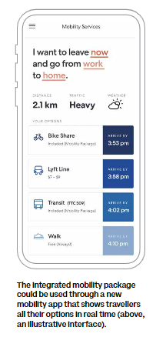

Figure 1: The proposed mobility package shown on a mobile phone application (p. 66).

### Theme: Equitable Access to Transit

#### How will transit (paratransit) be prioritized?

* Related MIDP text:
  + Vol.2, Part 6 Designing People-First Streets (Vol. 2, pp. 92-107).
* Supported by guiding accessibility principle: 3, 4, 6, 11
* Degree of Support: Fully supported
* Excerpt:

Getting to work

Back out ago hoping wheel trans will be on time to get me to work. GREAT! Wheel trans is here and I’m off to work. Sometimes wheel trans doesn’t even show up, or it can be up to one hour late, which means I get to work late and I’ll be late for everything else during that day. It’s a good thing that my work can make accommodation for your tardiness. If the Wheeltrans doesn’t show up I should call the cap, which is very expensive and it can add to a defect for my budget at the end of the month. Everything in Toronto is very expensive. (p. 19)

Transit will be prioritized through the proposal for “people-first street designs,” a design focusing on creating a safer, more comfortable walking and cycling network (p. 92). There will be four street types, each designed for a specific mode with a specific speed restriction. Each mode would either prioritize automobiles, public transit, cyclists, or pedestrians. Boulevards and Transitways are the faster street types (up to 40km/h), prioritized for vehicles and public transit respectively. Laneways and Accessways are the slower street types, prioritized for cyclists and pedestrians where traffic moves at cycling and pedestrian speeds (Vol. 2, p. 94).

Vehicles are not permitted on Laneways and Accessways, except for “accessible ride-hail, Wheeltrans and emergency vehicles,” which are permitted on every street mode at the given speed limit (Vol. 2, p. 106). Therefore, the prioritization of paratransit is fully supported according to the MIDP Accessibility Principles.

### Theme: Integration with Metro

#### How is accessibility of the smart city area integrated with the rest of the city?

* Related MIDP text:
  + Creating a balanced transportation network that connects to the city (Vol. 2, p. 28).
  + Part 1 Expanding Public Transit (Vol. 2, p. 32).
  + Part 2 Enabling Walking and Cycling Year-Round
    - Plan for a “15-minute neighbourhood” (Vol. 2, p. 44).
* Supported by guiding accessibility principle: 1, 3, 5, 7, 11
* Degree of Support: Fully supported
* Excerpt:

As a newcomer in Toronto, it was challenging to navigate the city layered with very different cultures, social norms and unspoken collective agreements shared between strangers. After landing here, I began to notice these differences, often with a debilitating level of acuteness and self-consciousness. In my culture, you are expected to seek out and utilize local knowledge when you are trying to navigate through a new or unfamiliar space; a sense of community is present even in public spaces and shared between strangers.

Here, in moments when I felt lost or confused and wanted to reach out to someone, I encountered apathy and occasionally even hostility. I come from a city that is far more complex and harder to navigate compared to Toronto. I have gotten lost several times while commuting, walking or driving in my city, but each time I was able to find my way with the help of strangers, which eased my anxiety. (p. 25)

Accessibility of the smart city area will be integrated with the rest of the city with the approved transit extension plan called the Waterfront Transit Network Plan, advocated by Sidewalk Labs (Vol. 2, p. 32). The plan consists of 6.5 km of light rail transit and will serve as a connection from Union Station along Queens Quay, past Quayside, onto Cherry Street and further east on Commissioners Street (Vol. 2, p. 38).Sidewalk Labs **also** proposes an optional light rail extension to the area north of the Keating Channel, north of Villiers Island (see Figure 2 below). This connects Quayside to surrounding neighbourhoods on the eastern Waterfront, such as Villiers and the East Harbour SmartTrack station and has the potential for connections from Quayside to Broadview Station as well (Vol. 2, p. 38). The light rail expansion will provide an efficient connection between the downtown core and eastern waterfront and connect neighbourhoods on the eastern waterfront.

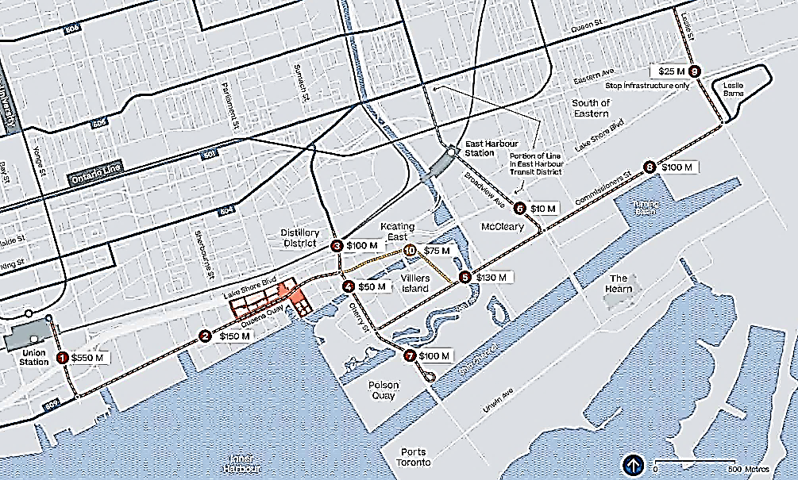

Figure 2: A $1.2 billion plan to extend light rail along the waterfront. The approved light rail extension is pictured in red and Sidewalk Labs’ proposal is pictured in yellow (p. 38).

It’s also important to highlight that Sidewalk Labs believes and advocates in the importance of integrating and expanding the existing transit network prior to the start of the new development (Vol. 2, p. 36). The MIDP states three key lessons that can be learned from past developments, which are:

1. New transit must connect into a system
2. Ignoring transit worsens congestion
3. Delaying transit expansion locks in car use (Vol. 2, p. 36).

Otherwise, if transit is not integrated into the existing transit system, it can isolate the development and stunt its growth. Ignoring transit and implementing it after the development is completed can also result in higher financial costs and travel disruptions, for example, Liberty Village (Vol. 2, p. 36).

In terms of walking/cycling, the accessibility of the smart city area is integrated with the rest of the city through Sidewalk Labs’ plan for a “15-minute neighbourhood” (Vol. 2, p. 44). Everyday services will be accessible within a 15-minute walk (or 1km), as well as surrounding neighbourhoods in the area with the improved walking and cycling networks. Overall, the degree of support for transit integration in the smart city area is fully supported by the MIDP Accessibility Principles.

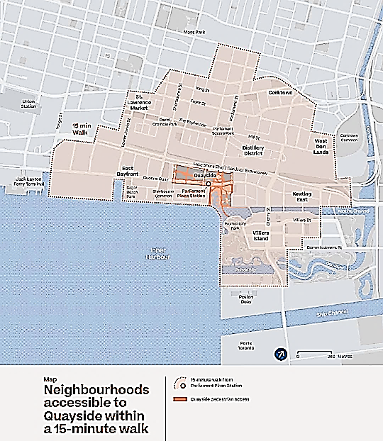

Figure 3: Neighbourhoods accessible to Quayside within a 15-minute walk include Villiers island, East Bayfront, St. Lawrence Market, Distillery District, Corktown, West Don Lands and Keating East (p. 43)

### Theme: Streetscape Design: Transit

#### Will transit shelters will be provided and suitable for all season conditions?

* Related MIDP text:
  + Vol. 2, Part 2 Enabling Walking and Cycling Year-Round, (Vol. 2, p. 44-52).
  + Vol. 2, Ch-1 Public Engagement.
    - #2 Improve Transit, expand it and make it inclusive (Vol. 2, p. 111).
* Supported by guiding accessibility principle: 1, 3, 6, 9
* Degree of Support: Partially supported
* Excerpt:

On the way home, James glances at his watch and realises that he’s running late. “Oh no, I booked Wheel Trans for 1:00”  James had to be at the front of his building on time because Wheel Trans would not wait and if he missed it, he wouldn’t get to go. James hurried home but had to be careful because it was winter and the sidewalks could be slippery. “It's not the ice you see that you have to worry about,” James muttered to himself. James arrived at the front of his building, “made it!” James felt relief. Despite the blue sky it’s chilly so James decides to wait in the foyer. “Ah, that’s better.” James let the warmth from the heater take the chill off.

James keeps a close out the door as he waits and waits and waits. James glances at his watch and waits some more. Finally, at 1:40, Wheel Trans arrived (p.7).

All-season transit shelters are not specifically addressed in the MIDP. However, Sidewalk Labs addresses all-season conditions for walking and cycling, where there will be “heated pavement in some sidewalks and bike lanes,” consisting of 1,200 square meters of sidewalks and pedestrian zones and 1590 square metres of bike paths (Vol. 2, p. 52). The pavements will be modular, where the components can be separated and recombined, which supports access to a heating system. The pavements operate automatically using IoT technology, where the heated pavements can connect to real-time weather forecasts and automatically power on 3-4 hours before a storm (Vol. 2, p. 52). The pavement would melt snow and allow for pedestrians to walk comfortably, heating to a temperature of 2-4 degrees. Once the pavement is dry, the heating system automatically turns off (Vol. 2, p. 52). The design of the heated pavements can support transit shelters for all season conditions, but more information in the MIDP needs to be provided.

In addition to this, Sidewalk Labs states that they are committed to the TTC’s policy, “to create step-free transit stops for streetcars and buses and to provide the most updated, accessible vehicles available at present to serve Quayside” (Vol. 2, p. 111). The accessibility of transit connections was addressed, where the plan proposes “high-quality pedestrian and bicycle connections to light rail and bus stops.” There will be dedicated lanes or entire streets prioritized for bike travel with bike/scoter parking adjacent to stations (Vol. 2, p. 45). For pedestrians, they can access transit stations with “pleasant sidewalks and access platforms via wide crosswalks that prioritize safe crossing” (Vol. 2, p. 44).

Overall, the degree of support is partially supported as more information needs to be provided regarding the accessibility of transit shelters and transit connections in all-season conditions.

#### Will transit stops be near stores and apartments?

* Related MIDP text:
  + Vol. 2, Part 1 Expanding Public Transit
    - Design a neighbourhood with transit first (Vol. 2, p. 35).
  + Vol. 2, Part 2 Enabling Walking and Cycling Year-Round
    - Plan for a “15-minute neighbourhood,” p. 44
* Supported by guiding accessibility principle: 1, 4, 6
* Degree of Support: Partially supported
* Excerpt:

After walking for a block, James began to calm down. He felt like he belonged because this was his neighbourhood. He saw people that he knew and started to feel better. He felt that he was getting all the garbage out of his mind. James arrived at the store in a better mood. He enjoyed coming to the store because he knew what it was all about. He could go out and get what he wanted all by himself and he liked that experience. It was so nice that the store was near James’ home. He could go whenever he wanted. (p. 7)

The plan has not highlighted if transit stops will specifically be near stores and apartments. Sidewalk Labs proposes that transit stops be spaced further apart, rather than the current design where transit stops are typically placed at each corner (Vol. 2, p. 35). Sidewalk Labs believes that these changes will make the service faster, more reliable and will reduce traffic congestion.

This may increase barriers to accessibility, as it may make it more difficult for people with disabilities to access public transit stops if they are placed further apart from each other. More information on the distance between transit stops needs to be given. However, this may also be disclosed in the Waterfront Transit Network Plan as this is an already approved transit expansion plan (Vol. 2, p. 32).

Additionally, Sidewalk Labs proposes a plan for a “15-minute neighbourhood,” where people can access every service/good they need within a 15-minute (1 km) walk (Vol. 2, p. 44). These services/goods are likely to be needed more than once a week and include schools, health care, groceries and recreation. This will increase accessibility of these services and ensure that residential spaces are located near these services. Overall, the degree of support is partially supported, as more information needs to be provided regarding the placement and accessibility of transit stops.

### Theme: Streetscape design

#### How will noise pollution (e.g. from traffic and nearby Gardener) be mitigated?

* Related MIDP text:
  + Vol. 2, Part 1 Expanding Public Transit
    - Map $1.2 billion plan to extend light rail along the waterfront (Vol. 2, p. 39).
  + Vol. 2, Part 2 Enabling Walking and Cycling Year-Round
    - Expand safe, comfortable walking and cycling networks, (Vol. 2, pp. 46-48).
  + Chapter 3: Buildings and Housing,
    - Enable a safe, vibrant mix of uses with real-time building codes (Vol. 2, p. 251).
* Supported by guiding accessibility principle: 3, 4, 6, 11
* Degree of Support: Partially supported
* Excerpt:

We finally make our way to street level. The constant sounds of traffic (trucks are the worst!), construction noise and people talking all blend into a cacophony of sound. It is hard to hear my companion, so conversation is not easy. Waiting at an intersection for our light to turn green, a wide-bodied truck makes a right turn in front of us. My companion pulls me back a few feet to avoid contact with the truck body and wheels. What seems like numerous encounters with construction hoardings has us veering off to the right or left to walk along the temporary wood surface. These tactile changes my feet felt, combined with the construction noises, do not feel safe. (p. 46)

Noise mitigation is addressed in the MIDP, “Chapter 3: Buildings and Housing.” Sidewalk Labs proposes a digital building code system that monitors interior spaces for noise, air pollution and other nuisance levels (Vol. 2, p. 251). The building code system would be managed by the building owner and enforced by standards established by the City of Toronto. The performance of building can be monitored using real-time data in the building code system, via environmental sensors placed in building halls. These sensors collect information on structural integrity and vibration, air quality and noise levels (Vol. 2, p. 252). For example, if the sensors detect a “noise level that exceeded a code standard, the landlord and city would be notified of the violation” (Vol. 2, p. 251). However, the building code system only addresses residential noise pollution and does not address building infrastructure that would mitigate noise pollution from traffic and the nearby Gardiner Expressway.

In the Mobility chapter, noise mitigation is addressed in the reconstruction of the Parliament Street and Cherry Street underpasses. Noise pollution in these underpasses would be mitigated by rebuilding the underpass with noise buffers (Vol. 2, p. 42). The Cherry underpass is already planned to be rebuilt as part of the light rail extension plans, however, the MIDP proposes to also rebuild the Parliament underpass as well. The Parliament underpass leads directly into Quayside, so the MIDP proposes to rebuild it in order to create a more pleasant commute for pedestrians and cyclists from surrounding neighbourhoods entering or exiting the Quayside neighbourhood (Vol. 2, p. 39).

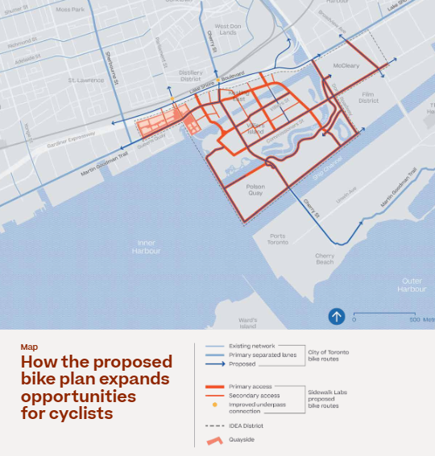

Figure 4 The proposed bike plan for cyclists, displaying the Parliament and Cherry underpasses, marked on the map as a yellow dot (Vol. 2, p. 47).

The pedestrians and cyclists traveling in the current Parliament and Cherry underpasses are “subjected to loud noises, dark and narrow tunnels, confusing paths” (Vol. 2, p. 46). The MIDP proposes that the rebuilt underpasses have separate pedestrian, bike, car and public transit lanes with “decorative lighting, acoustic panels, bike lanes and tree-lined walk-ways” (p. 48), which would serve as a safer, more “appealing gateway between Toronto’s downtown core and its emerging eastern waterfront” (Vol. 2, p. 48). The lighting will enhance wayfinding and noise buffers will be installed in the form of acoustic panels, which will decrease noise pollution from traffic.

Overall, the degree of support is partially supported as more information on the placement of noise buffers and noise mitigation from traffic and the Gardiner Expressway needs to be provided.

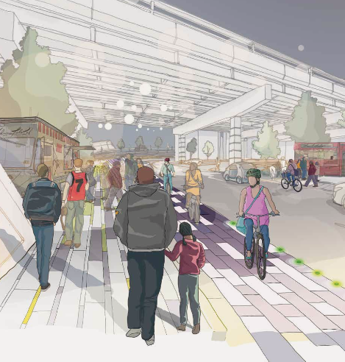

Figure 5 The proposed rebuilt Cherry Street underpass (p. 48)

#### Will lighting be controlled to balance safety and light pollution concerns?

* Related MIDP text:
* Vol. 2, Provide signal propriety for walking and cycling, (Vol. 2, p. 49).
* Vol. 2, Part 6 Designing People-First Streets, (Vol. 2, pp. 106-107).
* Supported by guiding accessibility principle: N/A
* Degree of Support: Not supported
* Excerpt:

my idea of smart doesn’t involve Electronic apps, or billboards with information, surveillance cameras everywhere and constant light and sound pollution. That all of these mess with our circadian rhythm, turning us into insomniacs and further harms those like my sons with autism, who have sensitivities to lights and sounds causing stress, overthinking and mental health issues due to constant information overload. (p. 36)

Individuals with varying levels of sensory perception and attention are addressed in the MIDP:

Self-driving vehicles promise a revolution in personal mobility, with particular benefits for people experiencing different levels of mobility and sensory perception. Sidewalk Labs plans to strong promote end-to-end accessibility for self-driving and ride-hailing vehicle services. (Vol. 2, p. 106)

Sidewalk Labs plans to develop street infrastructure that enables self-driving vehicles in the future**,** increasing accessibility for those with varying levels of sensory perception. However, this is not supported by the MIDP Accessibility Principles, as light pollution mitigation needs to be directly addressed and more information must be provided.

Additionally, the MIDP proposes a potential risk for increased light pollution with the signal coordination system for cyclists called “green waves” (Vol. 2, p. 49). The signal coordination system consists of LED strips installed on the pavement, acting as a bike lane border between cyclists and drivers. The green waves would increase the visibility of cyclists and increase safety for pedestrians crossing the street. It also allows cyclists to maintain higher speeds for longer distances according to traffic signals. Although this may be beneficial, the signal coordination system needs to be further investigated, regarding light pollution concerns and the brightness of the LED lights during the day/night, which may affect accessibility for individuals with information overload or sensory sensitivity (i.e. sensitives to light).

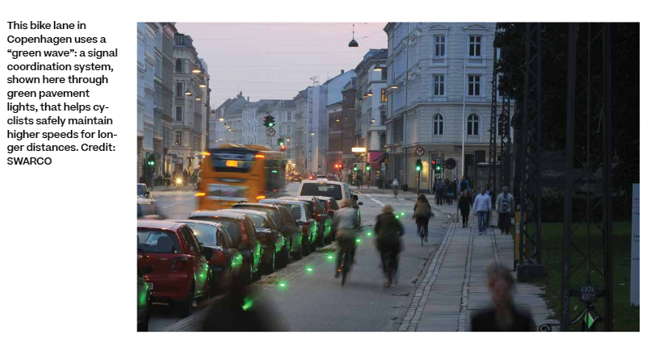

Figure 6 The signal coordination system implemented in Copenhagen, which is proposed in the MIDP (p. 49).

(Please also see Q33)

#### What are the safety features for individuals who cannot see or hear traffic?

* Related MIDP text:
  + Vol. 2, Part 2 Enabling Walking and Cycling Year-Round, (Vol. 2, p. 42).
  + Vol. 2, Provide signal propriety for walking and cycling (Vol. 2, p. 49).
  + Vol. 2, Part 6 Designing People-First Streets, (Vol. 2, pp. 92-107).
* Supported by guiding accessibility principle: 1, 3, 6, 7, 14
* Degree of Support: Partially supported
* Excerpt:

My companion pulls me back a few feet to avoid contact with the truck body and wheels. What seems like numerous encounters with construction hoardings has us veering off to the right or left to walk along the temporary wood surface. These tactile changes my feet felt, combined with the construction noises, do not feel safe. (p. 46)

Sidewalk Labs proposes “people-first street designs,” introducing four street types that have safety features for individuals who cannot see or hear traffic. Each street mode is designed for a specific mode with a specific speed restriction (Vol. 2, p. 94). Each mode prioritizes either automobiles, public transit, cyclists, or pedestrians. Boulevards and Transitways are the faster street types (up to 40km/h), designed for vehicles and public transit respectively. The slower street types are Laneways and Accessways, prioritized for cyclists and pedestrians, where traffic moves at cycling and pedestrian speeds (Vol. 2, p. 94).

In Boulevards and Transitways, there will be physical separations between the lanes for cars, bikes and pedestrians (p. 94). Adaptive traffic signals will also be introduced, increasing safety for pedestrians and cyclists. It will detect the type of traveller and give priority to pedestrians and cyclists at intersections (p. 98). An example of the adaptive traffic signals is given:

For example, consider an elderly woman with a cane who starts crossing a boulevard, which is designed to handle the most vehicle traffic. A typical crossing signal changes the light when the predetermined crossing time is up, whether or not this person has made it across safely. But an adaptive traffic signal can detect that the woman remains in the middle of the street—in an anonymous way that preserves privacy—and extend the crossing time until she is safely on the other side. (Vol. 2, p. 49)

This would be a key safety feature for individuals who cannot see or hear traffic, as the traffic light would adapt to the individual and allow enough time for the individual to cross the street safely. In addition to this, there will be wider sidewalks that would have “at least enough room for two people using mobility devices (such as wheelchairs, scoots and white canes) to ride or travel side by side in each direction” (Vol. 2, p. 107). Roadways will also be narrower, which would make it safer for individuals who cannot see or hear traffic because crosswalks would be shorter and safer to cross (Vol. 2, p. 100).

In Accessways and Laneways, traffic moves at bike speeds (up to 22km/h) and pedestrian speeds (up to 8km/h), respectively. No vehicles are permitted in Laneways or Accessways, except for vehicles for accessibility purposes or delivery vehicles at the given speed limit (Vol. 2, p. 104).

Accessways and Laneways further increase accessibility for individuals who cannot see or hear traffic, as limited vehicles are permitted on these street types. However, more information on additional safety features for each street mode need to be provided to increase accessibility and support individuals who cannot see or hear traffic.

#### Will systems and design support wayfinding?

* Related MIDP text:
  + Vol. 2, Part 2 Enabling Walking and Cycling Year-Round (Vol. 2, p. 46).
  + Vol. 2, Part 6 Designing People-First Streets, (Vol. 2, pp. 92-107).
* Supported by guiding accessibility principle: 7, 10, 11, 20
* Degree of Support: Partially supported
* Excerpt:

When we disembark at Union Station, we make our way to the elevator. I’m not able to see the buttons on the panel, even though it has red backlighting. It is not enough contrast for me to see. I have to wait for someone else to push the button. The Braille buttons are a nice "feel good" feature for those who are sighted or blind (if the blind can find it...). Not many low vision persons know Braille.

When we get off the elevator, we are now in what I call “chaos,” with people rushing in every which direction. My companion struggles to find the sign to the street because the station has changed so much recently. The environment at Union is constantly changing due to the ongoing renovations. This makes it confusing to find our way around. (p. 45)

The people-first street design, including the four street types, will all support wayfinding with wayfinding beacons. The MIDP states that:

Wayfinding beacons can broadcast information about the environment to people who are blind or partially sighted to help them navigate the area. In Quayside, beacons would enable the use of BlindSquare and other wayfinding apps as part of the default street-level experience (Vol. 2, p. 107).

Each street type (Boulevard, Transitway, Accessway, Laneway) will support wayfinding with wayfinding beacons and have additional accessibility features (More information regarding the accessibility in the street types can be found in Question 7, p. 78). such as curbless streets and wider sidewalks that would have “at least enough room for two people using mobility devices to ride or travel side by side in each direction” (Vol. 2, p. 107). The MIDP also states that the proposed rebuilt Parliament Street and Cherry Street underpasses (discussed in Question 1, Theme: Streetscape design p. 71), would have noise buffers and enhanced lighting that would support wayfinding (Vol. 2, p. 46). Overall, the degree of support is partially supported by MIDP Accessibility Principles. Under the Physical Accessibility Principles, Principle 10 states “enable way finding in multiple formats,” and under Digital Accessibility Principles, Principle 20 states “use common standard for messages in audio wayfinding features.”

The MIDP did not provide specific information regarding these principles, so this information must be **provided** in order to fully support the MIDP Accessibility Principles.

(Please also see Q39)

#### Will all exits be available all of the time (i.e. no internal barriers)?

* Degree of Support: Not supported
* Excerpt:

Had this been a digitally timed locking device, this would not have been possible.... There was a car double-parked between the designated wheelchair permitted spots...Barriers to access is a common experience in my daily life and I am appreciative of the awareness and assistance of others when available. (p. 11)

Information regarding exits and internal barriers were not stated in the Mobility chapter. Sidewalk Labs needs to provide information on availability of exits, internal barriers and human assistance options in the public realm.

#### What options for vertical transportation (e.g. elevator, stairs, ramps, flat escalators, etc.) will be available?

* Degree of Support: Not supported
* Excerpt:

In this scenario, the stone is taken from its environment and used as a display piece. For example, this may add a certain aesthetic to someone’s home or serve as a decoration for his or her living space. In this scenario, the stone becomes part of the background; it’s not a focal point. It’s only brought up when it needs to be presented, but otherwise it’s sidelined as an object for display.

Impact on Accessibility:

Here, we see accessibility as a trend. It’s used as a real-world display piece to demonstrate compliance with legal requirements. This treatment puts more importance on the presentation of meeting accessibility (the superficial), not actually serving the core needs of accessibility (the meaningful).

Example(s):

Elevators that are designed to be accessible, but in fact do not meet the diverse needs of the users its intended to serve. The placement of the control panel is placed out of the hand range, the design of the buttons are limiting, a lack of voice-activated controls, etc. (p. 43)

Excerpt 2:

I arrive at the conference venue feeling very stressed. This is not helped by the fact that I almost fell down the stairs when making my way to the correct floor amid a crowd of other conference-goers. The stairs don’t have a continuous handrail and there are no tactile markings on the floor. I don’t know where the stairs begin and end. A ramp would have been better! (p. 46)

Information on vertical transportation is not stated/covered in the Mobility chapter**.**

(Please also see Q51)

#### Will the design of routes and trails be inclusive to all?

* Related MIDP text:
  + Vol. 2, Part 2 Enabling Walking and Cycling Year-Round (Vol. 2, p. 42).
    - Provide signal propriety for walking and cycling (Vol. 2, p. 49).
  + Part 6 Designing People-First Streets (Vol. 2, pp. 92-107).
* Supported by guiding accessibility principle: 1, 3, 4, 6, 7, 9, 10, 11, 20
* Degree of Support: Fully supported
* Excerpt:

He said my only option was to leave through a different exit. This was concerning to me because it was a longer route and I was very tired at this point. (p.11)

Sidewalk Labs proposes “people-first street designs,” a design focusing on creating a safer, more comfortable walking and cycling network which will support inclusion (Vol.2, p. 92). This design has four street types, each designed for a specific mode with a specific speed restriction. Each mode either prioritizes automobiles, public transit, cyclists, or pedestrians. Boulevards and Transitways are the faster street types (up to 40km/h), designed for vehicles and public transit respectively. The slower street types are Laneways and Accessways, prioritized for cyclists and pedestrians, where traffic moves at cycling and pedestrian speeds (Vol. 2, p. 94).

In Boulevards and Transitways, there will be physical separations between the lanes for cars, bikes and pedestrians (Vol. 2, p. 94). There will also be adaptive traffic signals that give pedestrians and cyclists priority at intersections, by detecting the type of traveller and giving more time for them to cross the street (Vol. 2, p. 98). There will also be wider sidewalks and narrower roadways as street parking will be eliminated. All thoroughfares would have “at least enough room for two people using mobility devices (such as wheelchairs, scoots and white canes) to ride or travel side by side in each direction” (Vol. 2, p. 107). Additionally, as roads are narrower, crosswalks would be shorter and safer (Vol. 2, p. 100). There will also be enhanced bike infrastructure, with designated bike spaces.

In Laneways and Accessways, traffic would move at cycling and pedestrian speeds and vehicles would be restricted. Only “accessible ride-hail, Wheeltrans and emergency vehicles” are permitted at the given speed limit (Vol. 2, p. 106). Additionally, there will be “Pedways,” which is a pedestrian-only street type where only pedestrian traffic is allowed (Vol. 2, p. 105).

Every street design in the proposal meets the 2005 AODA requirement and Sidewalk Labs aims to exceed these requirements whenever possible (Vol. 2, p. 106). Additional accessibility features include curbless streets, accessible vehicles, modular heated pavement, sidewalk width and wayfinding beacons. Curbless streets with tactile indicators would replace the vertical step separating pedestrian and vehicle traffic (Vol. 2, p. 107). Street crossings, intersections and sidewalks will be modular heated pavements that melt rain and snow (Vol. 2, p. 52). Building awnings will also prevent rain and snow buildup, which would ensure accessibility for people using wheeled mobility devices and for service animals (Vol. 2, p. 107). Wayfinding beacons in the development will allow people who are blind or partially sighted to use BlindSquare or other wayfinding applications to navigate the area (Vol. 2, p. 107). Overall, the accessibility features in the people-first street design and the four street modes will support inclusion. The street design provides accessible and safe routes and is fully supported by the MIDP Accessibility Principles.

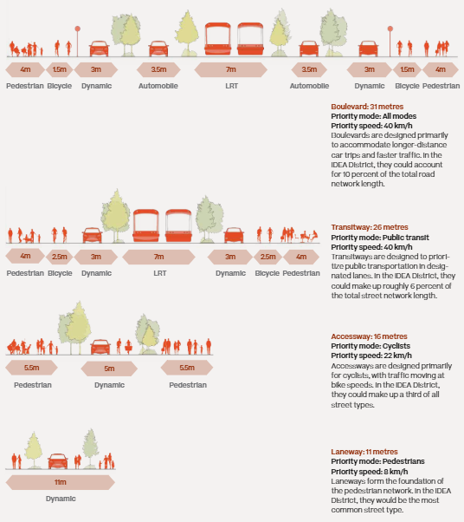

Figure 7 An illustration of the four proposed street types: Boulevard, Transitway, Accessway and Laneway (p. 97).

## MIDP Chapter 2—Public Realm

The “Public Realm” chapter of the MIDP envisions a system of open spaces, streets and plazas that encourage expansive community engagement and activity throughout the year. The themes that were developed for the MIDP evaluation for this chapter include, accessibility, community building and design, governance, streetscape design, spirituality and social supports. These topics highlight the key considerations raised in the content expert stories in addressing access to community amenities, governance organization and inclusion for all members of the community.

### Theme: Accessibility Standards

The accessibility standards theme outlines the essential features that participants want to see in the design proposal. It is an important consideration for the MIDP to have when planning out open spaces and areas in order to properly accommodate a diverse range of needs.

#### How will accessibility in all spaces (including commercial) be assured, go beyond building code (i.e. function)?

* Related MIDP text:
  + Vol. 2. Ensuring open space is more responsive (Vol. 2, 178).
  + Vol. 2. Sidewalk Labs has incorporated an expansive, diverse network of open spaces into the plan for Quayside and followed design principles focused on inclusive, participatory programming (Vol. 2, 178)
* Supported by guiding accessibility principle: Supported
* Degree of support: Partially Supported
* Excerpt:

“After the last conference panel...at a nearby restaurant” (p. 47)

The open space design strategy is to create responsive designs that can be managed and developed as the uses of the spaces increase and evolve. This would be overseen by the Open Space Alliance (OSA), a non-profit governing body that would work with the community to provide programming and operational needs to the various spaces. With the help of the digital map platform, people would be able to access open space information on public and commercial spaces throughout the day. They would be able to see real-time updates on construction and maintenance needs, as well as what pathway systems can be used to get to their desired location (MIDP, 2019). For accessibility needs, Sidewalk Labs have proposed designs such as a dynamic curb and curbless streets to maintain a consistent and smooth grade. Along with this innovation, the streets will contain a heating system to address snow and ice. Other considerations include the weather intervention tools to mitigate wind, sun, rain and snow for commercial and public spaces (MIDP, 2019). The design proposals are stated as compliant with the Accessibility for Ontarians with Disabilities Act (AODA). Sidewalk Labs proposes to work with regulators to ensure that AODA regulations are followed. For new design proposals like the Raincoat or Fanshell, a review system would be implemented to certify that the accessibility standards are upheld. In comparison to the 22 accessibility principles outlined in the MIDP, the question relates to making pathways accessible and convenient, as well as focusing on end-to-end accessibility. Furthermore, states specifically that the design and function of the neighbourhood will go beyond the legal requirements (Vol. 2, p. 137). In the stories created in the co-creation workshop, a key concern was being able to network at events in accessible ways. Any person regardless of their abilities should be able to move from location to the next with ease without having to worry about any barriers. Sidewalk Labs has proposed providing accessible amenities that create a sense of belonging to help improve engagements.

Apart from the commitment to accessibility and inclusion, there needs to be a clear indication of how the design of spaces would go beyond the building code, as the proposal does not reference a specific code other than stating that, it will “ensure AODA compliance for these systems” (Vol. 2, p. 170).

### Theme: Accessible Amenities

Accessible amenities outline the features and equipment that are important for participants to be able to access and navigate throughout the neighbourhood. The theme covers specific features such as parking, washrooms and inclusive design features that make it accessible to the entire community.

#### Will public washrooms be plentiful?

* Supported by guiding accessibility principle: Supported
* Degree of support: Partially Supported
* Excerpt:

I found it to not be so accessible after all, as it was in fact also being used as a non-gendered and family washroom (p. 13)

The plan for the open space design includes various recreational, leisure and retail activities with multi-purpose capabilities from the park to the plaza areas. The digital map planned for Quayside would include different amenities, physical infrastructure locations and pathway systems. Public washrooms would be displayed on the digital map for the public as well, however the number of washrooms was not indicated within the design proposal. In the general accessibility principles section, ensures that the proposal will have end-to-end accessibility, which can be correlated to the need for public washroom availability. In the “Public Engagement” section, Sidewalk Labs stated that participants were adamant on having access to essential amenities like accessible washrooms. However, the proposal does not provide a plan on the location of the washrooms, as well as what design features will be in the washrooms to make it accessible to all. A key aspect that should be included would be the accessible design assets that will be found in each public washroom and how it will be accessible to all users. It is important that all community members have access to public washrooms that reflect their needs.

#### Will there be accessible parking available within the city?

The vision for Quayside as proposed by Sidewalk Labs is to develop streets for the people with focus on the pedestrian realm. With the new design direction, vehicle parking would be less prioritized and the reclaimed spaces would be put towards developing pedestrian streets. Additionally, one of the design strategies for the roadway and streets is to eliminate curbside parking, which would decrease the number of available parking spots around the neighbourhood. The curbside parking would be replaced with pick-up and drop-off zones (MIDP, 2019). An outline of parking locations and allocation can be found in the Mobility chapter of the MIDP.

### Theme: Community Building

Community building reflects the importance of community engagement, socialization and neighbourhood development. This theme was important to participants during the evaluation process as they want to have access to spaces to host group events, as well as being able to meet people. Establishing an open and diverse community environment is essential in creating an inclusive neighbourhood.

#### Will there be systems or a platform to foster community engagements?

* Related Text
  + Vol. 2. Seed Space (Vol. 2, p. 164).
  + Vol. 2. CommonSpace (Vol. 2, p. 185).
* Supported by guiding accessibility principle: Supported
* Degree of support: Partially Supported

In the MIDP, Sidewalk Labs proposes a variety of tools to promote community engagement and growth. These applications include Seed Space, which is a digital platform for businesses to introduce their vision and outreach to customers, as well as providing a straightforward set-up model for creating a physical presence. This application focuses on business development that allows businesses to test out new ideas and help them analyze customer feedback (MIDP, 2019). The second platform will be called CommonSpace, where all community members will be able to provide real-time feedback on various spaces around the neighbourhood. The development would begin with park operators and community organizers to help them analyze the best spaces to hold events and activities. The application would use open-sources data with an open data standard that would allow the public to provide input on spaces to help the various environments to grow and adapt to the needs of the community. A third community engagement tool proposed by Sidewalk Labs, is a digital 3D map illustrating geospatial data of the entire smart neighbourhood. The map would be under the operation of the OSA and provide real-time information on all open spaces and amenities, including construction zones and location of physical infrastructure like benches and picnic tables. The digital map allows people to select the spaces that suit their needs and navigate through the neighbourhood to avoid any barriers. The goal of these tools is to establish a responsive neighbourhood design that prioritizes the needs of the community. In the accessible guiding principles, the principles do not mention community engagement platforms. It is unclear how the platforms will work for community members to host events and run activities as the application and visualization are prototypes at this stage. Furthermore, the application alone would not have the capability to encourage community participation. There needs to be a strategy or workshop that helps people understand the function of the application and other strategies to create a community-led design. Would community members be expected to lead all community event planning? The plan does not show other strategies to encourage community engagement other than creating longer hours for streetscapes and retail spaces. The plan states that, “An expansive open space network is vital to creating a neighbourhood culture and forming community bonds” (Vol. 2, p. 120). The reasoning is that by providing accessible, diverse and safe spaces that this would establish community bonds. “An “everyday” public realm is not meant to be an escape from the city, but instead to be a fundamental shaper of the community— filled with civic engagement, exploration and connections to people and place” (Vol. 2, p. 121). These goals outlined by the plan illustrate a design that fosters community engagement. The three open spaces provide diverse ranges of uses and spaces for play, leisure and relaxation. However, these strategies reflect self-motivational design techniques and does not provide enough information on how it could foster engagement.

#### Is there a plan to foster community integration and growth?

* Related Text
  + Vol. 2. Generative design (Vol. 2, 140).
    - Identifying opportunities for open spaces that compliments existing network
    - Machine learning, simulations to show possible choices and impacts
  + Vol. 2. Villers Precinct Plan—idea of breaking down development of blocks into series of small buildings with pedestrian courtyards to create intimate spaces for residents to socialize
    - Variables analyzed—percentage of open space, sunlight access in courtyard and density
    - Spaces would create important pedestrian connections across the island and allow for close mingling areas
  + Helping Planners Analyze Options (Vol. 2, p. 142).
  + Diverse micro-neighbourhoods (Vol. 2, p. 153).
  + Community-led programming (Vol. 2, p. 182).
* Supported by guiding accessibility principle: Supported
* Degree of support: Partially Supported
* Excerpt:

This makes me concerned, not only for our community that once was, but for the future of my children, that they will be scrutinized by the families and the children they grew up with are now afraid of them because of their socio-economic status. Where government programs have failed, grassroots programs have thrived. People leading their own patrols, policing their own communities. Opening their doors, feeding the people and being that village. I have seen the outpour of kindness and generosity from those who have nothing because it is in their nature to give because they know what it feels to live without (p. 34).

Community integration is an essential feature to promoting community growth. The MIDP proposes to use generative design analysis to identify the best opportunities for public spaces around the site. This analysis tool would use machine learning and simulation techniques to understand the different choices available to a particular space, as well as the subsequent impact it would have on the community (Vol. 2, p. 140). Sidewalk Labs plans on using the generative design tool to enrich open spaces within the interior of the neighbourhood and identify areas for housing and job development. With the increase in open space allocation, Sidewalk Labs states that there would be more pedestrian connection to improve areas of socialization and community development. Furthermore, the MIDP outlines the use of ground floor spaces as diverse micro-neighbourhoods that, “…could become the new heart of an integrated neighbourhood that spaces the canal, with both sides brought to life through small retail stalls on the water’s edge that could be connected to large, open-air market spaces“ (Vol. 2, p. 153). In this explanation, the MIDP believes that the generative design analysis would help with community engagement through the various public spaces made available to the community.

Another strategy proposed in the document is community-led programming that would allow people to access and organize events and group spaces. This would be addressed by introducing shared and flexible infrastructure to encourage affordable innovation and collaboration amongst the community. The programming infrastructure would be organized through the Open Space Alliance (OSA) to ensure that the tool can be used for shared spaces. The OSA would focus on, “delivering local programming, operations and maintenance, working in close concert with the community and leveraging new technology” (Vol. 2, p. 178). The non-profit entity would act as a coordinator to the shared physical spaces around the neighbourhood and help the community gain access to various shared features like projection screens, lighting, sound and public wireless internet (refer to Figure 1). The community-led approach hopes to allow community members to lead and plan their own spaces and utilize the diverse infrastructure though the civic engagement tool and the OSA. The governing body would work as a public-private partnership with the City of Toronto to address the funding requirements of maintaining all city-owned open spaces. In this scenario, the open spaces would be under the ownership of the government with the OSA acting on the programming and maintenance side. However, the MIDP outlines the importance of protecting private ownership while implying the importance of a public space in the same breath. “The public realm needs to reflect a truly public space—with the city retaining ownership of city-owned open spaces—while also protecting the needs and rights of private property owners on their land” (Vol. 2, p. 181). This statement contradicts their emphasis on complete public spaces for the community. The MIDP outlines examples of possible programming uses such as youth dance group spaces on outdoor spark stages and environmental advocacy groups assessing the quality of the environmental features. The tool focuses more on the shared aspect of public spaces and driving innovative ideas but does not detail how it would enhance community building. The purpose of the question was to identify how different socioeconomic groups could foster a community together. As well as, address the different types of community spaces that would be available to all members. The community-led programming tool in the MIDP, outlines shared spaces but does not provide additional information on spaces that could be used for specific purposes for those members who required a consistent location or area for their group/event. The adaptable use of the shared spaces indicate that the amenities and services would not always be consistent throughout the day. There needs to be more emphasis and information that outlines how the community programming will encourage community integration and growth. The concept of community building is not present in the 22 accessibility principles, however, number 15 of creating an adaptable and customized physical realm would help with community engagement (Vol. 2, p. 137).

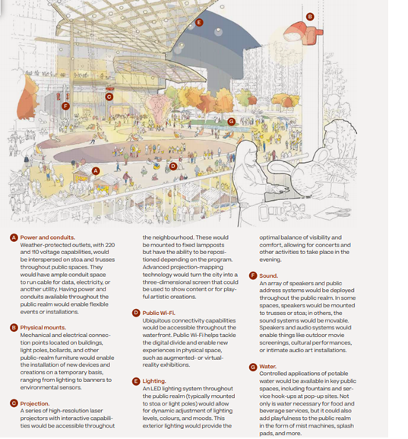

Figure 8: Shared physical infrastructure in public spaces (MIDP, 2019)

### Theme: Environmental Design

Access to nature and environmental elements was a key factor raised during the co-creation workshops with our participants. There is a lack of natural spaces in some of their neighbourhoods. The access to the waterfront and natural environment is valuable to community engagement and sustainable design.

#### Do support animals have space in environments/transit areas to relieve themselves and areas to get water?

* Related MIDP text:
  + Incorporating water features and connecting to the lake
    - Splash pad for children, mist machines for art installations mentioned as water features
* Supported by guiding accessibility principle: Partially supported
* Degree of support: Partially supported
* Excerpt:

My guide dog and I start our morning with a walk by the lake (p. 44).

The Public Realm section does not specifically mention support animals and their role in the design of public spaces and other facilities. However, the MIDP does discuss incorporating water features and creating connections to the lake which can relate back to the sentence of, “My guide dog and I start our morning with a walk by the lake.” The narrative outlined the character’s need for access to natural spaces for physical activity for them and their service animal. Additionally, Silo Park one of the open spaces proposed for Quayside would have space for a dog park (p. 144). It could be concluded that support dogs would be able to access drinking water and resting space at this area of the park. Furthermore, the location of the park would be near Parliament Slip which is the open space located by the waterfront with access to the water. Furthermore, in the “Public Engagement” section, Sidewalk Labs did respond to the request for a flexible public realm by creating spaces with diverse uses like the dog park. An essential consideration going forward with the project would be to show where support animals can rest and participate in the environments.

### Theme: Green Spaces

Green space access and availability in cities has become essential to the health and strength of the community. Areas that encourage play, relaxation and a diverse range of activities can help improve the overall community structure of the city. Green Spaces reflect public areas and open spaces that provide access to services and amenities like a community garden and centres to establish a cohesive system. It should be an accessible environment where anyone regardless of socio-economic background, gender, age and ability can come to use the space.

#### How can people find information on the location and maintenance of these green spaces?

* Related MIDP text:
  + Large amounts of park spaces found at island’s perimeter, no dedicated parks in neighborhoods interior (Vol. 2, p. 141).
  + Digital Map of Open Spaces (Vol. 2, pp. 186 – 188).
    - 3D high-resolution visualization map that outlines maintenance, infrastructure and public spaces along with physical infrastructure and moveable assets
* Supported by guiding accessibility principle: Supported
* Degree of support: Partially supported
* Excerpt:

The green spaces that I enjoyed with my children growing up, became parking lots and then became condo developments, which only the rich can afford, making me feel like a stranger in my own neighbourhood. Incorporating more green spaces that are not only accessible to all, but also are affordable to all. Using rammed earth, strawbale, adobe, cobb, in our structures to reduce our strain on the environment. A tiered building system so that each apartment can grow their own food with passive solar windows and outdoor patios that encourage the owners to grow their own foods (p. 32).

In addressing the inquiry on information access on maintenance and green space location, the MIDP proposes to create a digital map of open spaces. The visualization outlined on the MIDP suggests launching a real-time digital map infrastructure to help track operations, maintenance and open space assets around the neighbourhood (Vol. 2 p. 186). The digital map would be a 3D high-resolution single repository that would track information on public spaces, ongoing maintenance to alert the community on construction zones. The data would include locations of benches, waste systems, moveable components and shared infrastructure spaces. Additionally, the proposal indicated that “Because there is so much park space dedicated to the island’s perimeter, there are no dedicated parks in the neighbourhood’s interior” (Vol. 2, p. 141). Community members would have general access to the digital map through a public digital display screen. To ensure that the digital map consisted of updated information, the plan proposes to place sensor devices throughout the spaces to keep track of service needs and potential issues like water pipe leakage. Only Open-space managers would be given full access to the map features, whereas the community would be able to have a, “A public visualization would help community members make far more informed decisions about their use of public spaces based on actual conditions—for instance, people could see when construction is scheduled“ (Vol. 2, p. 187). This strategy was proposed to ensure that community members would not be overwhelmed with information but still be able to navigate through the various spaces and avoid construction barriers.

In the story, the character emphasizes the importance of accessible and inclusive green spaces that can accommodate a diverse range of people, as well as having consideration for the environmental impacts that the design can have on the environment. Silo Park is one of the proposed green spaces with multi-purpose features to maximize the variation of uses in the public space. The overall goal of the public spaces is to bring together the community by providing an interactive space for people of all age’s year-round (Vol. 2, p. 145). The space boasts activities designed for all-season weather, play features, moveable furniture and food areas but does not specifically discuss the natural features of the open space. Where the plan does highlight the use of natural features like trees is outlined in the benefits of the vision where it states that, “Nearly twice the number of sidewalk trees as on typical boulevards” (Vol. 2, p. 122). In the accessibility principles, the principle of wayfinding in the physical spaces through a variety of modalities, as well as on digital accessibility and establishing new communication tools to help with public space navigation (Vol. 2, p. 137). Through the public engagement workshops, there was a key emphasis on having a connection to nature and water. The three open spaces proposed by Sidewalk Labs reflect an array of diverse spaces and uses both through physical activity and access to green space and the waterfront with Silo Park and Parliament Slip. To further illustrate how information will be accessible in different locations, there needs to be mock-ups of maps and information boards illustrated in the plan.

(Please also see Q69 and Q74)

### Theme: Governance

The theme of governance outlines the structure and system in place to allow a neighbourhood to function and grow. It provides a standard and order to addressing concerns and create assistance to services when it is required. Governance illustrates the level of competency that a community has in regard to a variety of topics like diversity, accessibility and sustainability. It measures how responsive the system is to the needs of the community.

#### Will spaces be made available for newcomers?

* Supported by guiding accessibility principle: Partially Supported
* Degree of support: Not supported
* Excerpt:

“This should include all cultures and helping to understand newcomers as well (p. 20)

The Public Realm chapter does not discuss the allocation of spaces for newcomers. However, in the Overview chapter the proposal outlines strength in diversity and mentions immigrants and newcomers as essential parts of developing a diverse community (Vol. 2, p. 152). Within the accessibility principles these questions relate to the principle of doing nothing about us without us. In the “Public Engagement” section of the chapter, Sidewalk Labs outlined the importance of being inclusive to all person’s regardless of “background or ability” (Vol. 2, p. 193). This could be attributed to newcomers as well; however, it is not mentioned how newcomers would be made a part of the community and the resources that they would have access to make their transition easier.

### Theme: Governance: Commercial Spaces

This section looks at the distribution and organization of commercial spaces. The equity and diversity in creating accessible spaces is essential to enhancing commercial success and development. Participants were interested in understanding how the allocation of spaces would welcome a diverse range of businesses. As well as, the standards and regulations that would be enforced to help with customer support and experience.

#### Will the retail spaces be allocated to support a broad range of retailers/local businesses?

* Supported by guiding accessibility principle: Supported
* Degree of support: Fully supported

To address the concern regarding retailer and local business support, the MIDP proposes a design concept called Stoa, which “…can support a range of uses, from a grocery store with broad aisles to a small network of art studios” (Vol. 2, p. 155) The ground floor design hopes to blend various business and retail uses from food stalls to marketplaces. The proposed design is projected to have ground floor space 33% more active every day. Sidewalk Labs suggests that with their design strategy, store hours could extend from 9 hours to 12 hours daily. This would be accomplished by introducing a diverse program blend and co-tenancy options. The costs of business operations would in turn decrease because walls and electrical work would not be needed during co-tenancy changes. The adaptable design would support a range of uses and allow small businesses to grow and expand their space as they increase in size. The flexibility of the ground floor design program would allow businesses to lease spaces using a digital platform and co-locate interdependent businesses with varying operating hours to maximize the activity throughout the spaces (Vol. 2, p. 156). In Figure 11, the layout of the Stoa design technique would include double-storey ceilings, deconstruct able separators, weather protection, movable furniture and modular devices to help with lighting changes. This proposal would introduce a diversity of local retail and commercial businesses and help foster local development for economic success. In relation to the question, the Stoa design and digital platform would be support business development. The digital business platform for leasing and business developed will be called, “Seed Space.” The platform would provide businesses with flexible leases, performance analysis, permit application and merchandise sales (MIDP, 2019). The business tool would minimize barriers and restrictions for businesses to enter to market by illustrating the various spaces available, as well as the cost of each location, as seen in Figure 11. The digital innovation would produce more active streetscapes and would help landlords attract creative tenants to the neighbourhood. However, the tool and ground floor space design do not provide an overview of the different rental/leasing prices for each unit, as well as how long each tenant would be able to lease the space. Additionally, the plan does not specify where the below market rental units would be located in relation to the Stoa design spaces. Coupled with these tools, the OSA would create a new venture fund for small businesses to encourage early-stage development.

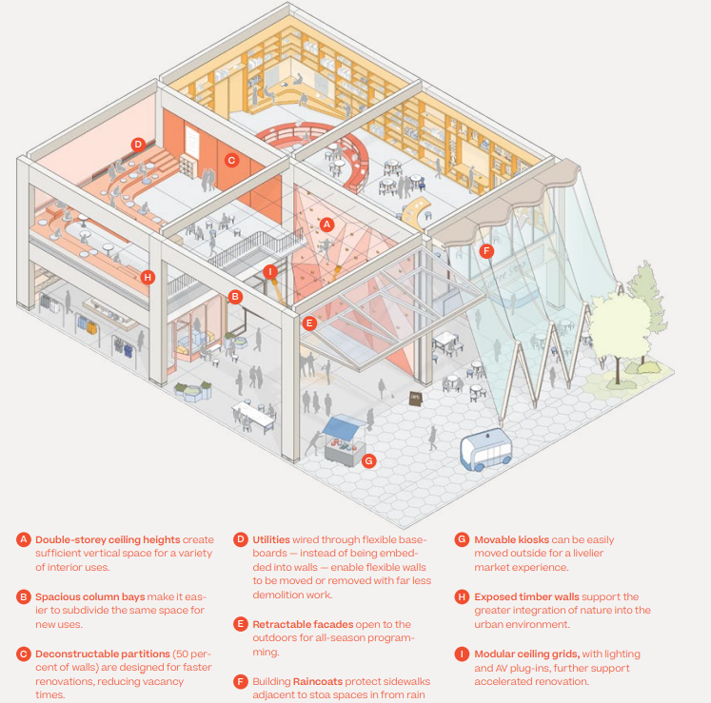

Figure 9: Stoa Ground-Floor Design Plan. (MIDP, 2019).

Another venture that Sidewalk Labs, discusses is located in the Economic Development section of the MIDP. The Urban Innovation Institute would be, “A proposed independent, non-profit, applied research center focused on urban innovation, designed in collaboration with local academic institutions

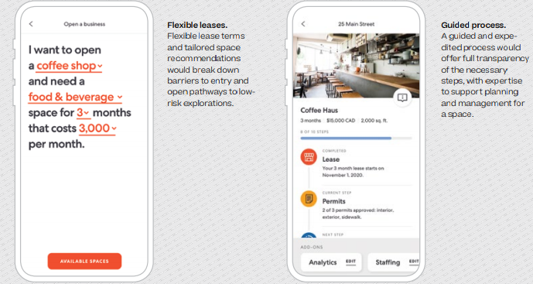Figure 10: Seed Space Business Digital Platform. (MIDP, 2019).

and stakeholders. “(p. 477) It would act as a support system to help and engage research on future development and allow entrepreneurs to develop their ideas. The program would promote collaboration between post-secondary institutions and other stakeholders to test and advance concepts. The principles do not mention businesses specifically in the section; however, the principles of end-to-end accessibility and multi-formatted information would help in bringing in a diverse range of businesses.

(Please also see Q56)

#### Will there be regulations to keep commercial rental rates affordable and from rising?

* Related Text
  + Seed space—allows businesses to establish physical presence and test out new concepts
  + Business diversity (Vol. 2, pp. 164-165).
  + Making space affordable (Vol. 2, p. 193).
    - Sidewalk Labs proposes to include adaptable retail spaces, flexible lease terms, options for co-tenancy and operating tools and services that tenants can use to reduce the upfront and ongoing costs of occupying ground floor spaces.
    - This mix of offerings would make it financially feasible for community, cultural and smaller businesses to set up shop (Vol. 2, 164).
* Supported by guiding accessibility principle: Partially Supported
* Degree of support: Partially supported

The non-profit governing body that Sidewalk Labs proposes is the Open Space Alliance (OSA). The entity would be responsible in bringing together residents, landowners and tenants. To address concerns regarding commercial rental rates, the MIDP proposes Stoa, a ground floor system that would be adaptable to the needs of every tenant. The design would allow for different ranges of uses from retail spaces to art studios. Sidewalk Labs encourages a business diversity framework model that would be a small business incubator and provide shared ground floor spaces for all types of businesses. With this business model, Sidewalk Labs is ensuring that a portion of stalls would have below market rental rates to enhance commercial affordability. Additionally, the ground floor design would boast all day ground floor activity that would reflect the needs of the community. Another strategy proposed by Sidewalk Labs is through a digital platform called Seed Space. The application would allow business to develop their physical identity and test out innovative ideas in the local market. (Vol. 2, p. 164) The Seed Space tool would minimize upfront costs and turn them into variable cost to help businesses launch their space. In terms of affordable features, the adaptable ground floor spaces could have co-tenancy options and provide operating tools to help different types of spaces. However, the proposal does not specify a specific percentage of stalls that would be allocated for below market rents. As well as, it does not address the issue of rising rental costs. Rather the MIDP, focuses on future development with commercial spaces being able to grow and adapt to the market trends for business growth. Within the accessible principles, affordability for rental spaces are not discussed, however in the Public Realm chapter, there are strategies being proposed to help maintain a fair and diverse business structure. This includes, Sidewalk Labs’ promise to include below market rental units and co-tenant leasing to minimize upfront costs for business owners.

(Please also see Q55)

#### How will commercial spaces be designed to optimize customer experience?

* **Related Text**
  + Stoa: ground floor design
  + Active streets (daily and seasonally): Movable furniture, adaptive pedestrian streets
* Supported by guiding accessibility principle: Supported
* Degree of support: Partially supported
* Excerpt:

Once I was done getting everything I needed, I found my way to the accessible cashier lane, only to find it unstaffed (p.11)

The purpose of the story illustrates the importance of customer experience based on their engagements and behaviour with the business environment. In the MIDP plan, Sidewalk Labs has proposed to improve commercial spaces to encourage community involvement and development. A key design innovation is called Stoa, a ground-floor adaptable commercial system created to accommodate businesses of all sizes and provide accessible design features to allow business to adapt and change the store fronts as they see fit (Vol. 2, p. 155). In Figure 9 the plan outlines the design features of the commercial spaces. In the story, the character was concerned with access to accessible amenities when they required them to purchase their items. The Stoa design focuses on the exterior of the commercial spaces and does not provide information on how the internal features like cashier lines and aisles will be made accessible to all customers. In order to properly address the concerns of the story, the plan should provide a guideline on accessible customer experience features and techniques that will be incorporated into the spaces. The plan focuses more on the flexibility of the spaces to change from one store to the next but does not discuss the accessible accommodations that would be made for people with mobility devices or people with disabilities.

Other commercial spaces like Parliament Plaza focus on enhancing active streets daily and seasonally. With community access to a 3D map visualization to help them locate services and amenities, as well as routes to take (Vol. 2, p. 182). Sidewalk Labs does not mention how the adaptable store fronts and streetscapes would optimize customer experience. There is a lack of a customer support structure in place for people who require assistance in commercial spaces. The proposal does not provide an in-depth explanation of how the commercial spaces would address customer experience. However, the proposal focuses on the businesses and tenants of the spaces rather than the features that would improve customer service standards. The application prototype called SeedSpace, would allow businesses to record and analyze their business statistics in a variety of functions (Vol. 2, p. 164). There is no application mentioned that would enhance accessible customer experience levels. Looking at the accessibility principles, the principles that would relate to supporting customer experience would be creating experiences that were not possible before, designing “nothing about us without us,” and providing technology that is flexible and straightforward in a variety of multi-media formats. In the commercial spaces, the plan does not provide an overview of the types of check-out lanes that will be provided to the community, as well as if they will be accessible to all customers. (Please also see Q57)

#### What do the customer supports standards look like? (i.e. retail stores)

* **Related Text**
  + Seed Space—businesses will have the capability to review customer analytics (Vol. 2, p. 154)
* Supported by guiding accessibility principle: Supported
* Degree of support: Partially supported
* Excerpt:

Another customer noticed me on the other side of the gate and approached customer service on my behalf (p.11).

The design proposal for public spaces in Quayside reflect a responsive community-led programming strategy that would allow community members to have input on events and activities, as well as allow various businesses to develop their ideas in the shared retail spaces. Customers would have access to the 3D visualization map that outlines the location and amenities available throughout the neighbourhood. They would be able to view real time information on store hours and route options for their specific needs. Sidewalk Labs proposes to implement infrastructure and facilities that create a responsive environment for users and planners. The community-led programming capabilities would be focused on open spaces like Silo Park and Parliament Slip. Parliament Plaza would be where retrial spaces would be located and create an active and year-round marketplace (Vol. 2, p. 146). Sidewalk Labs has proposed to introduce longer hours and adaptable streets that would welcome a variety of shops and access for everyone through the Stoa design layout (Vol. 2, p. 154). Customers would be notified of changed throughout the day with the 3D map display around the public spaces. Community members would have access to a diverse array of stores and amenities, as well as extended hours from 9 hours to 12 hours, which would result in a 33% increase in street activity (Vol. 2, p. 152). Other customer support systems are not mentioned in the design proposal other than the 3D map visualization for store hours and location services. In the accessibility principles, the proposal states that feedback would be a priority and would provide users with multi-modal tools to access the digital technology within the spaces. The key concern with this question is if customer service will be accessible and understanding to the different needs of every person. How would customer service be inclusive to all members of the community?

(Please also see Q58)

### Theme: Governance: Community Spaces

Community space governance reflects the allocation of public spaces and the establishment of community connection and integration into the design of the neighbourhood. Aspects such as, multi-cultural design and diversity were topics of discussion amongst the participants. Creating a system that understands the diversity of the community and distributes spaces and services in an accessible manner will help to improve community engagement.

#### Will there be a variety of groups and events for the whole community?

* Supported by guiding accessibility principle: Supported
* Degree of support: Partially supported
* Excerpt:

It was great that the seniors had their own space within a larger community centre (p.7**Error! Bookmark not defined.**).

In creating interactive open spaces for the whole community, Sidewalk Labs has proposed to “make space more responsive to the needs of the community” (Vol. 2, p. 121). This would be encouraged through shared infrastructure like projection screens and equipment, as well as spaces for public installation and a 3D map illustrating real-time space uses around the neighbourhood. Through the proposed community-led programming strategy, community members would be able to book and host events in various spaces around Quayside through the Open Space Alliance (OSA) entity. Silo Park, one of the three proposed open spaces would contain a variety of multi-use spaces that could host sporting events, a dog park, splash pad and outdoor leisure areas. The plan is to “maximize the diversity of uses within urban parks, with a number of flexible principles in mind” (Vol. 2, p. 144). The design would be in partnership with Waterfront Toronto and the City of Toronto. Street furniture would be flexible and moveable to adapt to the different uses in each space throughout the day. In creating groups and events, the design proposal focuses on community-driven planning and programs that would encourage more social gatherings and activity in the spaces provided. For example, Parliament Plaza and Parliament Slip would each have spaces allocated for events that would allow easy access from one space to the next. Other examples of potential groups include spaces for play, art groups, community groups and environmental groups (Vol. 2, p. 183). The plan outlines an abundance of diverse possibilities related to community development and engagement for Quayside.

To further address the need for individual spaces and booking information, the proposal should outline how the OSA would structure their community space booking platform.

An important aspect in the story, was the access that members had to their own spaces. The MIDP should indicate how long spaces can be booked for, as well as the structure of the booking system to ensure that it is accessible to all members of the community. In providing spaces to encourage diverse community uses, the accessibility principles that reflect the question would be to prioritize seamless accessibility and autonomy, which would relate to community-led programming strategies. As well as, enabling flexibility and customization, providing information in multiple and easily accessible formats. The design proposal and principles support an inclusive and accessible plan that welcomes diverse groups and events to Quayside.

### Theme: Governance: Public Spaces

This theme looks at place making and the use of public spaces that are created and maintained for the community. In creating universal access to public spaces, they should be organized in a manner that is inclusive and accessible to all community members regardless of age, gender or disability. Participants were concerned about the regulation of spaces during crowded events and how to access information regarding location and placement of amenities around the neighbourhood.

#### How will accessibility be maintained during crowded events?

* Related MIDP text:
  + Operations managers can schedule crews for events through digital map, (Vol. 2, p. 187)
* Supported by guiding accessibility principle: Supported
* Degree of support: Not supported
* Excerpt:

I almost fell down the stairs when making my way to the correct or amid a crowd of other conference-goers (p. 46).

In addressing crowd issues for events and community engagements, a section of the Public Realm chapter in the MIDP discusses the use of a 3D digital map for operation, community open spaces and maintenance overview. There would be Open Space Managers that would have full access to the maps capabilities in order to schedule maintenance updates, as well as crews for event clean-up (MIDP, 2019). Sidewalk Labs proposes to use the digital map as a navigational and activity tracker platform to help the community make informed decisions and provide information on construction zones and store locations. Besides the mention of scheduling a clean-up crew for events, the MIDP does not mention the accessibility standards during crowded events. In addressing accessibility, Sidewalk Labs states that they will ensure end-to-end accessibility, remove all obstacles and provide easily accessible information in a variety of formats for community use. The proposal mentions community-led design opportunities for people to host events and activities but does not outline how each would be organized to reduce accidents and over-crowding concerns.

(Please also see Q59)

#### Is there a plan for governance for spaces that supports fair use and distribution? Does the ratio of community space exceed industry standards?

* Related MIDP text:
  + Business diversity (Vol. 2, pp. 156, 164).
* Supported by guiding accessibility principle: Supported
* Degree of support: Partially supported
* Excerpt:

There was a lot going on all the time but, in their space, things were slower- paced and quieter. The room was just for them and everything that they needed was in that one spot (p. 7).

In addressing business diversity and fair distribution, Sidewalk Labs proposes a two-part business strategy in the MIDP. The first part includes the commercial spaces acting as a small business growth center that promotes business development and funding support (MIDP, 2019). This strategy was tested out at 307, one of Sidewalk Labs offices where new Canadian food entrepreneurs were able to unveil their ideas to the market. Sidewalk Labs hopes to send out proposal requests to attract potential partners who would be responsible for searching, reviewing and submitting new businesses (Vol. 2, p. 156). Additionally, to support a fair market distribution, Sidewalk Labs has promised to reserve a portion of the stalls for under market rentals. The second part of the strategy is to create shared ground-floor amenities between various businesses. This would help boost street activity throughout the day, as well as leverage shared facilities to help elevate upfront costs for set-up and maintenance. For instance, food market stalls would share kitchen space to help manage the costs of preparing and setting up different kitchens. In order to obtain a full picture of the various support systems, Sidewalk Labs needs to provide a breakdown of the stalls that will be distributed for below market rentals and advertise on how new businesses can participate in the shared market. In creating business diversity, the guiding principles of the MIDP promises to create simple and reliable infrastructure with seamless accessibility, as well as provide customization and give support for machine learning strategies. In the proposed Quayside development structure, there would be 33% of non-residential spaces dedicated to commercial and educational uses. Within this ratio, 39% will be traditional commercial spaces, 8% will be loft commercial spaces and 45% will be dedicated to the Stoa design. It is not clear whether or not these percentages exceed industry standards. Sidewalk Labs has stated that these commercial spaces would introduce about 3,900 jobs in Quayside (Vol. 2, p. 101). This strategy could relate to the guiding principle of creating new experiences that were not possible before through the variety of commercial diversity offered at Quayside. The community-led design strategy would allow people to lead and run activities and events in their own spaces by booking spaces through the OSA platform. It would give more control to community members, but the process of booking spaces was not outlined in the proposal. The story illustrates the importance of having services and amenities near-by and familiar to the person. The design proposal does not cover how the adaptable store fronts and streetscape design would remain familiar and accessible to all users.

(Please also see Q61)

#### How walkable is the city?

* Related MIDP text:
  + Curbless streets (Vol. 2, p. 126).
  + Infrastructure diversity (Vol. 2, p. 182).
* Supported by guiding accessibility principle: Supported
* Degree of support: Partially supported
* Excerpt:

But today, James was determined to go outside and get what he needed for his new seniors club (p. 7).

Sidewalk Labs has proposed to design curbless streets to ensure optimum connectivity. Figures 3 and 4 outline the new pedestrian street design where people are prioritized over other modes of transportation like vehicles and transit. The consistent grade allows for a walkable sidewalk as the design expects to minimize barriers and obstructions from one area to the next (MIDP, 2019). Sidewalk Labs states that the neighbourhood will be within a 15-minute walk from end-to-end (Vol. 2, p. 44). Technology like the weather prevention tools, an active street front and new street design promotes pedestrian activity throughout all of the spaces. Limited private parking availability and LRT connections encourage people to find other modes of transportation throughout the spaces. Sidewalk Labs design for pedestrian streets eliminates the need for on street parking and increases the level of convenience through shared vehicles and pathway designs. The guiding principles support a walkable city through their ideals of creating predicable, accessible and convenient experiences, as well as providing wayfinding tactics in various formats. Other supportive principles include removing barriers around spaces and paths and creating adaptable spaces for everyone (Vol. 2, p. 137). Furthermore, the plan for a community-led strategy would give community members the ability to run events and have group meetings in the spaces that they want. All members would have access to shared infrastructure that would support “diverse types of infrastructure built into the environment” (Vol. 2, p. 182). This design proposal would improve the walkability of the neighbourhood because people would be able to use the spaces would be made more convenient for their needs. Additional information on booking schedules and access to different types of equipment would be helpful in addressing the connectivity of the spaces to one another. In relation to the story about James, the importance is on convenience and familiarity with the neighbourhood design. A key concern that arises relates to the changing uses of the streetscape and store fronts. James requires recognition and proximity to amenities like community centres and stores. With the adaptable streetscape and store front design, this could impede his ability to find his way to the places that he needs to go to. This calls into question the principle of creating predictable and intuitive experiences. The reason is that, the intuition of a space would be diminished if it was to be a seating space during the day and marketplace in the evening.

(please also see Q60)

#### How will people be able to move through different public spaces easily? Will the design of routes and trails be inclusive to all users?

* Related MIDP text:
  + Curbless streets (Vol. 2, p. 13).
  + Open space designs (Vol. 2, 144).
* Supported by guiding accessibility principle: Supported
* Degree of support: Partially supported
* Excerpt:

He said my only option was to leave through a different exit. This was concerning to me because it was a longer route and I was very tired at this point (p.11).

The introduction of the curbless streets and pedestrian focused spaces create a seamless and quick transition from one space to the next. This strategy would allow the public space to expand and change as the day progresses. The sidewalk would have a consistent grade with minimal barriers that separate the road from the pedestrian area and other modes of transportation. Pedestrians would have priority over the other types of transportation as curbs and crossings would be eliminated (MIDP, 2019). Mobility devices and other accessibility supports would be able to move freely throughout the various public spaces. The plan promises to create safe, inclusive and accessible features and spaces throughout the neighbourhood. This would be accomplished through multi-sensory experiences, encourage community engagement though activities and stalls. Community-led programming would help emphasize inclusion standards and enhance accessibility standards throughout the trails, with tactile and audio pavement systems. In creating a sense of connection, the guiding principles state that pathways will be accessible and convenient, as well as predictable and provided in multiple wayfinding styles for all users. Furthermore, the physical infrastructure will be adaptable and customizable to suit the needs of everyone. There needs to be more information on how exists and entrances will be located to minimize the amount of movement for people with different abilities. These plans outlined by the proposal address the technical concerns of movement and route connectivity. In the story, the issue with the design was that the character was not able to use their original exit and did not have proper customer support in order to leave the building. This illustrates a flaw in the proposal as it does not mention how customer support and experience would be addressed in situations like exiting a building. Customer accommodation should be factored into the design and placement of entrances and exists to spaces to ensure that everyone is able to move to their desired location. Furthermore, this illustrates the need for customer support training protocol, so that workers understand that customers have different requirements. The proposal does not specify what customer support systems will be available, as well as the different access points throughout the different spaces.

(Please also see Q64)

#### How will accessibility be infused into all service delivery planning (i.e. snow removal)?

* Supported by guiding accessibility principle: Supported
* Degree of support: Partially supported
* Excerpt:

The snowplough has gone and piled the snow.

The main strategy to address accessibility needs for service delivery is through the 3D digital map of open spaces which would be overseen by the OSA and Open Space managers. The digital platform would provide real-time updates and conditions of all spaces within the neighbourhood, along with construction and maintenance schedules (Vol. 2, p. 186). Open Space managers would be able to schedule clean-up crews and technicians for events and overall maintenance needs like snow removal. However, there is not enough detail on how the service delivery planning would look like, as well as how it would inform community members beyond the visual map. In terms of accessibility principles, there are five that reflect accessible information. These include creating futureproof designs that are able to remain accessible for years, as well as seamless accessibility. Additional principles that relate to service delivery are the removal of barriers, providing information through a variety of formats and creating a standard audio system to help with navigational needs.

The MIDP design proposal does not specifically outline how barriers would be mitigated and the techniques on how to inform the public on changes to service planning. The heated pavement design would help manage snow and ice; however, it is unclear how snow removal will be scheduled and placed to avoid creating barriers to pathways and streets.

### Theme: Streetscape Design

Streetscape design refers to the built and natural features that influence the design of an environment. The design of a public place influences the interactions and activity of the community and creates various levels of function given the features available in the space. It can include features such as light posts, street furniture, landscaping and signs. The design of the streets was important to participants in the co-creation workshop. Features that were discussed included safety and light pollution concerns, sidewalk maintenance and placement of street furniture along trails.

#### Will lighting be controlled to balance safety and light pollution concerns?

* Related MIDP text:
  + Planning for safety—Sidewalk Labs incorporated safety into every facet of its planning process and plans to design spaces that promote safety—for example, by including lighting in the public realm that would ensure the appropriate visibility at all times (Vol. 2, p. 197).
* Supported by guiding accessibility principle: Partially Supported
* Degree of support: Partially supported
* Excerpt:

My idea of smart doesn’t involve Electronic apps, or billboards with information, surveillance cameras everywhere and constant light and sound pollution. That all of these mess with our circadian rhythm, turning us into insomniacs and further harms those like my sons with autism, who have sensitivities to lights and sounds causing stress, overthinking and mental health issues due to constant information overload (p. 36).

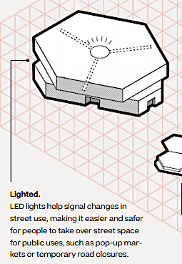

Figure 11. Lighting Design for Paved Streets. (MIDP, 2019).

Design safety is essential in promoting an inclusive design that understands the various needs of all users. Lighting safety and control is one of the key elements of concern for the Sidewalk Labs development proposal. The design strategies that the MIDP proposes certifies that design safety is a priority by, “…including lighting in the public realm that would ensure the appropriate visibility at all times” (Vol. 2, p. 197). An example of the lighting design can be seen in Figure 2, where the paved surfaces within the neighbourhood would contain LED lights to signal for changes in street usage. Examples of the changes include pop-up markets and temporary road closures. The MIDP does not specify how the LED lighting system will change to indicate different uses, nor does it outline the concerns with lighting pollution. Furthermore, the design details do not reflect the concern in the story. The key point of the story is to move away from technology and address health concerns related to the overstimulation that can be caused by light and sound pollution. The chapter goes over design aspects like visibility and safety standards but fails to address concerns regarding mental health and sensitivities to environmental design. The chapter does not provide information on the material or structure of the lighting system, as well as how the lights will be distributed around spaces to ensure safety, while minimizing light pollution. Sidewalk Labs ensures that all design aspects would conform to AODA specifications but does not reference any AODA policies in particular (Vol. 2, p. 170). The only clear design innovation for lighting is the pavement lighting for service and street use changes. The accessibility principle that best reflects the safety and lighting question would be reflected in the seamless accessibility principle.

(Please also see Q9)

#### Will the city be designed to clearly separate pedestrian, bike and other travel?

* Related MIDP text:
  + Vol. 2, Part 1—Creating More Open Space (Vol. 2, p. 127).
  + 91% more space dedicated to people (Vol. 2, p. 128).
  + Flexible open spaces can quickly be reconfigured by day or season (Vol. 2, p. 143).
* Supported by guiding accessibility principle: Partially Supported
* Degree of support: Partially supported
* Excerpt:

I dream that our public transportation would be tied into our tax system so that it would be free for all, or that it would be geared to income. So that it would be more equitable for people like me don’t have to pick between putting money on a presto card or feeding my children that week, just so that I can go to work to support my family (p. 36).

The plan proposes to create affordable spaces in the commercial and tenant spaces that would reduce upfront costs for maintenance for businesses (Vol. 2, p. 164). However, the concern for affordable services like transportation is not addressed in the “Public Realm” chapter. Sidewalk Labs proposal emphasizes pedestrian streets over vehicular roadways. This strategy outline in the MIDP, suggests four different pedestrian street designs to enhance the pedestrian realm. The designs include, narrowing lanes and buffer spaces, reducing vehicular lanes, sharing transit rights-of-way and eliminating on street parking. These strategies would have an increase in pedestrian street use anywhere from 28% to 118%. The design recommendations would adapt the standard streetscape design to prioritize pedestrians. Traditionally, streets have allocated 3.5 meters to 7 meters of sidewalk space with more emphasis on vehicular and transit lanes. However, with the proposed designs, the sidewalk lengths would have a minimum of 7 meters of space and up to 17 meters of pedestrian only sidewalks, as specified in Figure 4. In addressing the concern for separated modes of transportation, the design features would include smaller buffers, trees and islands to create a degree of separation between each mode. Along with sidewalk width increases, the dedicated bike lanes would increase from 4 meters to 5 meters for cyclists. Within the pedestrian realm, the proposal envisions streets reflective of the pre-automotive era. Examples of the physical infrastructure would include indoor-outdoor spaces, weather protection, natural elements, dedicated bike lanes and utilities (refer to Figure 3). The buffer zones in the proposed design would consist of trees, light posts and greenery. Additionally, the plan recommends that LRT systems share their right-of-way with self-driving cars for future develop to ensure a consistent flow of traffic. In accordance with the guiding accessibility principles, the two that reflect the question include number 6, which is making paths completely accessible and convenient for the user, as well as number 11 to remove friction and obstacles (Vol. 2, p. 137). The transit system would be an extension of the TTC subway and LRT lines in the Quayside neighbourhood. This would indicate that the ticket cost for Presto and the TTC would remain the same.

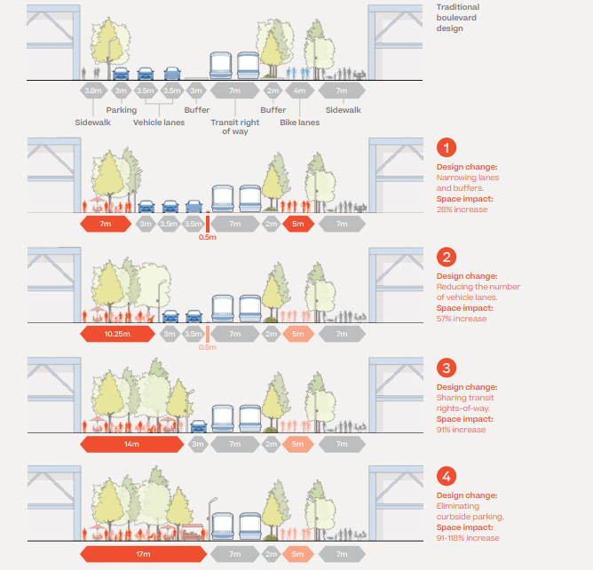

Figure 12: Four plans for sidewalk, car and transit spacing move from traditional sizing to complete removal of curbside parking and creation of wider sidewalks.

In the story, the key concern is having access to affordable transportation to help mitigate living costs for families. The “Public Realm” chapter does not provide information on transportation costs or discusses tax allocation for families. More information on costs and transportation can be found in the “Mobility” chapter of the MIDP. Sidewalk Labs has proposed a separate entity that looks at real-time traffic management tools, pricing strategies and integrated mobility systems to encourage modes of transportations other than personal vehicles. The pricing strategies are of interest in relation to the story on affordable transportation options to improve cost of living for families. The MIDP states that “an integrated mobility package that could save two-person households roughly $4,000 a year if they choose to go car-free” (Vol. 2, p. 55). This cost would be mitigated with the self-driving ride-hail and combined modes of transportation like walking, transit and cycling. The plan does not provide pricing information on the transit costs for people who rely on transit currently to get around the city. For people use transit as their primary mode of transportation, the rice-hail vehicle incentives and pricing would not address their concern of government funded public transportation costs.

The MIDP supports the separation of the different modes of transportation from pedestrian, cycling and transport but does not address the cost concerns for people with different socio-economic backgrounds.

#### Is the sidewalk surface smooth and clear of ice/obstructions in all seasons?

Related Text

* Curbless streets (Vol. 2, p. 132).
* Heated, lighted and green pavement (Vol. 2, p. 136).
* Digital map to help open space managers to schedule maintenance after events and operations (Vol. 2, p. 186)
* Supported by guiding accessibility principle: Partially Supported
* Degree of support: Partially supported

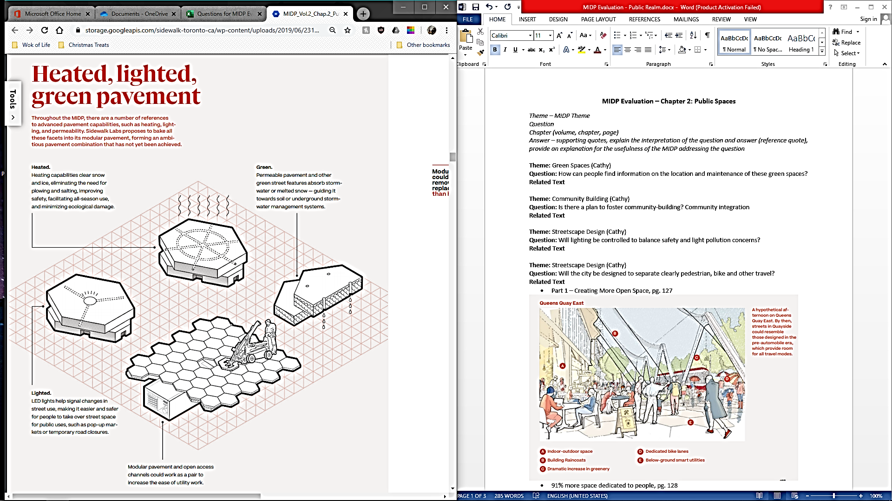

Figure 13. Heated, Lighted and Green Pavement Design. (MIDP, 2019).

In creating an open space environment with focus on pedestrian needs, the MIDP proposes the use of curbless streets. This would entail a seamless and consistent pathway and roadway grade that, “the entire street would be at one consistent grade, enabling the sidewalk to grow or shrink quickly and easily” (Vol. 2, p. 132). This design innovation hopes to facilitate and reflect an inviting environment. In terms of accessibility features, the pathways would contain responsive sound and tactile pavement elements to address any visual and hearing impairment needs. Furthermore, Sidewalk Labs claims that the curbless street design would allow public spaces to expand and adapt throughout the day for various needs. For all season maintenance and care, the paving material

proposed in the MIDP consists of heated modular pavement that would be able to clear snow and ice thereby minimizing plowing and improving safety standards in public spaces (Vol. 2, p. 136).

The modular design was adapted from the French Institute of Science and Technology for Transport, Development and Network (FISTTAR) in Nantes, France to address issues related to utility maintenance and disruptive street construction (Vol. 2, p. 137). The pavement design would reflect a hexagonal form about 1 meter deep and 2 meters wide with a removable cover that would house essential utilities from street lighting to fibre optics. Sidewalk Labs modeled this design with interlocking lap joints that would ensure a consistent and resilient surface. In Figure 5, the shape and design of the pavement can be seen with the heating capabilities for easy ice and snow removal, as well as the maintenance access with each modular piece. However, the proposed modular pavement design does not address issues of heavy rainfall amounts and large snowfall occurrences. In terms of barrier maintenance along sidewalk surfaces, the new design would produce fewer disruptions and less time commitment as it would take one worker with a handheld tool to replace each modular slab (Vol. 2, p. 138). Furthermore, with the proposed 3D digital map, Sidewalk Labs states that maintenance work could be scheduled by Open Space Managers and alert the community to any construction work on a community board. Other tools to combat weather occurrences include interventions called a Raincoat, Fanshell and Lantern Forest (refer to Figure 6). The Raincoat would be able to extend and retract to protect the area around the building from rain, wind and sun. The Fanshell would act as an open space cover for up to 100 people, while the Lantern Forest would minimize the number of wind tunnels in-between building gaps.

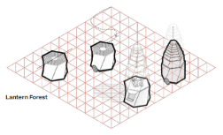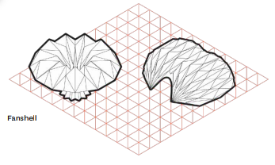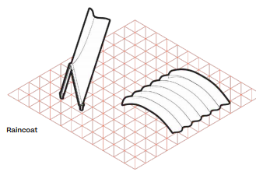

Figure 14. Weather Interventions: Raincoat, Fanshell and Lantern Forest. (MIDP, 2019).

A potential concern regarding the mapping system include, the location of the digital maps, as well as how people would access the information within their homes, offices or leisure spaces. Additionally, given the flexibility of the sidewalk, the streets can change throughout the day, which include changing and moving furniture and equipment. The weather interventions would be focused on rain, wind and sun and did not indicate a solution for ice or snow besides the heated pavement streets. In Figure 7, the edge of the sidewalk could be used as drop off areas for vehicles and then change to pop-up vendors in the evening. Would an individual be expected to check the digital map for updates constantly to view changes? How would frequent space changes impact individuals who are blind or have low vision? The sidewalk design for Quayside would follow the principles of being accessible and convenient, as well as eliminating barriers throughout the seasons; however flexibility of use could introduce barriers if navigation supports are not provided.

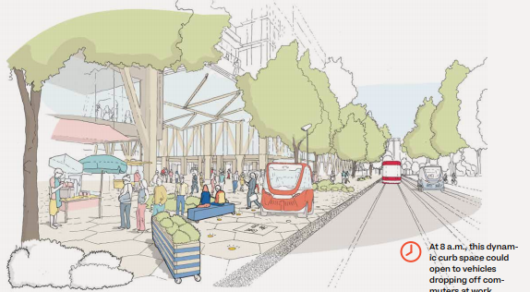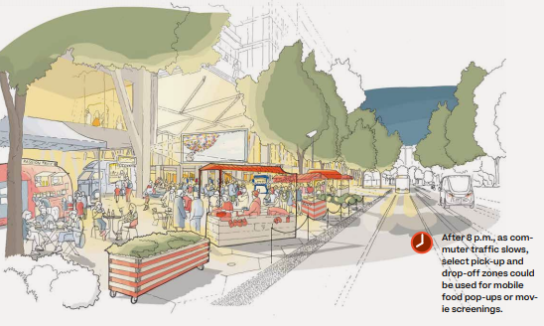

Figure 15. Adaptable Streets in Action (Morning and Evening). (MIDP, 2019).

#### Will there be seating and public spaces along the trails? Are all spaces for relaxation and enjoyment accessible?

* Related MIDP text:
  + Silo Park (Vol. 2, p. 145).
  + Parliament Plaza (Vol. 2, p. 147).
  + Parliament Slip (Vol. 2, p. 148).
  + Digital map of open space assets (Vol. 2, pp. 186-187).
* Supported by guiding accessibility principle: Partially Supported
* Degree of support: Partially supported
* Excerpt:

He felt like he belonged because this was his neighbourhood. He saw people that he knew and started to feel better.” (p.7).

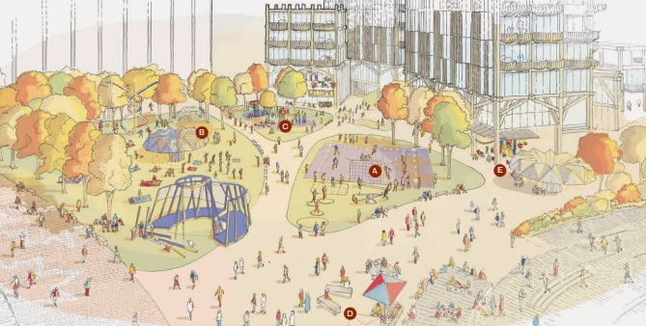

Figure 8. Silo Park: Multi-Purpose Design. (MIDP, 2019).

In Sidewalk Labs MIDP, there are three main public spaces introduced to establish a community-led design with focus on pedestrian well-being and adaptability. The three spaces are Silo Park, Parliament Plaza and Parliament Slip. Silo Park will be designed as a multi-purpose park with various activities and features to ensure that people of all ages can engage with others and their surroundings. With the limited open space availability in cities, Sidewalk Labs recommend the multi-purpose design to revitalize recreational infrastructure for public use (refer to Figure 8). The park would include at least three different sporting spaces that are accessible year-round, as well as play features for people of all ages, movable furniture and spaces for eating. About 90% of the furniture like tables and benches would be mobile. Furthermore, the park will include a variety of trees and green spaces to encourage leisure activity and enjoyment. The multi-purpose functionality of the open space will be able to adapt to the needs of the community. The consistent grade throughout the

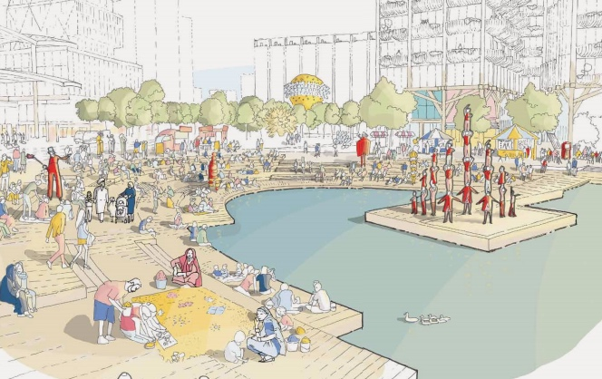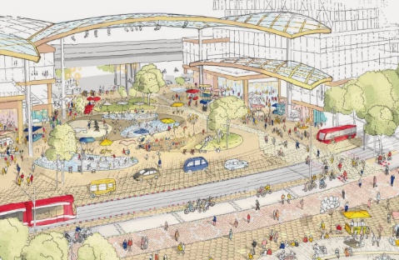

Figure 9. Parliament Plaza and Parliament Slip. (MIDP, 2019).

streets will ensure that mobility devices and other support aids will have easy access through the spaces (MIDP, 2019). The second open space will be called Parliament Plaza which would be dedicated to markets, public art displays, events and all age engagement. In the design, it is considered an adaptable plaza that contains both permanent and temporary features for community engagement. The space could be converted from a flat grade design to pop-up markets and installations with weather protection and lighting. An example given for an adaptable activity, would be a splash pad during the summer and ice rink during the winter. Similarly, to Silo Park, the plaza would contain moveable furniture throughout the space. Furthermore, the location of Parliament Plaza would be along the shared roadway with LRT and vehicular movement. The third public space will be called Parliament Slip, which is proposed to be a 6,000 square meter water-bound space with multi-purpose rotating uses (refer to Figure 9). Example of possible activities include, cafes, ecology courses and research. Additionally, Sidewalk Labs proposes to create barges along the section to encourage these community programs. All three open space designs would be visible on the digital map with real-time updates to navigate and provide information to all community members. These spaces provide flexible and movable furniture and infrastructure that can adapt to the needs of all users. The proposed open spaces contain features that can integrate with various activities and events and provide elements to encourage all age engagement. A key consideration of the story is to address the importance of creating a sense of belonging. The open space designs introduce diverse activities and amenities for the community. Given these design features, the plan should include an explanation on how the designs would improve community relations and encourage community socialization. In the story, the character was familiar with people in the neighbourhood and was comfortable walking around the area. How will the design of open spaces be familiar to a diverse range of people and how will they feel welcome? The plan proposes that the sense of belonging will come from participatory design, accessible services and diverse programming (Vol. 2, p. 193). However, with the movable design features and adaptable streets, the space would not remain a consistent design throughout the year. Events and activities would change depending on the seasons and needs of the community and therefore, people would not always be in the same area. The plan does not specify how long a community group or space would remain the same and how the changes would be informed to the public going beyond the map visualization.

Given the overview of the three public spaces, the plan does outline that there will be moveable furniture like benches, tables and chairs. However, given that these features are mobile, there is no plan available to see where permanent seating furniture would be placed for individuals who require consistent seating along trails and pathways. The question regarding available seating along trails can best be addressed through the guiding principles of an accessible and aesthetically pleasing path with various natural features and open spaces. The seventh principle looks at seamless accessibility which can be reflected in providing seating along all the pathways, as well as within the public spaces. Addressing the accessibility of the open spaces, the guiding principles encourage relaxation and recovery, as well as provide adaptable features that can change to the needs of everyone (Vol. 2, p. 137).

The proposal provides a diverse overview of the open spaces that would be created for the community but does not provide information on how the spaces would improve a person’s feelings.

#### What community institutions (schools, libraries, community & recreation centres) are planned for the smart community and how many? What are the community spaces available?

* Related MIDP text:
  + Vol. 2. Silo Park p. 145, Parliament Plaza, pg. 147, Parliament Slip, pg. 148.
  + Vol. 2. Urban Innovation Institute, pg. 191.
  + The Overview—p. 101 <https://storage.googleapis.com/sidewalk-toronto-ca/wp-content/uploads/2019/06/23202306/MIDP_Volume0_AccessibleDocument.pdf>
* Supported by guiding accessibility principle: Partially Supported
* Degree of support: Partially supported
* Excerpt:

After walking for a block, James began to calm down. He felt like he belonged because this was his neighbourhood (p.7).

There are a variety of community spaces proposed by Sidewalk Labs such as, Silo Park, Parliament Plaza, Parliament Slip and the Urban Innovation Institute. Three of the spaces would be considered open space environments with the institute acting as a research hub for post-secondary institutions and interested stakeholders. Silo Park would consist of recreational and community spaces that will engage people of all ages and provide infrastructure for events and various installations. It would serve as a multi-purpose recreational outdoor space. The second open space will be called Parliament Plaza, which will focus on ground floor retail space, shared roadways and pedestrian streets filled with movable furniture, stalls and play spaces. Parliament Slip will be a water-bound environment containing tiered seating facing the water with barges to separate a variety of uses from research courses to market spaces (MIDP, 2019). Sidewalk Labs has proposed an Urban Innovation Institute for post-secondary institutions and various stakeholders to create and design their ideas for future development. These four spaces were the focus in the Public Realm chapter of the MIDP. There is a proposed plan for an elementary school for Quayside that would be about 60,000 square feet and take about 7% of the non-residential space (MIDP, 2019). Other community spaces were not mentioned, however the curbless pedestrian streets and ground floor spaces would provide spaces for various needs for the community. It is unclear how the community design of public spaces would create a sense of belonging for all members. There needs to be more information and examples outlined on how to create a welcoming community for everyone. The MIDP uses terms to establish a sense of place like seamless design and functionality. There is no discussion on the human aspect of creating a sense of place for the people. The plan outlines the importance of public engagement, but the proposed design focuses on general terms like seamless design, unique experiences and responsive environments. The question that needs to be addressed is how the design of the neighbourhood will make people feel welcome and reflect their needs in establishing a community environment. Furthermore, the proposal introduces a community-led programming strategy that would allow people to take the lead on planning events and activities in shared spaces with access to a variety of equipment through the Open Space Alliance entity. However, it is unclear on how the spaces could be booked and how the schedule how the resources would be allocated to each community space.

#### Will handrails of multiple heights be utilized throughout outdoor spaces?

* Related MIDP text:
  + Chapter provides overview of safety being priority with consistent grade pavement material, lighting and navigational systems but does not specifically cover handrail heights (Vol. 2, p. 197).
* Supported by guiding accessibility principle: Partially Supported
* Degree of support: Not supported
* Excerpt:

The stairs don’t have a continuous handrail and there are no tactile markings on the floor. I don’t know where the stairs begin and end. A ramp would have been better! (p. 46).

The Public Realm Chapter in the MDIP does not specifically mention the design of accessible handrails, as well as the various height requirements for community members in their public spaces. The safety concerns listed in detail include a curbless street with a consistent pavement grade, lighting indicators for visibility and navigational digital maps for open space environments and maintenance updates. Given the detail provided for the accessible pathway systems and weather intervention tools, there should be a section outlining accessible features throughout the various open spaces. The guiding principles do not mention handrails specifically, however, the principles for number 7 and 15 state that the designs would contain seamless accessibility which would be adaptable and customizable (Vol. 2, p. 137).

(Please also see Q48)

### Theme: Streetscape Barriers—Temporary

The design of a streetscape influences community engagement, accessibility and behaviour of a person to their environment. Addressing concerns regarding obstacles and barriers is imperative to creating an inclusive space because it affects how a person can interact with the environment. Even if temporary, participants stated that barrier indication was important to their daily lives. Spaces should be built with people with disabilities in mind. Working with the end user from the beginning of the design proposal is imperative to the success and function of a streetscape. Participants and stakeholders should be involved with the process throughout the planning and implementation period to help with user testing and accessible considerations of the design.

#### Will systems and design support wayfinding? How will barriers introduced by things like construction be communicated/mitigated?

* Related MIDP text:
  + Digital map (Vol. 2, p. 186).
  + Heated, lighted pavement (Vol. 2, p. 136).
  + Decrease maintenance and repair time—one-person job in less than ½ a day’s work with handheld equipment
  + IFSSTAR—modular paver system consisting of hexagons
  + Digital infrastructure for proactive maintenance (Vol. 2, pp. 186-187).
    - Digital 3D map of open spaces being maintained by OSA
    - Public visualization available to community for construction updates (Vol. 2, p. 187).
* Supported by guiding accessibility principle: Supported
* Degree of support: Partially supported
* Excerpt:

These are some examples of features that are perhaps unintended landmarks.” “the station has changed so much recently (p. 45).

The main tool proposed by Sidewalk Labs in creating a responsive and connected neighbourhood is to introduce a 3D digital map that outlines all open spaces, including utility structures and various physical infrastructure locations. The system would be displayed in public areas to allow the community to see the real-time location and conditions of each space and make informed decisions on route preference in order to avoid obstacles and delayed travel. The map would be updated daily and outline the location of media projectors, movable infrastructure and electrical outlets. The access to the map would be divided by role, whereby the Open Space managers would have full view of all geospatial assets to help schedule maintenance and workflow. The public would be able to see open space conditions and construction zones on their end. The explanation of the digital map does not provide any details on how the map visualization will be displayed nor does it mention multi-sensory design considerations for people who are visually impaired or hearing-impaired. The guiding principles that would support wayfinding include number 10, 16 and 20, which discuss the importance of inclusive wayfinding strategies. These include audio informational systems and other multi-sensory formats (Vol. 2, p. 137). The main communication tool introduce by Sidewalk Labs in relation to construction and barrier notification is a digital 3D map of the open spaces and other amenities, which will be maintained by the OSA. “A public visualization would help community members make far more informed decisions about their use of public spaces based on actual conditions” (Vol. 2, p. 187). This suggests that the map information would be primarily a visual tool, as audio and tactile information techniques were not included in the description. In comparison to the guiding principles, the design would work to remove obstacles and create accessible pathways that would be connected in a variety of communicative formats. Sidewalk Labs has proposed longer hours to promote street activity and market success by creating an active streetscape throughout the day. The streets would be able to change from a market place to event area depending on the needs of the community.

However, the flexibility and changing environment could potentially decrease the comfort of some users. Concerns that were raised by the content experts included being able to understand the space and have features to help with wayfinding. As the streets change throughout the day, people would have to reorient themselves within the space and locate new tools for wayfinding. There should be designs in place that provide a sense of familiarity and structure to ensure consistency in the spaces.

(Please also see Q11)

### Theme: Spirituality and Culture

Each person has a cultural or spiritual belief system that helps to shape the individual that they are. It is important that a neighbourhood design and structure be respectful of the different belief systems and provide strategies to meet the needs of the community. Participants stressed the importance of having a safe space for their cultural and/or spiritual expression. Cultural and religious needs should be addressed by communicating with people and understanding what aspects are important to them.

#### Will there be religious or spiritual places available? How will spiritual practices (smudging, prayer, meditation, chanting and incense, etc.) be accommodated?

* Related MIDP text:
  + Three open spaces cover more of general uses than specific ones related to religious or spiritual places (Silo Park, Parliament Plaza, Parliament Slip)
* Supported by guiding accessibility principle: Not supported
* Degree of support: Not supported
* Excerpt:

So, I can connect with my ancestors and not take home the emotions of fear after a hard day of work.” “Some days people in the neighbourhood ask me to leave the park because they say that it is loud and they can’t stand the smell of my medicine burning and, on some days, they literally attack me (physically) (p. 21).

The proposed design for Quayside, introduces three open space areas which are, Silo Park, Parliament Plaza and Parliament Slip. The key features of these spaces is to promote a multi-purpose environment that is designed for recreational, leisure, educational and social uses. The community-led programming initiative opens up opportunities for members of the community to organize events and spaces for their needs around the year. This strategy indicates that spaces can be open to religious and/or spiritual practices, it depends on what activities and events are included in the community-led programming as there is no specific mention of spaces solely for religious or spiritual purposes. The MIDP does not mention spirituality and religious uses. The guiding principles only illustrate that the neighbourhood will promote relaxation, wellbeing, as well as support flexible needs for all users. The adaptability of the spaces would be beneficial for religious and spiritual uses; however, the proposal should provide detail on areas where spirituality and religious practices could be expressed as it was not one of the activities mentioned in the “Public Realm” chapter. The concern in the story was to have a safe space for spiritual and religious expression without fear. The chapter does not discuss any plans to address religious expression or how it plans on showing respect for the people’s diverse beliefs. The fact that the term “religion or spirituality” cannot be found in the plan is not inclusive to the needs of the community. Religion and culture need to be addressed by communicating with all community groups to understand the needs of everyone. The plan should be mindful of the different beliefs of the community and provide an outlet to listen and support the diversity of the people.

### Theme: Social Supports

Creating an accessible and inclusive environment cannot be accomplished without establishing social supports. Having a support system in place enhances quality of life and provides people with help to access the services and amenities that they need. Social supports come in a variety of formats from emotional, physical and informational support. Positive social support structures establish an open community that is able to accommodate the diverse needs of all community members.

#### Is there a plan to foster social supports? Will there be spaces for health clinics, schools, homeless shelters and other social services?

* Related MIDP text:
  + Community-led programming (Vol. 2, p. 182).
  + CommonSpace (Vol. 2, p. 185).
* Supported by guiding accessibility principle: Partially supported
* Degree of support: Partially supported
* Excerpt:

Newcomer adjustment.” “Cultural centres, Free Clinics and public access buildings were being relocated and replaced by Starbucks, Tim Horton’s, Urban Outfitters and other corporate entities, removed all the individuality that made up our neighbourhood affecting single mothers, refugees, All homeless, those with addictions and mental health affected communities. Access to Shelters, food banks, walk in clinics being replaced by private practices in a tiered healthcare system, shelters are moved to the suburbs, further denying basic human needs to the people that make up my community so that they have no choice but to move away. The taking over of lands replacing inaccessible resources to those who cannot afford and gentrifying spaces making them inaccessible causes those that are affected by these changes to suffer as a result (p. 32).

Social supports in a city are important in creating an open and diverse community. Sidewalk Labs proposes to have community-led programming with the assistance of the OSA to develop and encourage community run events and programs. The participatory programming strategy would encourage inclusive engagement standards to help people develop and showcase their ideas and values. The proposal hopes to establish a sense of belonging within each space and provide access to community building. Applications like CommonSpace, would provide updates on public spaces and the various activities that people are having within the space. Its open sourced data would allow for different uses to input their observations to continuously adapt and innovate community spaces (Vol. 2, p. 185). In terms of social services, the Quayside development plan will be allocating 7% of their non-residential space for an elementary school. Additionally, an Urban Innovation Institute will be established at Quayside to foster grant research and ideation projects from post-secondary education to entrepreneurs (Vol. 2, p. 191). In terms of other social services, the Stoa design strategy of co-leasing ground-floor spaces will allow different businesses to have a physical presence in the neighbourhood. This would allow health clinics and shops to open along Parliament Plaza. Spaces such as homeless shelters were not mentioned in the chapter, however given the shared space allocation it would be concluded that there would be potential spaces for social services. In relation to the guiding principles, the proposal provides some social support by creating an easily accessible feedback system, as well as making plans to have community participation every step of the planning process of, “do nothing about us without us” (Vol. 2, p. 137). The proposal provides a lot of information on business development and growth but does not provide a detailed proposal on the access to social services like health clinics and shelter spaces for the community. In addressing the newcomer concerns in the story, the “Public Realm” chapter does not contain any information on how newcomers would be able to access and participate in the community.

The MIDP provides an overview of platforms and community programming tools to help with socialization. However, it does not provide information for newcomers or the social supports that would be available to them in the community.

#### Will emergency healthcare be available?

* Supported by guiding accessibility principle: Not supported
* Degree of support: Not supported
* Excerpt:“ER wait times.”

The three main public spaces, Silo Park, Parliament Plaza and Parliament Slip does not mention an emergency healthcare centre. The shared ground-floor Stoa strategy proposed by Sidewalk Labs indicates that a healthcare clinic could lease a space within the plaza for these types of services. Parliament Plaza contains spaces to house various stores and businesses. However, a space for an emergency healthcare centre was not specifically mentioned. Additionally, the guiding principles do not cover emergency care in their platform. In addressing ER wait times, the proposal does not address the organization and structure of the healthcare services for the neighbourhood.

#### Will stores and amenities support the needs of the community? Will the customer support standards be inclusive of the needs of everyone?

* Related MIDP text:
  + Silo Park, Parliament Park and Silo (Vol. 2, pp.145-147).
    - Responsive open space (Vol. 2, p. 178).
    - Coordinate programming, day-to-day function of public realm should be seamless, OSA structured to support creative ideas and operations, well maintained public realm
* Community-led programming (Vol. 2, p. 182).
* CommonSpace (Vol. 2, p. 185).
* Digital map (Vol. 2, p. 186).
* Supported by guiding accessibility principle: Partially supported
* Degree of support: Partially supported
* Excerpt:

Digital options were simply not working and I desperately needed a more human connection for assistance (p.11).

The solution was simple. I explained to the guard that I needed to go through that exit to get to my vehicle. However, he was resistant (p.11).

In creating a social support structure for the community, Sidewalk Labs has proposed a responsive open space approach with community-led programming tools to encourage community participation and planning. The Open Space Alliance (OSA) would act as the main entity for the community to help with operations, maintenance and community programming requirements (MIDP, 2019). The organization would ensure a seamless transition of each space and coordinate community programming tasks throughout the day. Through this process, community members would be able to book and use shared spaces and equipment for specific needs and events (Vol. 2, p. 182). The proposed open spaces of, Silo Park and Parliament Plaza contain customized and adaptable features that welcome multi-modal learning and ideation. The amenities within these spaces would reflect the needs of all users and engage the community in building a multi-purpose environment. Furthermore, this provide the community with a leading role in determining how the space should look and what events to host. Furthermore, the digital map would provide real-time updates with open sourced data that would allow community members to send in updates to ensure that everyone is able to make decisions on spaces to visit and use. An application proposed by Sidewalk Labs, called CommonSpace collects and stores data on how people use and interact with various spaces. This tool would be beneficial in assessing customer reviews and support the community in ensuring that the services provided reflect their needs. The application would work with the Public Life Data Protocol, an open design standard that would help to track and record data submitted by users. The proposal details who and what the application could be used for but does not outline the steps or guidelines on how to access and upload information. Additional information outlining other customer support systems should be further detailed in the MIDP, as the application cannot be accessed by everyone. In providing community support through amenities and stores, the guiding principles ensure that nothing is completed without the involvement of everyone, infrastructure will be simple and reliable for the shared use of the community and seamless accessibility is essential to the proposed development. Independence is another key factor in the proposed design, which can provide community members with the flexibility of incorporating their ideas. Enabling personal assistive technology and creating multiple facets to experience digital technology are important aspects to consider in creating a community focused support structure. The MIDP does not provide information on a training protocol for customer support services in that would provide assistance to people with disabilities. The proposal emphasizes digital community connections and does not specify how people would have access to human connections when they need it.

## Chapter 3—Building and Housing

The “Building and Housing” chapter (Vol. 2, p. 203) addresses how building will be built in the Smart City. This includes their proposal to develop a mass timber industry (Vol. 2, p. 212) specifically for Quayside, supported by digital tools in the manufacturing process, from mechanization of the factory and the reliance on pre-fabricated standardized building parts and the development of a library of parts (Vol. 2, p. 220). It also includes plans on the design of efficient and ultra efficient units (p. 256) and shared communal spaces as part of their plan to have Quayside include people from a mix of socio-economic statuses (Vol. 2, p. 270). Overall, what the MIDP proposes are solutions to building delays and costs, to buildings that aren't energy or space efficient and to Toronto's housing crisis that affects both poor and middle-class citizens. While there are a number of attempts at incorporating accessibility as a concept and larger goals, there aren't many instances of going into the specific of how this will be achieved apart from an assurance it will guide the whole project.

### Theme: accessibility governance/ accessibility

#### Is there any plan to include accessibility committees for sections? i.e. towers, retail, streets

* Related MIDP text:
  + Vol. 0: Overview, Social Infrastructure (Vol. 0, pp. 112-113); Foster an inclusive community supported by robust social infrastructure (Vol. 0, pp. 153-154).
  + Vol.1, Ch.1: Introduction, Social infrastructure (Vol. 1, p. 45); Building towards a complete community (Vol. 1, pp. 216-217); Care Collective (Vol. 1, pp. 220-221); Civic Assembly (Vol. 1, pp. 224-225).
* Supported by guiding accessibility principle: Nothing about us, without us
* Degree of support: Not supported
* Excerpt:

In this scenario, the stone [=inclusiveness] is completely ignored. Even though it has a shine, its own appeal and characteristics, none of those are taken into account. The stone receives no attention and no value.

Impact on Accessibility: There are two different degrees of impact on accessibility: partial and total. Total neglect involves no action toward accessibility. This creates stigma and discrimination towards accessibility. It also reinforces the blind spots that society may have about accessibility, making the issue even more challenging to resolve. (p. 38)

The question relates to the role accessibility will have in governing different part of Quayside, such as retail, the public realm, the infrastructure of the smart city, etc.

There is no mention of decision-making groups that would be community-based in either Vol.2, Ch. 3 Building and Housing, or in Vol. 2, Ch. 4 Sustainability. There is no mention in chapter 3 about, how and even if, accessibility will be included in any governing aspect of the smart city. In the overview and in the introduction, what is proposed as a means of involving resident in the governance of Quayside are a series of community-based governing groups, such as the Open Space Alliance, the Civic Assembly, the Care Collective, the Quayside Neighborhood Association and Collab. These serve as forums where people can get information, participate in decision-making processes that affect the whole community.

What isn't clear is what kind of decision-making process they will follow (majority rule, consensus?) to which extent decision made in those spaces will affect actions in Quayside. It is also unclear what kind of relationships these groups will have with the municipality, the provincial government, Sidewalk Labs and the management of Quayside as a profit-driven commercial project. In fact, the internal organization, mandate, values and practices of each group are not defined. The idea that democratic participation will simply work by virtue of being democratic is implicit but never addressed full on.

It is clear however that the social infrastructure of Quayside, in part via these community-based governing groups is woven into the development of Quayside as a socially progressive neighborhood. Quayside is presented as a better version of current neighborhoods, one where inequalities and inaccessibility are remediated via more inclusive architecture, sustainable building and energy practices and digital solutions. This vision relies on an implied understanding that the organization of physical spaces, policy infrastructures, will determine the development of Quayside and the IDEA district as communities with an engaged membership.

In its commitment to include accessibility as a guiding principle in the development of Quayside, how accessibility will be included within these community-based governing is going to be work that needs to be done with the contributions of people with disabilities.

Both inclusiveness and accessibility are presented in the excerpt as inherently valuable, in and of themselves. At the same time, the author knows that despite this inclusiveness and accessibility may not be treated as valuable by others. When it comes to ensuring a robust engagement with accessibility—and to following the MIDP's own accessibility principles- there needs to be a clear commitment in the form of explicitly stated guide lines in how those governing bodies will be composed, managed and types of actions and focus they will enable.

| **Governing entities** | **Aim** | **Reference** |
| --- | --- | --- |
| Care Collective | Community space for the promotion of health and the enhancement of well-being | Vol. 0, pp. 112-113, 154, 183; Vol. 1 Ch. 1 pp. 45, 216, 220 |
| Open Space Alliance | Non-profit entity for the coordination of programming, operations and maintenance of parks, plazas, streets and water spaces | Vol. 0, pp. 106-107; Vol. 1, Ch. 1, pp. 41, 156, 225, 227 |
| Civic Assembly | Physical and virtual space to connect and share with others and find out about activities, events, as well as get help and information on digital tools | Vol.0, pp. 112-113, 183; Vol.1 Ch.1 pp. 45, 86, 225 |
| Quayside Neighborhood Association | Neighbourhood association | Vol. 1 ch.1, pp. 225, 227 |
| Collab | Online resource for programming events | Vol. 1 Ch. 1 p. 45 <https://collab.sidewalklabs.com/> |

### Theme: Accessibility Standards

#### How will accessibility in all spaces (including commercial) be assured -go beyond building code (i.e. function)?

* MIDP Related MIDP text:
  + Vol.2 Ch. 3 Public Engagement (Vol. 2, pp. 291- 292).
* Supported by guiding accessibility principle: Go beyond legal requirements; Enable flexibility a customization; make the accessible path the most convenient, delightful path
* Degree of support: Not supported
* Excerpts:

A:

Another reaction to seeing a precious stone is to look at how you can use it to your own benefit. Essentially, the stone becomes an object of consumption.

Story: For example, the stone can be marketed, promoted and sold. Driven by these motives, the stone is only valuable by serving the "business," not in its own right. The stone is just like any other stone, extracted from its environment and sold for its material benefit. Impact on Accessibility: This relates to accessibility because it's often valued from a commercialized or business perspective. This puts accessibility as a risk of becoming commoditized. It downgrades the value of those with accessibility needs by dehumanizing the person. Both the uniqueness and diversity found in inclusivity are removed in favour of efficiency and scale.

Example: The pricing and business model for a variety of accessible products and services demonstrate the commercialization of accessibility:—Powerchairs that come at a price tag that is unreasonable for any individual to purchase, causing them to rely on funding or other means—Accessible tech and devices that are provided and serviced by organizations and—The extremely high price point for accessible vans and its maintenance at a specialized shops (p. 41).

B:

After the last panel at the conference, a group of colleagues and I decide to continue the discussion at a nearby restaurant. The restaurant website indicates that it is accessible. (…) The hostess at the restaurant is putting tables together to accommodate our large group. We explain to the hostess, we need a table with a bright light because of my low vision. But once we’re seated, I find it’s not bright enough for my needs. I ask if the lights can be turned up and the answer is no. The noise level of music and people talking and dishes/glasses clinking is loud and it is hard to have a conversation with anybody (p. 47).

The "Public Engagement" section of the chapter is at the end and serves as both a reminder of Sidewalk Labs commitment to an ongoing consultation process and a summary of that process that relates to the chapter content. Their response to participants of their consultation with the public and "experts" of different kinds wanting a neighborhood "to be accessible to those with limited mobility" (Vol. 2, p. 290), their plans are to design buildings where "threshold moments" (Vol. 2, p. 291) like using automatic doors are accessible and to make wide walkways "when possible.” The language used is ambiguous here: which aspects of the build environment does Sidewalk Labs commit itself to making accessible? Only those "thresholds moments"? And, how is the accessibility of automatic doors related to the accessibility of the space once entered?

While Sidewalk Labs seems to want to incorporate accessibility, the MIDP isn't clear on whether this is limited to certain features only (such as "accessible fixtures " in 20% of their units, Vol. 2, p. 292) and to convenience ("when possible"). With only 20% of units pledged to have accessible fixtures and only "thresholds" being made accessible, Inclusive Design is not achieved, ad one has to wonder why it hasn't been included more fully in a plan where adaptability and flexibility seem to have such an importance overall?

The MIDP has developed a space called the Loft that is modular, flexible and adaptable (Vol. 2, p. 241).

The unit is a long rectangle with high ceilings that give a small space the feeling of being bigger. This unit can be expanded by joining it with other units and can easily be transformed to match the need of the current inhabitants and can switch easily from a residential space to a business space. The space also enables "wetboxes" (Vol. 2, p. 241) that comprise both kitchen and bathrooms and can just be slid into place as needed. The question remains as to how those prefabricated, flexible spaces will adapt to the needs of people with disabilities who will need bathrooms and kitchen configured differently? If there exists a plan for an "accessible" version of the loft, it hasn't been included in the MIDP. More importantly, if the goal is to create a flexible, adaptable unit, why not build in accessibility in it from the start, instead of having to retrofit and adapt that basic design every time a person with disability moves in.

There are two main concerns that emerge here: the first is related to where Sidewalk Labs thinks people with disability are in the MIDP? If the main unit design is not accessible and if its adaptability and flexibility depend on it NOT being accessible, then how can people with disabilities adapt their use of their living and working spaces? If only people with disabilities must remain in unchanging, stable spaces, then aren't they already excluded from how the smart city is supposed to be organized? The second is related to who they think people with disabilities are: if disabled people are also innovators, entrepreneurs, artists, community leaders and business people, then they too will benefit and need to be included in the smart city's flexible and dynamic public realm. If, on the other hand, people with disabilities are conceived of as only the recipient of community care, as being included without being able to be part of the life of the community, then there is no need to make the basic space unit accessible to them. (Please also see Q25)

#### Will public and retail spaces be designed to dampen noise levels?

* MIDP Related MIDP text:
  + Vol.2, Ch.3, Part 2 Enable a safe, vibrant mix of uses with real-time building codes (Vol. 2, p. 251). A system based on outcomes (Vol. 2, p. 252).
* Supported by guiding accessibility principle: Make infrastructure simple, durable and reliable; Prioritize end to end accessibility
* Degree of support: not supported
* Excerpt:

We are handed menus and I put mine aside. The server comes to our table and starts talking rapidly. "Hi, my name is...? And I am your server tonight. The specials are blah blah blah ...... And comes with blah blah blah. And the soup is blah blah blah. Can I get you something to drink?"

I have no clue what the specials areas it was too noisy to hear and too fast to follow. By now, YES, I need a drink! I order my usual as it's a standard drink. My companion tells me slowly and clearly what the specials are. (p. 47).

Quayside is designed to mix residential, commercial, industrial and community spaces in order to enable neighborhood to adapt to the needs of the community (p. 236). Spaces are meant to be flexible and to easily shift from residential to community or commercial, based on their concept of the Loft, "an adaptable living space" (Vol. 2, p. 238), that would be easy to renovate and adapt to a different use, from residential to commercial, for example.

The idea is to build a building infrastructure within which modular units and modular components, such as kitchen/bathroom combo, can be slotted in. This includes flexible walls that can easily be moved and enable quick renovations (Vol. 2, p. 246) adaptable and modular design features and changes in zoning policies (Vol. 2, p. 252). The modular units have been designed to be boxes with long floor plans and high ceilings (Vol. 2, p. 241). High ceilings are detrimental to people who are hard of hearing/Deaf or have sound processing issues as the sound reverberates and amplifies in such environments. This can be magnified with hard floors and walls. The design of the loft would have benefited from the input of disabled people and certainly, focusing on making infrastructure simple, durable and reliable in order to prioritize end to end accessibility would have been needed here.

Sidewalk Labs have already been working with the City of Toronto to change zoning categories in order to have the ability for the same space to be both commercial and residential or to switch from one to another (using a user-neutral zoning category) without having to change zones (Vol. 2, p. 252). The MIDP proposes that this change in zoning categories reflect how our world has changed with people working from home and having businesses out of their home (Vol. 2, p. 253).

Because of this mixture of different types of spaces living close to another, different strategies need to be developed to deal with noise levels and other quality of life issues. Their solution is to develop a digital tracking system for noise, air pollution structural integrity and vibration (Vol. 2, p. 252) that would measure and track real-life changes that the building owner would administer. If tenants follow the rules of the building—which are not stated—then whether they are commercial, residential, or industrial wouldn't matter. If any of the building rules regarding noise, pollution, vibration, or structural integrity are not followed then this digital system would let the City of Toronto and the landlord know, but no enforcing mechanism beyond this is discussed (Vol. 2, p. 251).

This doesn't seem a very robust way to ensure rules related to noise and pollution are respected. A certain reflection on how standards interact with accessibility need is also needed here: standards may say that X amount of pollution is acceptable, but those standards may be too generous for people with multiple chemical sensitivities, or people with immune disorders for example. If Sidewalk Labs is committed to going beyond legal requirements for accessibility, then questions about who determines the standards need to be asked alongside questions about developing accessible process to enforce them. Enforcement of specifically accessibility standards around noise levels and how to develop alternative practices in public spaces such as restaurants in order to make them fully inclusive of hard of hearing and Deaf people needs to be included in the MIDP.

#### Will the smart city include pet-friendly spaces that will be accessible and will pets be allowed in units?

* Related text in MIDP: none
* Supported by guiding accessibility principle: Prioritize end to end accessibility; Prioritize autonomy first
* Degree of supported: Not supported
* Excerpt:

Now that I am out of bed and in my wheelchair and ready to go, I have to take my baby out. My baby’s name is Juba and he walks on four legs. So, I put my baby in his bag and took him to the park for about 45 mins. We head back home, where I am going to leave Juba in a climatized environment as I’ll be gone for most of the day. I wish there were a way to access the thermostat in case it warms up or cools down during the day while Juba is at home. It would also be great to have a camera to watch him and maybe access to a community dog walker (p.19).

The Building and Housing chapter of the MIDP doesn't include any information on how pets and service animals will be included or not. The design of spaces for animal companions to relieve themselves, of dog parks, or of policies regarding animals in residential or commercial units is not discussed anywhere in volume 2, chapter 3.

An important value of many disability communities is interdependence. Interdependence is the recognition that we need others in order to achieve anything of value. Struggles for greater inclusion are collective struggles: if inclusion is always something that must be negotiated on an individual case basis, then the environment where that takes place is not inclusive. As disabled people, we live our lives knowing that we depend on other people to achieve autonomy and belonging: that includes for many relationships of interdependence with non-human animals: guide dogs, support animals and animal companions. They enable our existence and in order for a community to be fully accessible, it needs to include provisions for their needs as well.

The MIDP needs guidelines on the roles of animals in the smart city, including designing spaces for their enjoyments, providing dog parks and community dog walkers and pet minders.

### Theme: Building design

#### Will handrails of multiple heights be utilized throughout indoor spaces?

* MIDP Related MIDP text:
  + Vol.2 Ch. 3 in Public engagement: Explore innovative building design (Vol. 2, pp. 290-291); create units that can adapt over time and encourage neighborliness
  + Vol. 1 Ch. 1 Planning for accessibility from the start (Vol. 1, p. 136); Accessibility principles (Vol. 1, p. 137); Dynamic accessible streets (Vol. 1, pp. 138-139); Accessible self-driving rides & seamless building thresholds p. 140; Infrastructure that reports back (Vol. 1, p. 141).
* Supported by guiding accessibility principle: Enable experiences that were not possible before; Make infrastructure simple, durable and reliable; Design predictable, intuitive experiences; Future proof by default
* Degree of support:
* Excerpt:

I arrive at the conference venue, feeling very stressed. This is not helped by the fact that I almost fell down the stairs when making my way to the correct floor amid a crowd of other conference-goers. The stairs don’t have a continuous handrail and there are no tactile markings on the floor. I don’t know where the stairs begin and end. A ramp would have been better! (p. 46).

Throughout the Building and Housing chapter the planning of how the construction and organization of buildings in Quayside is explained in detailed but broad strokes. This doesn't include specific instances of accessible features the following six questions ask about. Although the accessibility concerns in this section may appear specific, from continuous handrails, to adaptable lighting and ceiling lifts in public washrooms, tactile markings in stairs and entrances and the importance of access to entrances, they are important to address in relation to the MIDP because they all represent ongoing and repeated frustrations that our expert contributors encounter everyday. They also are fairly concrete design fixes that all point back to the importance of having consistent standards of accessibility in place to insure a fully inclusive accessibility.

In the Building and Housing chapter, accessibility is only addressed in the "Public Engagement" portion, which doesn't address these concerns specifically enough. One assumes there will be ramps and elevators and not only stairs, in the same way that one assumes accessibility is a concern of designers. Assuming doesn't necessarily lead to accessibility.

In the Introduction however, there are more information on specific accessibility features, but they are limited to certain circumstances that were explored during a hackathon via specific digital and digitally supported technologies. While this is an indication of an interest in addressing accessibility issues, this seems limited to issues that can be "fixed" via digital solutions and isn't part of a comprehensive plan on how to address inaccessibility and develop strategies for designing accessibility in a sustainable and inclusive way. These questions should easily and simply be answerable for disabled people by the MIDP, but they are not.

#### Will public washrooms have options for increased brightness?

* MIDP related text
  + Vol.2 Ch. 3 in Public engagement: Explore innovative building design (Vol. 2, pp. 290-291); create units that can adapt over time and encourage neighborliness (Vol. 2, p. 292).
  + Vol. 1 Ch. 1 Planning for accessibility from the start (Vol. 1, p. 136); Accessibility principles (Vol. 1, p. 137); Dynamic accessible streets (Vol. 1, pp. 138-139); Accessible self-driving rides & seamless building thresholds p. 140; Infrastructure that reports back (Vol. 1, p. 141).
* Supported by guiding accessibility principle: Enable experiences that were not possible before; Make infrastructure simple, durable and reliable; Design predictable, intuitive experiences; Future proof by default
* Degree of Support: Partly supported
* Excerpt:

I need to use the washroom before we leave. As I bump my way past tables that are too close together, I reflect that this is not a wheelchair friendly space as well as not a low vision or hard of hearing friendly. The washroom is dimly lit. The stall doors and partitions are dark and so are the walls of the room. I finally spot a white toilet and use it. The sink and soap are manageable, although finding the dark paper towels and the garbage can is a challenge. And the door to get out of the washroom is the same colour as the walls. Finally, I see the glint of a metal handle on the door and open it (p. 48).

Please see discussion for Q48

#### Will all entrances and exits provide flexible options for access?

* MIDP related text
  + Vol.2 Ch. 3 in Public engagement: Explore innovative building design (Vol. 2, pp. 290-291); create units that can adapt over time and encourage neighborliness (Vol. 2, p. 292).
  + Vol. 1 Ch. 1 Planning for accessibility from the start (Vol. 1, p. 136); Accessibility principles (Vol. 1, p. 137); Dynamic accessible streets (Vol. 1, pp. 138-139); Accessible self-driving rides & seamless building thresholds (Vol. 1, p. 140); Infrastructure that reports back, (Vol. 1, p. 141).
* Supported by guiding accessibility principle: Enable experiences that were not possible before; Make infrastructure simple, durable and reliable; Design predictable, intuitive experiences; Future proof by default
* Degree of Support: Partly supported
* Excerpt:

The stairs don’t have a continuous handrail and there are no tactile markings on the floor. I don’t know where the stairs begin and end. A ramp would have been better!

See discussion for Q48.

#### What options for vertical transportation (e.g. elevator, stairs, ramps, flat escalators, etc.) will be available?

* MIDP related text
  + Vol.2 Ch. 3 in Public engagement: Explore innovative building design p. 290-291; create units that can adapt over time and encourage neighborliness (Vol. 2, p. 292).
  + Vol. 1 Ch. 1 Planning for accessibility from the start (Vol. 1, p. 136); Accessibility principles (Vol. 1, p. 137); Dynamic accessible streets (Vol. 1, pp. 138-139); Accessible self-driving rides & seamless building thresholds (Vol. 1, p. 140); Infrastructure that reports back, (Vol. 1, p. 141).
* Supported by guiding accessibility principle: Enable experiences that were not possible before; Make infrastructure simple, durable and reliable; Design predictable, intuitive experiences; Future proof by default
* Degree of Support: Partly supported
* Excerpt:

From an experience of one of the participants:

I called the first elevator with my Chinese chopsticks and I entered alone. To my surprise I discovered the control panel being located on the other short side left toward corner instead of the long side. Well, it was impossible to reach that corner: my footplate of the PW chair did not allow me to get closer, let alone the fact that the buttons again were located too high. Then I got stuck in and I waited until one commuter opened the door from the exterior. The old lady was nice and I walked with her to the second elevator where again I experienced the same brand-new accessible design. Thanks, TTC to have them being installed after years of frustration.

(Please see discussion of Q13.)

#### Will transferring equipment such a Hoyer lift or a ceiling lift be available in public bathrooms?

* MIDP related text
  + Vol.2 Ch. 3 in Public engagement: Explore innovative building design p. 290-291; create units that can adapt over time and encourage neighborliness (Vol. 2, p. 292).
  + Vol. 1 Ch. 1 Planning for accessibility from the start (Vol. 1, p. 136); Accessibility principles (Vol. 1, p. 137); Dynamic accessible streets (Vol. 1, pp. 138-139); Accessible self-driving rides & seamless building thresholds (Vol. 1, p. 140); Infrastructure that reports back, (Vol. 1, p. 141).
* Supported by guiding accessibility principle: Enable experiences that were not possible before; Make infrastructure simple, durable and reliable; Design predictable, intuitive experiences; Future proof by default
* Degree of Support: Partly supported
* Excerpt:

From an experience of one of the participants:

Sometimes, when commuting or attending different places, I need to use the washroom. Obviously, I search for an accessible one. And I find one in most common spaces: hospitals, schools, malls, community centres, airports etc. Automatic doors are installed, room is acceptable and sometimes even more, some exhibit tap or light sensors. Now for simple things as peeing, I can manage. However, for bigger needs, my condition requires a transferring equipment such a hoyer lift or a ceiling lift. I have never seen such equipment with public accessible washrooms in GTA.

(Please see discussion for Q48)

#### Will all exits be available all of the time (i.e. no internal barriers)?

* MIDP related text
  + Vol.2 Ch. 3 in Public engagement: Explore innovative building design (Vol. 2, p. 290-291); create units that can adapt over time and encourage neighborliness (Vol. 2, p. 292).
  + Vol. 1 Ch. 1 Planning for accessibility from the start (Vol. 1, p. 136); Accessibility principles (Vol. 1, p. 137); Dynamic accessible streets (Vol. 1, pp. 138-139); Accessible self-driving rides & seamless building thresholds (Vol. 1, p. 140); Infrastructure that reports back, (Vol. 1, p. 141).
* Supported by guiding accessibility principle: Enable experiences that were not possible before; Make infrastructure simple, durable and reliable; Design predictable, intuitive experiences; Future proof by default
* Degree of Support: Partly supported
* Excerpt:

Heading back to the grocery store, I started to realize that mall closure had already begun unannounced. I noticed that the accordion gate between the grocery store and the Mall had been closed, so I looked for a security guard to ask for assistance. I communicated that I needed passage through the grocery store to get to where I parked.

He said my only option was to leave through a different exit. This was concerning to me because it was a longer route and I was very tired at this point. I can see through the now-closed barricade, other shoppers still using the store on the other side. The solution was simple. I explained to the guard that I needed to go through that exit to get to my vehicle. However, he was resistant. Another customer noticed me on the other side of the gate and approached customer service on my behalf. She was refused by customer service to address the situation. She came over to speak to me and we discussed the unexpected early mall closure, which had left me feeling unwelcome and devalued as a customer. When she couldn’t find staff to help, she resorted to simply opening the gate herself and letting me through. No special knowledge was required, just compassion. Had this been a digitally timed locking device, this would not have been possible (p.11).

Please see discussion for Q48

### Theme: Rents governance: equity

#### Will residential units be accessible?

* MIDP-Related MIDP text:
  + Vol.2 ch.3 Introduction (Vol. 2, p. 205); Design affordable and flexible housing units (Vol. 2, p. 253); Efficient and ultra efficient units p. 254; Housing trends from around the globe (Vol. 2, p. 257); Designing residential units to support changing household needs (Vol. 2, pp. 258-259); Providing co-living spaces to strengthen community & creating value through "affordability by design (Vol. 2, p. 260).
* Supported by principle
* Degree of support:
* Excerpt:

The story “Getting Around” begins and ends in an apartment dwelling of a wheelchair user.

Units in Quayside are designed to be adaptable to changing life circumstances. Affordable residential environment is designed as a mixture of efficient and ultra-efficient units and co-living spaces (Vol. 2, p. 205). Efficient and ultra-efficient units are smaller spaces designed with adaptable furniture meant to maximize space, with less on-site storage space and more vertical storage space due to high ceilings (Vol. 2, pp. 253-254). The proposal for these units is have convertible furniture, folding tables and shelving built into the walls (Vol. 2, pp. 256-257). Storage facilities would be off-site and available via the underground delivery system Quayside is supposed to have (Vol. 2, p. 255). Co-living spaces, such as shared, collective kitchens and living spaces, inside or outside (Vol. 2, p. 260) would give people living in these smaller units more livable spaces and would foster community. Finally, the MIDP proposes that their plans to "expand the public realm,” that is to have outside and inside community spaces where people can live outside of their apartment more readily, would make the feasibility of efficient and ultra-efficient units more livable (Vol. 2, p. 259).

It's difficult to assess to which extent this would enhance accessibility in residential areas: one the one hand flexible and adaptable furniture and environment would be helpful to many disabled people, on the other hand accessibility often requires more space and the lives of disabled people cannot be necessarily fit in efficient and ultra-efficient things.

Similarly, while on the surface an enhanced community through co-living seems like a good idea for many disabled folks, the success of that would rely on whom this community is made up of and their role in creating that community. How much power will people with disabilities have in choosing who they share space and thus also depend on, for their day to day survival? Certainly, the assumption that shared co-living spaces necessarily benefit people with disabilities and seniors is a dangerous one that ignores the abuse those same populations encounter at the hands of those who "care" for them.

While 20% will have "accessible fixtures" (Vol. 2, p. 292) what those fixtures will be is not explored in the MIDP and, this commitment doesn't ensure that units will be accessible overall.

### Theme: Governance: commercial spaces

#### Will there be regulations to keep commercial rental rates affordable and from rising?

* MIDP-related text
  + Vol.2 Ch.3: Stoa: A flexible new ground floor (Vol. 2, p. 242-243).
  + Vol. Ch.1: Preparing for the future of retail (Vol. 1, pp. 166-167).
* Supported by guiding accessibility principle: Future proof by default
* Degree of support: partially supported
* Excerpt:

When I walked through my neighbourhood, old storefronts that were once family-owned, are now replaced with larger brand-named stores that could afford the high rental rates. Cultural centers, Free Clinics and public access buildings were being relocated and replaced by Starbucks, Tim Hortons, Urban Outfitters and other corporate entities, removed all the individuality that made up our neighbourhood affecting single mothers, refugees, All homeless, those with addictions and mental health affected communities. Access to Shelters, food banks, walk-in clinics being replaced by private practices in a tiered healthcare system, shelters are moved to the suburbs, further denying basic human needs to the people that make up my community so that they have no choice but to move away (p. 32).

The MIDP proposes that some commercial rental units, especially those that would be occupied by community groups, artists, local innovators and start-ups be offered at below market rent (Vol. 2, p. 205), as a way to ensure spaces for entrepreneurs be always available (Vol. 1, p. 167). The Stoa is a concept that Sidewalk Labs takes from the Greek marketplace of the same name. Their conceptualization of it is as a dynamic and changing first floor of buildings, where pop-up shops and event spaces would take place, that would draw people and create community with some of the space as maker spaces where different tools and resources would be available for new entrepreneurs, artists and technologists. However, there aren't any provisions that have been made as yet to regulate these rental rates, or at least they don't appear in the Housing and Building chapter of the MIDP.

Another question that arises is how affordable rental rates in the Stoa spaces will impact the accessibility of those spaces for people with different types of accessibility needs? Especially since such an emphasis is put on creating smaller spaces in order to keep rental prices down and to encourage temporary businesses for the same reason. A final question would be whether the affordability of rents would be impacted by community organizers, artists, entrepreneurs and business owners with disabilities should they require spaces that are adapted to their accessibility needs?

(Please also see Q24)

#### Will the retail spaces be allocated to support a broad range of retailers/local businesses?

* MIDP Related MIDP text:
  + Vol.2, Ch. 3: Stoa: A flexible new ground floor (Vol. 2, pp. 242-243).
  + Vol. 1 Ch.1: Stoa program (Vol. 21, pp. 76-77).
* Supported by guiding accessibility principle: Make infrastructure simple, durable and reliable; Design predictable, intuitive experiences; future proof by default
* Degree of support: partially supported
* Excerpt:

All that I have witnessed in my community is a direct result of colonization. The taking over of lands replacing inaccessible resources to those who cannot afford and gentrifying spaces, making them inaccessible causes those that are affected by these changes to suffer as a result (p. 33).

This question can in part be answered with the concept of the Stoa addressed in the previous question. The concept is of an ever-changing and dynamic spaces (Vol. 2, pp. 242-243). However, by its nature, the Stoa is dynamic and while many of its allure seems based on this dynamism, how the changing configurations of local retailers would affect the stability of the neighborhood should be a question we ask. On the one hand having spaces made available to smaller business to hold pop-ups, for artists to directly engage with community members makes Quayside an exciting spaces, but this very scheme is also characteristic of gentrified neighborhoods that have pushed out local or privately owned businesses as well as community spaces to give way to corporate entities that impede the development of community life. The commercial vision of Quayside also includes commercial spaces that would be stable and permanent such as shops, cafes and pharmacies, etc. (Vol. 1, p. 77). Would these more permanent and stable spaces be those reserved for larger corporate chains? Would local stores and spaces only be afforded temporary homes? Emphasis is put on a mixture of local and chain commercial spaces (Vol. 1, p. 77) but it isn't discussed how that would be decided in the Building and Housing chapter. Would the Open Space Alliance decide on who makes up the commercial landscape of Quayside? How much of a voice would the residents have in choosing which businesses are allowed in Quayside?

(Please also see Q23)

#### How will commercial spaces be designed to optimize customer experience?

* Related text in MIDP:
  + Vol. 2 Ch. 3: Create an adaptable "Loft" spaces built for all spaces (Vol. 2, pp. 238-239); Loft's five flexible design features (Vol. 2, pp. 240-241); Stoa: A flexible new ground floor (Vol. 2, pp. 242-243).
* Supported by guiding accessibility principle:
* Degree of support:
* Excerpt:

Once I was done getting everything I needed, I found my way to the accessible cashier lane, only to find it unstaffed (p.11).

The loft unit is modular, easily adaptable in size and easy to renovate (Vol. 2, pp. 238-239). It has design features like high ceilings, long floor plans, that make it easy to change from residential to commercial and back again (Vol. 2, pp. 240-241). The Stoa spaces are also designed to enable changing size and use of commercial and community spaces (Vol. 2, pp. 242-243). It would also require that each time renovations are done, those needs are taken into consideration, preferably using accessible.

The issue here is how accessibility would be incorporated with each change and following Sidewalk Labs commitment to efficiency of space, to also respect the needs of disabled customers and the requirements of the AODA. This would require some more specific rules and regulations that each new pop-up space would need to insure they meet. If you have an accessible cashier lane but it regularly is unstaffed, then it isn't accessible concretely. If you have an accessible washroom but use it as storage space, then you don't really have an accessible washroom. The MIDP will need to reflect on whether they are creating such instances of accessibility features that are made ineffective by human practices surrounding them. These standards would need to be spelled out in detail for each new renovation team to follow. A lot of consideration would need to be paid to consistency in designing the accessibility standards and practices that would be implemented in businesses and other commercial spaces.

#### What does the customer support standards look like? (e.g. retail stores)

* MIDP-Related MIDP text:
  + Vol.1 Ch. 1: Planning for accessibility from the start (Vol. 1, p. 136).
* Supported by guiding accessibility principle: Design predictable, intuitive experiences
* Degree of support: Not supported
* Excerpt:

Another customer noticed me on the other side of the gate and approached customer service on my behalf (p.11).

There isn't anywhere in the chapter on Building and Housing where the issue of how any of how the AODA's customer service standard will be applied to any type of spaces, commercial, residential, or other. The AODA is only mentioned as a reference point that Sidewalk Labs is committing itself to meet or exceed, but no real thought about how that would be achieved seems to have been developed.

Nor is it indicated how practices within businesses, such as stores, but also within the stoa's changing spaces and within other public spaces will reflect Quayside's commitment to accessibility as a guiding principle of its project?

In this story, inaccessibility is created not only by rules and policies that have been designed without taking into consideration that not all its customer base is able-bodied, but also by employees that have been trained to follow rules more than common sense understanding of what a given situation demands. Here, it was an employee refusing to open a closed but not locked gate to let a wheelchair user get into the store that they had to exit to find an accessible bathroom. The expert contributor for this story stresses the importance of being able to connect with people who can understand your point of view and who see you as a fellow human being, instead of as someone who is not following rules, that are both arbitrary and that already didn't think you existed.

(Please also see Q26)

### Theme: governance: Public spaces

#### How will accessibility be maintained during crowded events?

* MIDP-Related MIDP text:
  + Vol. 1 Ch.1: Public realm (Vol. 1, p. 41).
* Supported by guiding accessibility principle: Prioritize end to end accessibility
* Degree of support: Partially supported
* Excerpt:

This is not helped by the fact that I almost fell down the stairs when making my way to the correct floor amid a crowd of other conference-goers.

The Open Space Alliance is the community-based governing entity that Sidewalk has imagined as a way to coordinate programming, operations and maintenance throughout Quayside (Vol. 1, p. 41). It would seem that developing accessibility guidelines for large events, as well as developing strategies to maintain accessibility and/or to address accessibility issues as they arise could take place here. However, because the internal organization and the decision-making reach of the Open Space Alliance and other community-based governing groups have not been defined this stay pure speculation.

(Please also see Q28)

#### How walkable is the city?

* MIDP-Related MIDP text:
  + Vol. 1 Ch. 1 Mobility Impact (Vol. 1, p. 92); Prioritizing pedestrians to create a walkable community (Vol. 1, pp. 110-111); Creating a more balanced, responsive streetscape (Vol. 1, pp. 130-131); Planning for accessibility from the start & Accessibility principles (Vol. 1, pp. 136-137); Dynamic accessible streets (Vol. 1, pp. 138-139).
* Supported by guiding accessibility principle: Eliminate barriers and friction
* Degree of support: Partially supported
* Excerpt:

But today, James was determined to go outside and get what he needed for his new seniors’ club (p. 7).

Quayside has been designed to increase pedestrian-friendly spaces by 91% (Vol. 1, p. 92) and to make streets "people-first" (Vol. 1, pp. 60-61). This includes both the streets within Quayside, with the goal of having any resident of the neighborhood be able to reach what they need within a 3-minute walk of where they live (Vol. 1, p. 111), but also to increase pedestrian paths from Toronto into Quayside (Vol. 1, p. 110).

Many design features are proposed to make this increase pedestrian space more accessible to people with different disabilities: adaptive crossing signals would give more time to people who move slower to cross the street (Vol. 1, p. 131); modular heating pavement would at crosswalk would insure snow melts and the removable components would make it easier and quicker to fix potholes (Vol. 1, p. 139). Additionally, curbless street would mean that the sidewalk is level and would include tactile indicator and larger sidewalk width the width of two people using scooters would make it easier for people with different mobility aids to walk around. Finally, Sidewalk plans to install wayfinding beacons, used in conjunction with smartphones or other digital devices to read them, to enable people who are blind and visually impaired to orient themselves better (Vol. 1, p. 139).

(please also see Q30)

#### Is there a plan for governance of spaces that supports fair use and distribution?

* MIDP-Related MIDP text:
  + Vol. 1 Ch.1: Public Realm (Vol. 1, p. 410.
* Supported by guiding accessibility principle: nothing about us without us
* Degree of support: Not supported
* Excerpts:

As a newcomer in Toronto, I felt more isolated with each passing day knowing I was on my own if I were to get lost. It took me a while to process and understand the information in maps, signs, schedules and way finders. Often, it overwhelmed me when I was experiencing confusion and anxiety. Language spoken feels more valuable than language read in such (p. 25).

The governance of spaces that would support fair-use and distribution will depend on how the community-based governing entities such as the Open Space Alliance, the Quayside Neighborhood Association, or the Civic Assembly will end up being developed (see Vol. 2 theme accessibility governance and Chapter 2: Public Realm). It will also depend on any future accessibility policies and standards that have not yet been determined. Vol. 2, Ch. 3 of the MIDP does not address any issues related to fair use and fair distribution.

(Please also see Q29)

#### Are all spaces for relaxation and enjoyment accessible?

* MIDP-Related MIDP text:
  + Vol. 1 Ch.1 Planning for accessibility from the start (Vol. 1, p. 136); Accessibility principles (Vol. 1, p. 137).
* Supported by guiding accessibility principle: Make the accessible path the most convenient and delightful path; Design predictable, intuitive experiences
* Degree of support: Not supported
* Excerpt:

My guide dog and I start our morning with a walk by the lake. This is a favourite spot because the boardwalk is wide and the white benches and handrails stand out against the background. I enjoy the soft sound of the waves and birds and the feeling of being with nature. This is a calming space for me as I get ready for the day ahead. I have a hearing loss as well as being legally blind, so these moments of quiet are important to me (p. 44).

Technically, all spaces, including those for relaxation and enjoyment would be designed following the 22 accessibility principles, but beyond this there is no indications of levels of access because of the lack of specific information as to what accessibility features would be included, or even how the spaces will be physically organized. This question will be further answered in the analysis of Vol. 2, Ch. 2 Public Realm.

#### How will sidewalks be more accessible to low-vision and blind people?

* MIDP-Related MIDP text:
  + vol 1. Ch.1: Dynamic accessible streets (Vol. 1, pp. 138-139).
* Supported by guiding accessibility principle:
* Degree of support:
* Excerpt:

Sidewalk surfaces are inconsistent

What seems like numerous encounters with construction hoardings has us veering off to the right or left to walk along the temporary wood surface. These tactile changes my feet felt, combined with the construction noises, do not feel safe (p. 46).

Quayside uses a system of wayfinding beacons that would transmit information about how to orient oneself through the built environment using BlindSquare or other wayfinding apps for people who are blind or have low vision. Further, the sidewalks would be modular and modules closer to the street and crossing would be both heated to melt snow and, would include tactile indicators (p. 139). As well, tactile markings on sidewalk and at curb would enable wayfinding.

#### How will people be able to move through different public spaces easily?

* Related text in MIDP:
  + Vol. 1 Ch. 1 Mobility Impact (Vol. 1, p. 92); Prioritizing pedestrians to create a walkable community (Vol. 1, pp. 110-111); Creating a more balanced, responsive streetscape (Vol. 1, pp. 130-131); Planning for accessibility from the start & Accessibility principles pp. (Vol. 1, 136-137); Dynamic accessible streets (Vol. 1, pp. 138-139).
* Supported by guiding accessibility principle: Make the accessible path the most convenient, delightful path
* Degree of support: Partially supported
* Excerpt:

He said my only option was to leave through a different exit. This was concerning to me because it was a longer route and I was very tired at this point (p. 101).

Quayside is committed to increasing pedestrian space (Vol. 1, pp. 110-111) by redesigning public spaces as prioritizing non-vehicle traffic, such as walking and biking. Quayside wants the majority of its public spaces to be car-free. Wide sidewalks, public plazas and commercial and public spaces that encourage e pedestrian traffic are some of the strategies Sidewalk Labs proposes to achieve this vision. This car-free design also has a goal of developing and linking to pedestrian access outside of Quayside. One of the objectives is to create a neighborhood where many of the day to day needs of residents is available to them by walking distances of 3 minutes (Vol. 1, p. 111). Designing a dynamic streetscape would include street lighting that would adjust to outside conditions Adaptive traffic signals that allows for pedestrians needing more time to cross. retractable facades and dynamic curbs would change the configuration of the street depending on what use of the spaces are in keeping with the adaptable and flexible themes of Quayside (Vol. 1, pp. 130-131). The design of public spaces in Quayside also includes many accessibility features such as curbless sidewalks, heated, modular sidewalks, wayfinding beacons and tactile indicators will make moving through public space easier for many people with different accessibility needs (Vol. 1, pp. 138-139).

As in other areas of the MIDP, while there are accessibility features, there doesn't seem to be an overall accessibility strategy or policy that would enable designers and policy makers to incorporate accessibility as part of any existing or new aspect of Quayside and the IDEA District. Doing so would be in keeping with Sidewalk lab's accessibility principles (Vol. 1, p. 137)

(Please also see Q31

### Theme: Governance: rented space

#### Do the regulations/policies for rents of all spaces support inclusion of people from all socioeconomic statuses?

* MIDP-Related MIDP text:
  + Vol. 2 Ch.3: Designing affordable and flexible housing units (Vol. 2, p. 253), Expanding tools for housing affordability (Vol. 2, pp. 262- 263); Achieving a 40% below-market housing program (Vol. 2, pp. 270-271), Truly affordable housing for lower and middle-income Torontonians (Vol. 2, p. 2890.
* Supported by guiding accessibility principle: Prioritize end to end accessibility; Prioritize autonomy first.
* Degree of support: Partially supported
* Excerpts:

The taking over of lands replacing inaccessible resources to those who cannot afford and gentrifying spaces making them inaccessible causes those that are affected by these changes to suffer as a result. As a single mother with three children, I cannot afford to move out of our one-bedroom apartment and with all the development makes affordable housing a pipe dream. How this type of thinking can benefit the design of a smart city which would create accessible homes for low income as well as for those that can afford market rate? (p. 33).

Quayside would include people from different socioeconomic statuses: 40% of units are reserved for below-market costs, for low-income (deep affordability) or middle-income (affordable) households (Vol. 2, p. 263). Low-income units would be efficient and ultra-efficient and only available for rent. Units for middle-income households would be for rent (15%) or 5% for share-equity ownership. 15% of marker-rate units would be available to rent and 45% to own (Vol. 2, p. 270-71). The affordable housing project of Quayside include units from studio size to 4-bedroom units (Vol. 2, p. 253). The place afforded for people with disabilities is not clear in the MIDP. Will disabled people only have access to deep affordability units assigned in collaboration with community housing groups? Or will it be possible for disabled people to access any unit they need for their household and for that unit to be made accessible for them. Being able to access accessible options is often a process full of gatekeeping and justification of disability status via medical diagnosis and professional experts having to weighing in on whether we deserve them or not.

Reading the MIDP, it isn't clear what politics Sidewalk Labs has around how access to affordable housing can be impacted not only by inaccessibility, but also by expectations of how disabled people should lead their lives. The figure of the solitary disabled person living alone is more pervasive, for example, than the reality of people with disabilities living in all kinds of household configurations. Would Quayside understand that a person with mobility requirements might live with 2 roommates, or might be parents in a family household? Basically, we need to ask: “Who are the people with disabilities that Sidewalk Labs has imagined as residents?”

There also needs to be a reflection on how affordability and accessibility are in relationship with one another and how the lack of accessible, affordable housing impacts levels of poverty, food insecurity, employment opportunities and social and cultural isolation.

However, here again, whether regulations and/or policies of Quayside would enforce this remains to be seen as they have not been defined and are dependent on whichever not-for-profit ends up delivering affordable housing for Quayside (Vol. 2, p. 289).

## Chapter 4—Sustainability

The sustainability chapter of the MIDP goes over the multiple strategies Sidewalk Labs proposes to use to make Quayside both sustainable and a model that other neighbourhoods and cities can emulate (Vol. 2, 298). In continuation of the energy efficient design of the buildings in the previous chapter, this chapter develops further ways to reduce the carbon footprint of Quayside. An off-site, but dedicated recycling and organic waste transforming plant (Vol. 2, 300), the development of a thermal grid to recycle building waste and waste water heating as well as geothermal energy (Vol. 2, 301) and a dedicated power grid are some of the larger strategies Sidewalk is proposing. Alongside initiative such as blue and green roofs, pay-as-you-throw smart waste chutes (Vol. 2, 350) and digital tools to monitor and control energy use by residents (Vol. 2, 322), the goal is for Quayside to be a "climate-positive community". Very little attention is spent on reflecting how these different initiatives will affect people with disabilities and chronic illnesses. More focus on the needs and realities of people with disabilities and chronic illnesses when it comes to sustainability and communal goals of energy efficiency is needed. Often disabled people's very continued existence is leveraged against attempts at sustainability that end up more an exercise in virtue-signaling (banning plastic straws disabled people depend on to live to "save the oceans"[9]) than recognizing the systemic aspect of environmental pollution and climate change (the fact that industry waste constitute the majority of ocean pollution and that governmental sanctions are needed[10])

### Theme: Accessibility Governance

#### Is there a plan for addressing ongoing accessibility feedback?

* MIDP Related MIDP text:
  + Vol.1 Ch.1 Infrastructure that reports back, (Vol. 1, p. 141).
* Supported by guiding accessibility principle: Nothing about us without us; Go beyond legal requirements; Allow an easy way to give feedback (on digital tools)
* Degree of support: Not supported
* Excerpt:

Additionally, ignoring feedback on the existing solutions for accessibility also contribute to neglect.

Examples:

A landlord that is solely interested in maximizing profit at the expense of the tenants. Despite being presented with the case for accessibility, the landlord outright dismisses these needs. Worse even, they use accessibility demands as a reason to divide tenants and make it difficult to find a solution for all.

Using payment terminals that don’t enable a “tap” functionality leads to privacy issues. Without a tap, a user has to share their pin-number with a third party (i.e. cashier), which puts their identity and security at risk.

Banks offer the service of a safety box, which is not designed to be accessible. Both the actual design of the infrastructure and the service itself are limiting and do not work for everyone (p. 39).

This excerpt shows that claims to be concerned about accessibility, defined as fairness of access to resources, can be used to dismiss disabled people's accessibility needs as either not profitable, or as sacrificing the convenience of the able-bodied majority and as antithetical to other design goals of everyday products. Which is why having well defined feedback processes that people with disabilities can access simply and easily about accessibility is important.

On the MIDP, vol. 1 of the Introduction the MIDP propose to use a digital tool/app on one's smartphone or device to let people know in real-time when there is construction or an unforeseen problem that causes inaccessibility (Vol. 1, p. 141). This digital tool would offer alternative route for people to follow. This is based on a prototype designed during one of the hackathon organized by Sidewalk Labs for blind people and people with low vision. Sidewalk Labs also "commits to developing infrastructure capable of reporting itself as broken.” This of course is not the same as accessibility feedback, which would enable people to report inaccessibility issues when they encounter them.

Apart from the community-based governing entities discussed above and a general stated mandate to use the 22 accessibility principles to guide the development and implementation of the project (Vol. 1, p. 137), nowhere in chapter 3 is the need for an ongoing process of feedback about accessibility related to building and housing discussed. While getting feedback on digital tools is important, so is the necessity to have a way to address accessibility issues for people who depend on it to live their lives.

Far from going beyond legal requirements, this lack of feedback process does not **meet** the current requirement of the Customer Service Standard of the AODA to "establish a process of feedback,” including how the organization will respond to feedback and make that "readily available to the public" <https://www.aoda.ca/customer-care-guide/#requirements> (Summary of requirements of the standards 3.a.)

### Theme: Disaster management/Sustainability

#### What supports will be mobilized in the event of an emergency/disaster/power outage

* MIDP Related MIDP text:
  + Volume 2 Ch. 4. Design an advanced power grid (Vol. 2, p. 326-329); Design a thermal grid to distribute clean energy (Vol. 2, pp. 336-339).
* Supported by guiding accessibility principle: Future proof by default- nothing about us without us.
* Degree of Support: Partially supported
* Excerpts: Partially supported

A

What happens when the power goes out? What backup for people who need services during flood? Where is Wheeltrans going to be when power goes out?

B

Now it’s time to go home and wouldn’t you know it starts to rain. I hated it when it rains when I go home because I leave south of Gardiner and it’s well known that during a rainstorm, it floods under the Gardiner, creating headaches for those ones of us trying to get home. Because of Toronto’s lack of infrastructure, the swear floods and the water seeps up to the street and in some case create power outages and increase pollution in water. When the swear overflows seeps up to the sidewalks and overflows over the manholes and flooding, the union station and cars are stuck there. I’m worried about my dog drinking this water and being affected by it. I’m also worried about a power outage and if I can get to my unit.

Luckily, I get home and the power is on. So, I take the elevator to my condo and take Jubo for a walk (p. 22).

Each building would have its own backup biodiesel generator with enough energy to sustain the building for 3 days (Vol. 2, p. 328) in case of a power outage of the Toronto grid.

Each neighborhood would also have a thermal energy loop that could distribute backup thermal energy in the case of an emergency (Vol. 2, p. 338).

The sustainability chapter doesn't include procedure for evacuation, or other emergency procedures that would take into account the evacuation of people with different disabilities.

### Theme: Environmental control

#### Will individuals be able to regulate/monitor their home environment?

* MIDP Related MIDP text:
  + Vol.2 Ch.4 Deliver passive-house inspired buildings (Vol. 2, p. 307); Five design strategies to create low-energy buildings (Vol. 2, pp. 308-309); Improving modeling through real-time metering (Vol. 2, p. 310); Use digital tools to energy outcomes to energy codes (Vol. 2, pp. 313-317); Home scheduler (Vol. 2, p. 322).
* Supported by guiding accessibility principle: Prioritize autonomy over all.
* Degree of Support: Partially supported
* Excerpts from participant’s experiences:

A:

I wish there was a way to access the thermostat in case it warms up or cools down during the day while Juba is at home.

B:

My stove has a touch screen control for the oven. Hmmm. Cannot see it. We put little bump pads on it to mark where I can touch for BAKE or BROIL. On the BAKE, the oven automatically sets itself to 350 degrees. If I want 375 or 400 degrees I have to feel for the bump pad next to the plus sign (and hope I have the right bump pad) and mentally count the number of times I push till it sets to (hopefully) 375 or whatever I want it at. If I lose count, I then locate the bump My stove has a touch screen control for the oven. Hmmm. Cannot see it. We put little bump pads on it to mark where I can touch for BAKE or BROIL. On the BAKE, the oven automatically sets itself to 350 degrees. If I want 375 or 400 degrees I have to feel for the bump pad next to the plus sign (and hope I have the right bump pad) and mentally count the number of times I push till it sets to (hopefully) 375 or whatever I want it at. If I lose count, I then locate the bump. "

There are two ways that home environments will be regulated. The first is built-in: Sidewalk Labs will use principle of passive house building to create buildings with materials and design that are meant to conserve both heat and coolness so that there is less need for heating or cooling apartments (Vol. 2, p. 307; 308-309).

The second strategy is the real-time monitoring and control of energy use (Vol. 2, p. 310). This would be achieved via a digital tool called "Perform" created by Sidewalk Labs. This would include a suite of Schedulers (Vol. 2, p. 313) (for office, home or building operator). Those schedulers would make it possible to control energy use throughout the day in individual units or commercial spaces. For example, to make sure electricity use is at a minimal when no one is home, or to turn on certain appliances- like a dishwasher during the night in order to take advantage of cheaper electricity rates (Vol. 2, p. 322).

Overall, the idea of having a controller where you can track your energy consumption is more sustainable; while it affords more control in keeping track of individual consumption, it also affords less autonomy to the individual.

In the two excerpts for this question there is the desire to be able to adapt the home environment to one's needs. Additionally, there is the focus on what doesn't exist that could make life more accessible for people with disabilities: wanting to control heating/cooling while away from one's animal companion and wishing that technology would simplify its interfaces so that people with low-vision can still use the latest version that create more inaccessibility compared to older models.

The MIDP would need to include information on how it plans to marry these accessibility features as part of its commitment to create a more energy efficient and sustainable neighborhood.

### Theme: Green Spaces

#### How can people find information on the location and maintenance of these green spaces?

* Related text in MIDP:
  + Vol. 1 Ch.1: Public Realm (Vol. 1, p. 41).
* Supported by guiding accessibility principle: Provide information in multiple, easily accessible formats and languages
* Degree of supported: Supported
* Excerpt:

The green spaces that I enjoyed with my children growing up, became parking lots and then became condo developments, which only the rich can afford, making me feel like a stranger in my own neighbourhood.

Incorporating more green spaces that are not only accessible to all, but also are affordable to all. Using rammed earth, strawbale, adobe, cobb, in our structures to reduce our strain on the environment. A tiered building system so that each apartment can grow their own food with passive solar windows and outdoor patios that encourage the owners to grow their own foods (p. 32).

What people need access to here is the power to shape their ways of living and to build community with others and with the environment. The choices that are made in the development of urban landscapes are not apolitical, nor is disability. Ignoring the fact that disabled people experience poverty at a disproportionate rate compared to non-disabled people[11] misunderstands an important part of understanding how ableism works in society.

While the MIDP has devised a plan to offer housing for different economic levels, there doesn't appear to be any recognition of the power differential between those groups and how it will affect those with less economic power. The plan to have affordable and "deeply affordable" housing also be smaller, more "efficient,” could create real problems for disabled people and older people as well who may require extra space. The idea that shared common spaces are a solution to elder and disabled people's isolation is especially troubling. Those two groups are subject to already high instances of bullying by those who are supposed to support them (staff and family); how is assuming that able-bodied people will necessarily take care of disabled people in shared spaces acceptable as a solution for the lack of power and autonomy they already face in society?

The Open Space Alliance would be the community-based governance entity that would regulate green spaces and other spaces. Residents of Quayside would be able to get information online and to contribute to it digitally (Vol. 1, p. 41).

(Please also see Q21 and Q74)

#### What accessibility features will be incorporated into green spaces?

* MIDP Related MIDP text: none
  + Supported by guiding accessibility principle: Nothing about us without us; Design predictable, intuitive experiences; Make infrastructure simple, durable and reliable
* Degree of Support: not supported
* Excerpt:

This is a favourite spot because the boardwalk is wide and the white benches and handrails stand out against the background.

How green spaces will be designed to incorporate accessibility is not discussed in the Sustainability chapter or in the Introduction.

### Theme: Sustainability: environment

#### Are the buildings operating sustainably with practices to reduce pollution?

* Related text in MIDP:
  + Vol. 2 Ch.4 Deliver passive-house inspired buildings (Vol. 2, p. 307), Create automated schedulers for offices, building and home operators p. 316; Design an advanced power grid (Vol. 2, p. 326); Capture building waste heat, geothermal energy, waste heater heat and other clean energy sources (Vol. 2, p. 340); Implement pay as you throw smart waste chute (Vol. 2, p. 350).
* Supported by guiding accessibility principle: Future proof by default
* Degree of support: Supported
* Excerpt:

A smart city for me would focus on sustainable living practices for all that improve our everyday living and the communities we live in. Using rammed earth, strawbale, adobe, cobb, in our structures to reduce our strain on the environment. Making Internal walls out of recycled products like pop cans, plastic water and glass bottles so that they don’t end up in landfills. I think about how this type of housing would benefit all of my friends on the street and make affordable housing more accessible .A tiered building system so that each apartment can grow their own food with passive solar windows and out door patios that encourage the owners to grow their own foods (p. 36).

There are a number of plans to make building operate sustainably in Quayside. First, the construction of low-energy buildings, following passive house principles: a lot of wall insulation, airtight exteriors and good quality windows create internal spaces that require less heating or cooling (Vol. 2, p. 307).

Second, a series of schedulers would allow for a more efficient use of energy based on needs of tenants (Vol. 2, p. 316).

Third, Sidewalk Labs plans to develop an advanced grid just for Quayside that would include solar energy, batteries and tools to manage energy consumption on a personal and collective level (Vol. 2, p. 326)

Fourth, Sidewalk Labs also wants to develop a thermal grid and to incorporate different clean energy source, such as energy from building waste energy, waste water energy and geothermal energy (Vol. 2, p. 340).

Finally, Sidewalk wants to implement public awareness around correct way to recycle, as well as institute a pay as you throw smart waste chute. These chutes would work via a digital app that would recognize a tenant and then charge a certain amount of money depending on how much waste is thrown and a reduced amount on recycling thrown (Vol. 2, p. 350). The idea is that you are incentivized to produce less waste and recycling. However, this could disadvantage many disabled people who use pre-cut and prepared food and could end up creating an additional cost of living for many.

#### What is in place to support sustainable living practices (e.g. community gardens)?

* Related text in MIDP:
  + Vol. 2 Ch. 4: Designing green infrastructure into a neighborhood (Vol. 2, pp. 360- 362).
* Supported by guiding accessibility principle: Future proof by default
* Degree of support: Supported
* Excerpt:

A smart city for me would focus on sustainable living practices for all that improve our everyday living and the communities we live in. Using rammed earth, strawbale, adobe, cobb, in our structures to reduce our strain on the environment. Making Internal walls out of recycled products like pop cans, plastic water and glass bottles so that they don’t end up in landfills. I think about how this type of housing would benefit all of my friends on the street and make affordable housing more accessible .A tiered building system so that each apartment can grow their own food with passive solar windows and out door patios that encourage the owners to grow their own foods (p. 36).

MIDP plans to develop a green infrastructure (Vol. 2, p. 360) to support sustainable living practices, such as green and blue roofs (Vol. 2, p. 361), rain water harvesting, heated pavement and increased plants and tree canopy. The MIDP proposes to include large areas around street with plants and trees, chosen for what they bring to soil salinity and that they are indigenous to Ontario. Additionally, they want to develop a stormwater system to collect rainwater and use it as needed in Quayside (Vol. 2, p. 362).

### Theme: Logistics/ Building & Housing and Sustainability

#### How is access to alternative transit (e.g. wheel trans, paid transport) supported?

* MIDP Related MIDP text:
  + Vol. 1 Ch. 1: The Quayside development plan (Vol. 1, p. 69); Public realm program (Vol. 1, p. 79); Diversity, accessibility, affordability, equity of opportunity, inclusion (Vol. 1, p. 81); The Quayside technical systems pp. 98-99; Connecting Quayside to the city: Future pedestrian, bikes and transit travel times (Vol. 1, p. 105).
* Supported by guiding accessibility principle: Make infrastructure simple durable and reliable; Prioritize end to end accessibility
* Degree of support: Not supported
* Excerpt: none

The development of Quayside is based on an expansion of pedestrian spaces, but also the development of an infrastructure (Vol. 1, p. 79) that would privilege bike and pedestrian traffic and transit (Vol. 1, p. 81). Sidewalk Labs offers to contribute to the financing of the light rail (Vol. 1, p. 69) in order to speed up the process and to add 2 new transit stop, one light rail and one bus stop within Quayside. That infrastructure would include transit in Quayside, but also the support of the infrastructure of public transit, bike and pedestrian paths connecting to it (Vol. 1, p. 105).

## Chapter 5—Digital Innovation

The “Digital Innovation” chapter outlines technology that will be used to overcome urban challenges and introduces the proposal for a standard for the collection and use of data in cities (p. 376). The themes that were developed for the MIDP evaluation for this chapter include green spaces, accessibility standards, ICT accessibility and interface/product design.

### Theme: Green Spaces

#### How can people find information on the location and maintenance of these green spaces?

* Related MIDP text:
  + Vol. 2, Ch. 5, Part 4 Launching Core Digital Services That Others Can Build On (Vol. 2, p. 442-445).
* Supported by guiding accessibility principle: #21.
* Degree of Support: Partially supported
* Excerpt:

The green spaces that I enjoyed with my children growing up, became parking lots and then became condo developments, which only the rich can afford, making me feel like a stranger in my own neighbourhood. Incorporating more green spaces that are not only accessible to all, but also are affordable to all. Using rammed earth, strawbale, adobe, cobb, in our structures to reduce our strain on the environment. A tiered building system so that each apartment can grow their own food with passive solar windows and outdoor patios that encourage the owners to grow their own foods (p. 32).

Sidewalk Labs proposes to launch core digital services, which would enable people to find information on the location and maintenance of green spaces. The core digital services would make urban data accessible to the public, which would improve affordability, mobility, sustainability and economic opportunity (Vol. 2, p. 442). The proposed services that would allow for people to find information on the location and maintenance of green spaces would be Open space usage and management (CommonSpace) and Public realm maintenance map (Vol. 2, p. 444).

Open space usage and management (CommonSpace) provides information on public spaces, including the usage of park spaces and equipment (Vol. 2, p. 445). This could improve the planning process for park operators and community-based groups**,** by allowing them to respond to community needs depending on the usage patterns. The Public realm maintenance map provides a real-time map of public realm assets such as park benches, drinking fountains and landscaped gardens. This would provide information on the location of green spaces, public realm assets and even information on the maintenance that would facilitate improved and automated maintenance services and scheduled maintenance operations (Vol. 2, p. 445). Sidewalk Labs also proposes that core digital services will facilitate further urban innovation from third parties to enable automated maintenance services (Vol. 2, p. 442).



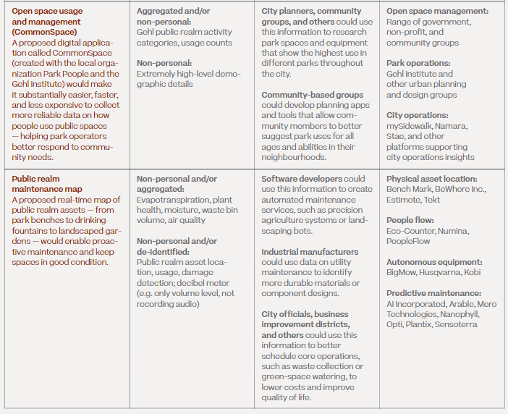

Figure 16 An overview of the proposed digital services, Open space usage and management (CommonSpace) and Public realm maintenance map (p. 445).

However, more information on the digital accessibility features of the core services needs to be given. The MIDP Accessibility Principles (Digital Accessibility Principles) which guide planning in Quayside, states:

Principle 16: Provide information in multiple, easily accessible formats and languages

Principle 17: Support multiple input modalities to all digital experience

Principle 22: Use the best digital accessibility standards available and set new, higher standards wherever possible

The accessibility of the core digital services is not supported by these guiding principles. Additional information needs to be provided by Sidewalk Labs to support the Accessibility Principles.

(Please also seeQ21 and Q69)

#### Will the natural spaces support access beyond physical access?

* Degree of Support: Not supported
* Excerpt (from expert’s experience documentary material):

Almost immediately my husband noticed several monarch butterflies. Then he spotted a tree covered with monarchs. They fluttered about the tree. I could see the occasional one moving in the tree although not clearly enough to see what they were. Still, I appreciated what was going on.

Information regarding natural spaces supporting access beyond physical access is not stated in the Digital Innovation chapter. People with disabilities want to enjoy themselves in all aspects of a space not just have the ability to access it physically. This access could be supported through multiple means including digital (please also see Q20, p. 87)

**//added by David:**

### Theme: Accessibility Standards

#### Do design, innovation and procurement policies support/facilitate accessible interactions?

* Degree of Support: Not supported
* Excerpt:

Meanwhile, the noise level is getting to me. If I turn the hearing aids down, it is hard to hear the people around me. If I leave the hearing aids alone, it is still difficult. I’m missing all the jokes and stories people are sharing with one another. The connections that they are making is something I am not a part of. Watching my fellow group members interact and not being able to participate makes me feel isolated. I’m not enjoying this, I’m enduring it. I can’t wait for the meal to end.

Please see discussion of Q15.

#### Will hearing support systems be standard?

* Degree of Support: Not supported
* Excerpt:

The hostess at the restaurant is putting tables together to accommodate our large group. We explain to the hostess we need a table with a bright light because of my low vision. But once we’re seated, I find it’s not bright enough for my needs. I ask if the lights can be turned up and the answer is no. The noise level of music and people talking and dishes/glasses clinking is loud and it is hard to have a conversation with anybody. We are handed menus and I put mine aside. The server comes to our table and starts talking rapidly. "Hi, my name is ? And I am your server tonight. The specials are blah blah blah ...... And comes with blah blah blah. And the soup is blah blah blah. Can I get you something to drink?" (p. 47).

Information regarding hearing support systems is not stated in the Digital Innovation chapter.

Please also see discussion of Q15.

### Theme: ICT Accessibility

#### How will people be informed about information on events, stores and amenities? (e.g. store hours)

* Related MIDP text:
  + Vol. 2, Ch. 5, Part 4 Launching Core Digital Services That Others Can Build On (Vol. 2, pp. 442-445).
* Supported by guiding accessibility principle: #19, #21
* Degree of Support: Partially supported
* Excerpt:

After walking for a block, James began to calm down. He felt like he belonged because this was his neighbourhood. He saw people that he knew and started to feel better. He felt that he was getting all the garbage out of his mind. James arrived at the store in a better mood. He enjoyed coming to the store because he knew what it was all about. He could go out and get what he wanted all by himself and he liked that experience. It was so nice that the store was near James’ home. He could go whenever he wanted (p.7).

Sidewalk Labs proposes to launch core digital services that would make urban data accessible to the public, which would improve affordability, mobility, sustainability and economic opportunity (Vol. 2, p. 442). These core digital services would also “enable subsequent innovations to emerge from local companies, entrepreneurs, start-ups, researchers, agencies, civic groups and others” (Vol. 2, p. 442), as Sidewalk Labs would make urban data publicly accessible, facilitating further digital innovations by third parties. Under the proposed core digital services, there is not a core digital service that specifically provides information on events, stores and amenities. However, the core digital services can provide the data possible for third parties to create applications and tools that can support this.

The closest digital service would be Public realm maintenance map and Civic engagement (Collab) (Vol. 2, p. 445). The Public realm maintenance map provides a real-time map of public realm assets such as park benches, drinking fountains and landscaped gardens (Vol. 2, p. 445). The Civic engagement (Collab) application would allow community members to be engaged in local decisions such as ideas for events (Vol. 2, p. 446). These applications could provide data to support third-party applications that provide information on events, stores and amenities.

Sidewalk Labs must provide more information on digital accessibility of the core digital services. Sidewalk Labs plans to provide digital support, by providing “free-to-use devices, tech support staff and digital literacy programming in the Civic Assembly and the Care Collective” which will ensure that the entire population can leverage digital tools and access the digital services (Vol. 2, p. 393). However, Sidewalk Labs needs to address the accessibility of core digital services and everyday human assistance options. For example, James in this story does not own or use a smartphone, so how can he access the core digital services and can it be accessible in public spaces (e.g. buildings or housing)? If further assistance is needed, will there be a human assistance option available directly in the core digital service (apart from the tech training provided)? Overall, more information on digital accessibility features for the core digital services needs to be provided in order to fully support the MIDP Digital Accessibility Principles.

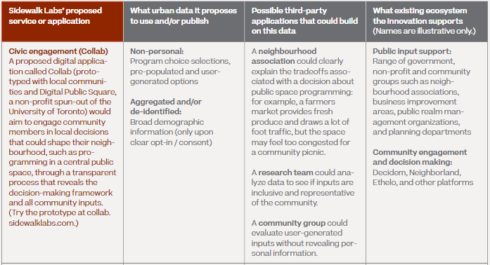

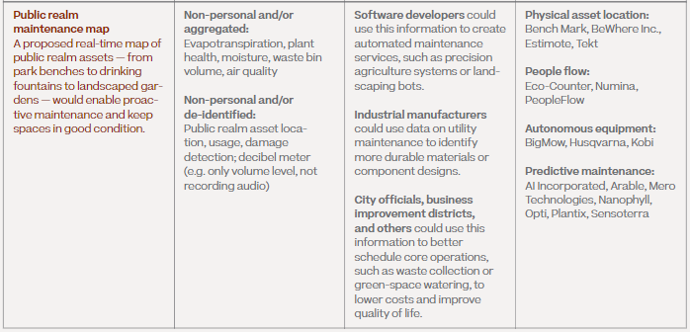

Figure 17 An overview of the proposed digital services, Open space usage and management (CommonSpace) and Public realm maintenance map (p. 445-446).

#### How will information be communicated in accessible ways?

* Related MIDP text:
  + Vol. 2, Ch. 5, Part 4, Launching Core Digital Services That Others can Build On (Vol. 2, pp. 442-447).
* Supported by guiding accessibility principle: #21
* Degree of Support: Partially supported
* Excerpt:

 Anib also gave James the support that he would need to get to the club, meet the coordinator and feel comfortable getting to know the other members. Anib helped him find his way around and know where things are (p. 7 ).

Information can be communicated through Sidewalk Labs’ proposed core digital services. These digital services would make urban data accessible to the public, which would improve affordability, mobility, sustainability and economic opportunity (Vol. 2, p. 442). These core digital services would also “enable subsequent innovations to emerge from local companies, entrepreneurs, start-ups, researchers, agencies, civic groups and others” (Vol. 2, p. 442), as Sidewalk Labs would make urban data publicly accessible, facilitating further digital innovations by third parties. For example, the core digital services include a Civic engagement (Collab) application. The Civic engagement (Collab) application allows for individuals to communicate and give feedback in local decisions, such as ideas for event planning (Vol. 2, p. 446). However, more information regarding the digital accessibility features for the core digital services needs to be provided in order to fully support the MIDP Digital Accessibility Principle, including Principle 22, “Use the best digital accessibility standards available and set new, higher standards wherever possible.”

#### How can people access transportation information?

* Related MIDP text:
  + Vol. 2, Ch. 5, Part 4, Launching Core Digital Services That Others Can Build On, (Vol. 2, pp. 442-453).
* Supported by guiding accessibility principle: #21
* Degree of Support: Partially supported
* Excerpt:

My story is a story about finding a sense of place in Toronto. As a newcomer in Toronto, it was challenging to navigate the city layered with very different cultures, social norms and unspoken collective agreements shared between strangers. In my culture, you are expected to seek out and utilize local knowledge when you are trying to navigate through a new or unfamiliar space; a sense of community is present even in public spaces and shared between strangers. I try to forget how frustrating and arduous it was to look for a home as a young, queer POC (person of colour) couple. For a few months in the process, we had to live with the possibility of being forced to move to an area that was remote—disconnected from our support systems and friends (p.25).

Sidewalk Labs proposes a mobility management system that will “coordinate all travel modes, traffic signals and street infrastructure and apply demand-based pricing to curb and parking spaces” (Vol. 2, p. 445). This system will reduce traffic congestion and improve safety, as it incorporates traffic patterns from all transit modes. The mobility management would provide data on curb space availability, pedestrian and cyclist counts, vehicle counts and speed, as well as restricted data such as vehicle identification data that is only used by the city for parking enforcement (Vol. 2, p. 445).

The mobility management system would use non-personal and de-identified urban data, such as trip counts, traffic congestion measures and curbside availability to manage traffic (Vol. 2, p. 452). For example, the system can estimate traffic flows by providing de-identified information such as the number of travellers and vehicles at an intersection. In curb spaces, sensors in the pavement can detect the number of vehicles and a separate license plate reader can capture license plates from vehicles that are violating parking rules and send this information directly to municipal enforcement (Vol. 2, p. 452).

In the Mobility Chapter, it also proposes an integrated mobility package, where all trip options can be viewed and paid for using the same service in a mobility application created for the IDEA district or through an existing third-party application (Vol. 2, p. 65). The integrated mobility package provides real-time information on mobility services and the transportation system times as well as real-time pricing (Vol. 2, p. 66).

As the mobility management system will be a digital service, even possibly a mobile application, more information on digital accessibility features needs to be provided in order to fully support the MIDP Digital Accessibility Principle, including Principle 16, “Provide information in multiple, easily accessible formats and languages” and Principle 22, “Use the best digital accessibility standards available and set new, higher standards wherever possible.”



Figure 18 The proposed mobility package shown on a mobile phone application (Mobility, p. 66).

#### How will information/communications be shared with support workers who may not live in the smart city area? (Greg)

* Related MIDP text:
  + Vol. 2, Ch. 5, Part 4, Launching Core Digital Services That Others can Build On (Vol. 2, p. 442).
    - Sidewalk Labs’ proposed launch services (Vol. 2, p. 444-447)
* Supported by guiding accessibility principle: #21
* Degree of Support: Partially supported
* Excerpt:

James keeps a close out the door as he waits and waits and waits. James glances at his watch and waits some more. Finally, at 1:40, Wheel Trans arrived. “I wish I could take the bus like I used to, but it just isn’t safe anymore.” James felt anger at the driver for being so late, but he smiled anyway and was polite because he might get the driver again and he relies on the driver and doesn’t want to get in his bad books (p.7).

Support workers and Wheeltrans staffwho may not live in the smart city area can access the information/communications through Sidewalk Labs’ proposed core digital services. The proposed core digital services will be accessible to the public who do not live in the area, such as through a mobile application. The core digital services enable public access to the urban data, which facilitates subsequent digital innovations by third parties, improving affordability, mobility, sustainability and economic opportunity (Vol. 2, p. 442). Third parties include local companies, entrepreneurs, start-ups, researchers, agencies and civic groups that may use the public data to create applications offering new services to the public, including people who do not live in the smart city area (Vol. 2, p. 442).

There is not a proposed core digital service that is specifically designed to support people with disabilities, but this could be beneficial and increase accessibility. For example, a digital service where support workers and Wheeltrans staff can connect/support their riders. In James’ story, James was waiting for the Wheeltrans, which was late. However, an application could make it possible for the Wheeltrans driver to communicate this to James. Overall, this is partially supported according the MIDP Accessibility Principles and more information on accessibility features of the core digital services and core digital services specifically designed to support people with disabilities, needs to be given.

#### Is there a system where accessibility features can be listed?

* Related MIDP text:
  + Vol. 2, Ch. 5, Part 4, Launching Core Digital Services That Others Can Build On (Vol. 2, p. 442).
    - Sidewalk Labs’ proposed launch services (Vol. 2, p. 444-447).
* Supported by guiding accessibility principle: N/A
* Degree of Support: Not supported
* Excerpt:

Sidewalk Labs has not proposed a core digital service that lists accessibility features. The current proposed core digital services enable public access to urban data, which allows for third parties to build new applications, services, products and tools (Vol. 2, p. 442). With that being said, the Outcome-based building code application is a real-time building code system that will monitor building infrastructure, where a third-party such as the City government can use the data from this core service to ensure code compliance (Vol. 2, p. 446). It is a possibility that a third party, such as local companies, entrepreneurs, start-ups, researchers, agencies and civic groups, could have the required data from the Outcome-based building code application to create a new application that could list buildings that have accessibility features and fully comply with the 2005 Accessibility for Ontarians with Disabilities Act (AODA).

However, this does not fully support inclusion as accessibility should be directly addressed as a priority and integrated into the plan versus after implementation. For example, Sidewalk Labs could introduce a core digital service that displays accessibility features in the smart city area. This core digital service could provide a map of the location and real-time information of accessibility features, such as the location and maintenance of elevators and ramps. Overall, this is partially supported as there is not a proposed core digital service specifically designed to support people with disabilities.

#### Will there be a standard of accessible training for residents to learn how to use smart technology?

* Related MIDP text:
  + Vol. 2, Ch. 5, Part 1 Providing More Affordable and Flexible Digital Infrastructure (Vol. 2, p. 393).
  + Vol.2, Ch. 5, Public Engagement (Vol. 2, pp. 456-457).
* Supported by guiding accessibility principle: #14, #16, #21
* Degree of Support: Partially supported
* Excerpt:

I walked into the grocery store using the specific entrance and as I was perusing the aisles, I found that there were several staff hovering over me, when all I wanted was for someone to just say “I am here if you need me.” Once I was done getting everything I needed, I found my way to the accessible cashier lane, only to find it unstaffed. So, then I went into a regular line, where a customer offered to assist me by taking the groceries out of my bag from the back of my chair onto the conveyor belt. The card reader was also not adjustable. It could not be moved and it was out of my reach, so it was impossible to be able to hide my personal information when I reached over. This was yet another awkward instance where I felt I did not have autonomy.

No staff assisted me; it was simply other shoppers that offered to help. Common empathy of the average person rather than the attentiveness of staff has been a recurring theme of my shopping experience. Without the kindness of strangers, I often find that advocating for myself in what are monitored public spaces increases the feeling of “invisibility (p.11).

There is not a standard of accessible training established by Sidewalk Labs. A standard of accessible training for tech staff, employees and residents in the area needs to be established, in regard to the MIDP Accessibility Principles and also meet the requirements of the Customer Service Standard in the 2005 Accessibility for Ontarians with Disabilities Act (AODA). In “Human Factor,” employees did not know how to interact or assist a person with disabilities. Full accessible training would equip employees with the knowledge and tools to serve people with disabilities. This is especially imperative for Sidewalk Labs’ proposed Tech Bar, which will train residents on how to use smart technology. The Tech Bar will provide group and one-on-one assistance with digital tools and smart technologies for community members (Vol. 2, p. 457). There will be tech support staff and digital literacy programming to educate people and a standard of accessible training will ensure that tech support staff can properly assist people with disabilities (Vol. 2, p. 393). Sidewalk Labs also plans to meet the requirements for digital inclusion in the National Digital Inclusion Alliance, a U.S. based non-profit (Vol. 2, p. 393). Overall, this is partially supported as a standard of accessible training needs to be established, in accordance to MIDP Accessibility Principles and also meet the requirements of the Customer Service Standard in the 2005 Accessibility for Ontarians with Disabilities Act (AODA).

#### Can security cameras be utilized to identify individuals who need help with an accessibility barrier?

* Related MIDP text:
  + Vol. 2, Ch. 5, Part 3 Creating a Trusted Process for Responsible Data Use
* Supported by guiding accessibility principle:
* Degree of Support: Partially supported
* Excerpt: derived from “Human Factor”

Security cameras can identify individuals who need help with an accessibility barrier, but it is unclear if it will be permitted to do so in certain spaces in the smart city area. In the public realm, which is a commonly shared spaced such as street or squares, there will be devices such as pedestrian counters or traffic cameras (Vol. 2, p. 426). These devices will collect urban data, as well as information collected in privately owned but publicly accessible spaces (e.g. building lobbies, courtyards) and by a third party in private spaces (e.g. tenant noise and air quality) (Vol. 2, p. 426). Most of the urban data collected for smart city services, such as the mobility management system, will be non-personal and use de-identified data that can detect and count pedestrians, cyclists and vehicles (Vol. 2, p. 437). The traffic cameras will be “immediately deleting any raw video footage, safeguarding the privacy of individuals who might be visible in the raw footage” (Vol. 2, p. 437). The cameras in publicly accessible spaces can potentially be used to help individuals who need help with an accessibility barrier, but the entity who seeks to do so would have to adhere to Sidewalk Labs’ proposed four-step process for proposals to collect or use urban data in the IDEA District, which includes submitting an RDU Assessment (Vol. 2, p. 426). In the RDU Assessment, it includes submitting the purpose of the proposal, type of urban data collected, potential impact, risk and benefits for the community (Vol. 2, p. 429). Therefore, an entity that seeks to use the security cameras to identify individuals who need help with an accessibility barrier would most likely have to go through this process.

The purpose of this is to create a trusted process for responsible data use, which includes implementing the urban data trust, establishing RDU Guidelines and setting a clear process for urban data use or collection (Vol. 2, p. 414). Policies and systems can be introduced by Sidewalk Labs to enable accessibility through the “human connection,” however, this is partially supported and more information needs to be provided.

### Theme: Interface/Product Design

#### How will interfaces be designed inclusively (or products with inclusive interfaces selected)?

* Related MIDP text:
  + Vol. 2, Ch. 5, Part 1 Providing More Affordable and Flexible Digital Infrastructure (Vol. 2, p. 384-393).
  + Vol. 2, Ch. 5, Part 4 Launching Core Digital Services That Others Can Build On (Vol. 2, p. 442-443).
* Supported by guiding accessibility principle: #1, #2, #16, #19
* Degree of Support: **Fully** supported
* Excerpt:

When we disembark at Union Station, we make our way to the elevator. I’m not able to see the buttons on the panel, even though it has red backlighting. It is not enough contrast for me to see. I have to wait for someone else to push the button. The Braille buttons are a nice "feel good" feature for those who are sighted or blind (if the blind can find it...). Not many low vision persons know Braille (p. 45).

Interfaces will be designed inclusively through Sidewalk Labs’ participation in GRIT Toronto (Gathering Residents to Improve Technology), a program founded by Code for Canada, that supports inclusive usability testing (Vol. 2, p. 443). Sidewalk Labs funds GRIT Toronto for co-creation and feedback in the creation of digital services and products. The program includes 350 people from “all digital skill levels, cultures, ages and backgrounds,” and collects their feedback into the creation of new digital services and products (Vol. 2, p. 443). The co-creation process ensures that the digital tools created will serve and support the needs of the entire population.

Sidewalk Labs must also ensure that feedback is collected from a wide range of people in this process, including people with lived experiences of disability, to ensure that the products are designed inclusively and have accessible features, such as contrast options on digital interfaces. There is a lack of information on accessibility features of digital interfaces and products/services in the smart city area and this information needs to be provided. This would also support the effectiveness of the process to design digital services inclusively and determine if this adequately includes the needs of the entire population in the creation of digital services/products.

Sidewalk Labs will also ensure digital inclusion by meeting the requirements for digital inclusion in the National Digital Inclusion Alliance, a U.S. based non-profit (Vol. 2, p. 393). This includes providing free-to-use devices for individuals who do not own smart phones. Tech support staff and digital literacy programming will be provided in the Civic Assembly and the Care Collective, which will educate individuals that have a lower technical skill level and allow them to leverage the digital tools such as the core digital services proposed by Sidewalk Labs (Vol. 2, p. 393). By doing this, it also allows for users to give feedback on the accessibility features of digital tools.

Overall, this is partially supported as more information on accessibility features of digital interfaces and products/services must be provided, in order to support the process of inclusive usability testing.

#### Will displays/interfaces be flexible (e.g. change contrast options on building directory)

* Degree of Support: Not supported
* Excerpt:

When we disembark at Union Station, we make our way to the elevator. I’m not able to see the buttons on the panel, even though it has red backlighting. It is not enough contrast for me to see. I have to wait for someone else to push the button. The Braille buttons are a nice "feel good" feature for those who are sighted or blind (if the blind can find it...). Not many low vision persons know Braille (p. 45).

Information on flexible displays/interfaces is not stated in the Digital Innovation chapter. Under Digital Accessibility Principles in the MIDP Accessibility Principles, the following principles state:

#16. Provide information in multiple, easily accessible formats and languages

#17. Support multiple input modalities to all digital experiences

322. Use the best digital accessibility standards available and set new, higher standards wherever possible

There is a lack of information on the accessibility features of digital displays and interfaces, given the Accessibility Principles. Therefore, specific information on accessibility features of digital displays and interfaces, such as contrast options for building directory displays or the proposed core digital services, needs to be provided.

## Summary Table of Questions and Evaluation Findings

| Story Title | Generated Question | Supporting Guiding Accessibility Principle | Addressed in MIDP Chapter | Degree of Support | Narrative Theme |
| --- | --- | --- | --- | --- | --- |
| Grades and Shades of Inclusion | Is there a plan for addressing ongoing accessibility feedback? |  |  | Not Supported | accessibility governance |
| Grades and Shades of Inclusion | Is there any plan to include accessibility committees for sections? i.e. towers, retail, streets |  |  | Not Supported | accessibility governance |
| Into the Chaos | Do design, innovation and procurement policies support/facilitate accessible interactions? | None | Digital Innovation | Not Supported | accessibility standards |
| Into the Chaos | Will hearing support systems be standard? | None | Digital Innovation: | Not Supported | accessibility standards |
| Getting Around | Will the smart city include pet-friendly spaces that will be accessible and will pets be allowed in units? |  |  | Not Supported | accessibility standards |
| Into the Chaos (Grades and Shades of Inclusion) | How will accessibility in all spaces (including commercial) be assured --go beyond building code (i.e. function)? | 6, 7, 14 | Public Realm, p. 178 | Partially Supported | accessibility standards |
| Into the Chaos | Will public and retail spaces be designed to dampen noise levels? | 3,4,5 |  | Partially Supported | accessibility standards |
| Into the Chaos | Is it possible to shape policies for the spaces to support a culture of inclusion via training and exceeding current AODA regulations? | None | Mobility, p.92-107, p. 111 | Partially Supported | accessibility: policy |
| James Goes Out on His Own (Getting Around) | Do the proposals to improve transit benefit accessibility and diverse needs? | None | Mobility, p.32, p.41, p.44, p.65 | Partially Supported | accessibility: transit |
| Human Factor | Will public washrooms be plentiful? | 7 | Public Realm, p. 186-187 | Partially Supported | accessible amenities |
| Human Factor | Will there be accessible parking available within the city? | None | Mobility, p.63-64, p. 112 | Partially Supported | accessible amenities |
| Grades and Shades of Inclusion | What options for vertical transportation (e.g. elevator, stairs, ramps, flat escalators, etc) will be available? | None | Digital Innovation. | Not Supported | building design |
| Grades and Shades of Inclusion | Will transferring equipment such a hoyer lift or a ceiling lift be available in public bathrooms? |  |  | Not Supported | building design |
| Into the Chaos | Will handrails of multiple heights be utilized throughout indoor spaces? |  |  | Not Supported | building design |
| Into the Chaos | Will public washrooms have options for increased brightness? |  |  | Not Supported | building design |
| Into the Chaos | Will all entrances and exits provide flexible options for access? | 9,11 | Mobility. | Partially Supported | building design |
| Human Factor | Will all exits be available all the time (i.e. no internal barriers)? | 9,11 | Digital Innovation. | Partially Supported | building design |
| Getting Around | How will planned designs/art honour indigenous & disabled individuals & their history? | 1,2 | Public Realm, p.194 | Partially Supported | community building |
| Smart City: Bringing Back Civilized to Civilization | Is there a plan to foster community-integration and growth? | 15 | Public Realm, p. 140, 142, 153, 182 | Partially Supported | community building |
| James Goes Out on His Own | What community institutions (schools, libraries, community & recreation centres) are planned for the smart city? How many? | 2 | Overview, p. 101/Public Realm, p. 145-148, 191 | Partially Supported | community building |
| James Goes Out on His Own | Will there be systems or a platform to foster community engagements? | 16,17,20 | Public Realm, p. 164,185 | Partially Supported | community building |
| Getting Around | What supports will be mobilized in the event of an emergency/disaster/power outage |  |  | Not Supported | disaster management |
| Getting Around (Into the Chaos) | Will individuals be able to regulate/monitor their home environment? | 1, 4, 8, 11 |  | Fully Supported | environmental control |
| Into the Chaos | Do support animals have space in environments/transit areas to relieve themselves and areas to get water? | 12 | Public Realm, p.196 | Partially Supported | environmental design |
| Getting Around | How will transit (paratransit) be prioritized? | 3, 4, 6, 11 | Mobility, p.92-107 | Fully Supported | equitable access to transit |
| Getting Around | Will spaces be available for newcomers? | 2 | Overview, p.152 | Not Supported | governance |
| Smart City: Bringing Back Civilized to Civilization (James Goes Out on His Own) | Will the retail spaces be allocated to support a broad range of retailers/local businesses? | 7,16 | Public Realm, p. 155, Economic Development, p. 477 | Fully Supported | governance: commercial spaces |
| Human Factor | How will commercial spaces be designed to optimize customer experience? | 1,2, 13, 15, 17, 19 | Public Realm, p. 155, 182, 185 | Partially Supported | governance: commercial spaces |
| Human Factor | What do the customer support standards look like? (eg. retail stores) | 17, 19 | Public Realm, p. 146 | Partially Supported | governance: commercial spaces |
| Smart City: Bringing Back Civilized to Civilization | Will there be regulations to keep commercial rental rates affordable and from rising? | 5 | Public Realm, p. 164, 193 | Partially Supported | governance: commercial spaces |
| James Goes Out on His Own | Will there be a variety of groups and events for the whole community? | 7,8,15,16 | Public Realm, p. 121, 144, 182-183 | Partially Supported | governance: community spaces |
| Into the Chaos | Are all spaces for relaxation and enjoyment accessible? | 12, 15 | Public Realm, p. 145-148, 187 | Fully Supported | governance: public spaces |
| James Goes Out on His Own | How walkable is the city? | 4, 6, 10, 11, 15 | Public Realm, p.126 | Fully Supported | governance: public spaces |
| Into the Chaos | How will accessibility be maintained during crowded events? | 7, 11, 16 | Public Realm, p. 187 | Not Supported | governance: public spaces |
| James Goes Out on His Own | Does the ratio of community space exceed industry standards? | 1 | Public Realm, p. 156 | Partially Supported | governance: public spaces |
| Into the Chaos | How will accessibility be infused into all service delivery planning (e.g. snow removal)? | 5, 7, 11, 16, 20 | Public Realm, p. 186-187 | Partially Supported | governance: public spaces |
| Human Factor | How will people be able to move through different public spaces easily? | 4, 6, 10, 15 | Public Realm, p.132, 144 | Partially Supported | governance: public spaces |
| James Goes Out on His Own (The Way Home) | Is there a plan for governance of spaces that supports fair use and distribution? | 3, 7, 15, 18 | Public Realm, p. 156,164 | Partially Supported | governance: public spaces |
| Smart City: Bringing Back Civilized to Civilization | Do the regulations/policies for rents of all spaces support inclusion of people from all socioeconomic statuses? | 3, 5, 11, 14 |  | Partially Supported | governance: rented space |
| Into the Chaos | What accessibility features will be incorporated into green spaces? | 4,15 | Public Realm, p.125,144,182 | Fully Supported | green spaces |
| Into the Chaos | Will the natural spaces support access beyond physical access? | 7,10 | Public Realm, p.125,144,182. Digital. | Fully Supported | green spaces |
| Smart City: Bringing Back Civilized to Civilization | How can people find information on the location and maintenance of these green spaces? | 10, 16,20, 21, 22 | Public Realm, p. 141, 186-188. Mobility, p.442-445 | Partially Supported | green spaces |
| Into the Chaos | Is there system where accessibility features can be listed? | None | Digital Innovation, p. 442-447 | Not Supported | ICT accessibility |
| James Goes Out on His Own | How will people be informed about information on events, stores and amenities? (eg. store hours) | 19, 21 | Digital Innovation, p. 442-445 | Partially Supported | ICT accessibility |
| James Goes Out on His Own | Will there be a standard of accessible training for residents to learn how to use smart technology? | 14, 16, 21 | Digital Innovation, p. 393, p. 456-457 | Partially Supported | ICT accessibility |
| Grades and Shades of Inclusion | Can security cameras be utilized to identify individuals who need help with an accessibility barrier? | None | Digital Innovation, p.414, p. 426-429, p.437. | Partially Supported | ICT accessibility |
| The Way Home | How can people access transportation information? | 21 | Digital Innovation, p. 442-453 | Partially Supported | ICT accessibility |
| James Goes Out on His Own | How will information be communicated in accessible ways? | 21 | Digital Innovation, p. 442-447 | Partially Supported | ICT accessibility |
| James Goes Out on His Own | How will information/communications be shared with support workers who may not live in the smart city area? | 21 | Digital Innovation, p.444-447. | Partially Supported | ICT accessibility: personal supports |
| The Way Home | How is accessibility of the smart city area integrated with the rest of the city? | 1, 3, 5, 7, 11 | Mobility, p. 28, p. 32, p. 44 | Fully Supported | integration with metro |
| Into the Chaos | Will displays/interfaces be flexible (e.g. change contrast options on building directory) | 1, 2, 16, 19 | Digital Innovation, p. 384-393, p. 442-443. | Fully Supported | interface/product design |
| Into the Chaos (Grades and Shades of Inclusion ) | how will interfaces be designed inclusively (or products with inclusive interfaces selected)? | None | Digital Innovation. | Not Supported | interface/product design |
| James Goes Out on His Own | How is access to alternative transit (e.g. wheel trans, paid transport) supported? | 3, 4, 5, 6, 11 |  | Partially Supported | logistics |
| Getting Around | Will residential units be accessible? |  |  | Partially Supported | rents-governance/equity |
| Getting Around | Will emergency healthcare be available? |  | Public Realm, p. 147 | Not Supported | social supports |
| Getting Around (The Way Home) | Is there a plan to foster social supports? | 11, 15 | Public Realm, p.182, 185 | Partially Supported | social supports |
| Human Factor | Will stores and amenities support the needs of the community? | 2, 3, 7, 8, 13 | Public Realm, p. 145-147, 178, 182, 186 | Partially Supported | social supports |
| Human Factor | Will the customer support standards be inclusive of the needs of everyone? | 13, 17, 19 | Public Realm, p. 145-147, 178, 185-186 | Partially Supported | social supports |
| Smart City: Bringing Back Civilized to Civilization (The Way Home) | Will there be spaces for health clinics, schools, homeless shelters and other social services? | 12 | Public Realm, p. 185, 191 | Partially Supported | social supports |
| Getting Around | Will there be religious or spiritual places available? | 12, 15 | Public Realm, p. 145, 147-148, 186-187 | Not Supported | spirituality and culture |
| Getting Around | How will spiritual practices (smudging, prayer, meditation, chanting, incense, etc) be accommodated? | 12 | Public Realm, p.145 | Partially Supported | spirituality and culture |
| Getting Around | How will the smart city honour the history of Indigenous people? | 2 | Public Realm, p. 194 | Partially Supported | spirituality and culture |
| Into the Chaos | How will barriers introduced by things like construction be communicated/mitigated? | 6, 11, 16 | Public Realm, p. 136,186-187 | Fully Supported | streetscape barriers-temporary |
| Into the Chaos | What are the safety features for individuals who cannot see or hear traffic? | 1, 3, 6, 7, 14 | Mobility, p.42, p.49, p.92-107 | Fully Supported | streetscape design |
| Human Factor | Will the design of routes and trails be inclusive to all users? | 1, 3, 4, 6, 7, 9, 10, 11, 15, 20 | Public Realm, p.132, 144 | Fully Supported | streetscape design |
| Into the Chaos | Will handrails of multiple heights be utilized throughout outdoor spaces? | 7, 15 | Public Realm, p. 197 | Not Supported | streetscape design |
| Into the Chaos | How will noise pollution (e.g. from traffic and nearby Gardener) be mitigated? | 3, 4, 6, 11 | Mobility, p.39, p.46-48. | Partially Supported | streetscape design |
| James Goes Out on His Own | Is the sidewalk surface smooth and clear of ice/obstructions in all seasons? | 6, 11 | Public Realm, p. 136,186 | Partially Supported | streetscape design |
| Smart City: Bringing Back Civilized to Civilization (Into the Chaos, Human Factor) | Will lighting be controlled to balance safety and light pollution concerns? | 7 | Public Realm, p. 136, 197. Mobility, p. 49, p.106-107 | Partially Supported | streetscape design |
| Into the Chaos | Will systems and design support wayfinding? | 7, 10, 11, 16, 20 | Public Realm, p. 186-187. Mobility, p.46, p.92-107 | Partially Supported | streetscape design |
| Smart City: Bringing Back Civilized to Civilization | Will the city be designed to separate clearly pedestrian, bike and other travel? | 6, 11 | Public Realm, p. 127,143 | Partially Supported | streetscape design |
| James Goes Out on His Own | Will there be seating and public spaces along the trails? | 6, 7 | Public Realm, p. 145, 147-148, 186-187 | Partially Supported | streetscape design |
| James Goes Out on His Own | Will transit shelters will be provided and suitable for all season conditions? | 1, 3, 6, 9 | Mobility, p. 44-52, p.111 | Partially Supported | streetscape design: transit |
| James Goes Out on His Own | Will transit stops be near stores and apartments? | 1, 4, 6 | Mobility, p.35, p.44 | Partially Supported | streetscape design: transit |
| Smart City: Bringing Back Civilized to Civilization | Are the buildings operating sustainably with practices to reduce pollution? | 3, 4, 5 |  | Fully Supported | sustainability: environment |
| Smart City: Bringing Back Civilized to Civilization | What is in place to support sustainable living practices (e.g. community gardens)? | 3, 4, 5 |  | Fully Supported | sustainability: environment |

# Conclusion

The MIDP is neither a great success nor a great failure when it comes to addressing and considering diverse needs, accessibility and inclusion. However, there is room for growth in understanding and implementing the guiding accessibility principles. Some of the themes and concerns raised by our experts may seem outside of the jurisdiction of the developers and planners of the smart community (e.g. customer service standards); however, our experts through their stories describe barriers that occur in their daily lives in an environment where accessibility and inclusion is generally viewed as an obligation rather than a way of being and thinking. The smart community aspires to be more than the typical community and to exceed in designing for people.

Addressing the issues raised by our experts through policies, plans and designs that support accessibility through inclusive design is a worthy aspiration for a smart community. From the expert stories, 76 issues or concerns were raised in the form of questions. The MIDP was evaluated based on how well these issues were addressed or planned for. (In some cases, an issue would relate to multiple chapters of the MIDP thus 86 question reviews are documented in the report). Only 14 of the expert-generated concerns were fully addressed in the MIDP while 17 were not addressed at all. Partial support was found for 45 of the concerns.

Figure 19: Degree of support in the MIDP of the 76 issues from the expert stories. 14 were fully supported, 15 were not supported and 45 were partially supported.

We envision this evaluation as an opportunity for Sidewalk Labs to create new ways of evaluating new plans and proposals going forward and for further delineating the inclusively designed features of the Quayside development in Toronto.

While the MIDP is guided by principles of accessibility and inclusion, the actual implementation of the principles and what that looks like is not well developed.

# Bibliography

Berne, P. (2015). Disability Justice—a working draft. Sins Invalid: An unshamed claim to beauty in the face of invisibility. https://www.sinsinvalid.org/blog/disability-justice-a-working-draft-by-patty-berne

Brown, L.X. (2011). The significance of semantics: Person-first language: Why it matters. Autistic Hoya blog <https://www.autistichoya.com/2011/08/significance-of-semantics-person-first.html>

Cohen-Rottenberg, R. (2015). The problem with person-first language. The body is not an apology blog. <https://thebodyisnotanapology.com/magazine/the-problem-with-person-first-language/>

Collier, R. (2012). Person-first language: Noble intent but to what effect? NCBI, CMAJ, 184(18): 1977–1978.

crippledscholar (2015). Why I don't use person-fisrt language: A brief history of my relationship with the language and disability. crippledscholar blog <https://crippledscholar.com/2015/03/03/why-i-dont-use-people-first-language-a-brief-history-of-my-relationship-with-the-language-and-disability/>

Goggin, G. & Newell, C. (2003). Digital Disability: The social construction of disability in new media. Lanham Md: Rowan & Littlefield.

Haelle, T. (2019). Identity-first vs person-first language is an important distinction. Association of Health Care Journalists. <https://healthjournalism.org/blog/2019/07/identity-first-vs-person-first-language-is-an-important-distinction/>

Inclusive Design and Research Centre (2018). Hackathon. Co-designing inclusive cities blog. <https://cities.inclusivedesign.ca/ideas/hackathon/>

Kapitan, A. (2017). On person-first language: It's time to actually put the person first. Radical copyeditor blog. <https://radicalcopyeditor.com/2017/07/03/person-centered-language/>

King, B.J. (2016). 'Disabled': Just #SayTheWord. NPR. <https://www.npr.org/sections/13.7/2016/02/25/468073722/disabled-just-saytheword>

Lamm, N. (2015). This is disability justice. The body is not an apology blog. <https://thebodyisnotanapology.com/magazine/this-is-disability-justice/>

Landau, E. (2015). Why person-first language doesn't always put the person first. Think Inclusive. <https://www.thinkinclusive.us/why-person-first-language-doesnt-always-put-the-person-first/>

Mingus, M. (2010). Wherever you are is where I want to be: Crip Solidarity. Leaving Evidence blog https://leavingevidence.wordpress.com/2010/05/03/where-ever-you-are-is-where-i-want-to-be-crip-solidarity/

Mingus, M. (2018) "Disability Justice" is simply another term for love. Leaving Evidence blog. <https://leavingevidence.wordpress.com/2018/11/03/disability-justice-is-simply-another-term-for-love/>

Sins Invalid. (2015). 10 principles of disability justice. Sins Invalid: An unshamed claim to beauty in the face of invisibility. https://www.sinsinvalid.org/blog/10-principles-of-disability-justice

Theodosia, R. (2019). How person-first language isolates disabled people. Medium, <https://blog.usejournal.com/how-person-first-language-isolates-disabled-people-61a681a4fac4#targetText=Using%20person%2Dfirst%20language%20for,central%20to%20who%20we%20are.>

Wong, B. (2019). It's perfectly OK to call a disabled person 'disabled' and here's why. Huffington Post. <https://www.huffingtonpost.ca/entry/what-to-call-disabled-person_l_5d02c521e4b0304a120c7549>

1. <https://cities.inclusivedesign.ca/ideas/co-design-draft-proposal/>

   <https://cities.inclusivedesign.ca/ideas/co-design-session-1/>

   <https://cities.inclusivedesign.ca/ideas/co-design-session-2/>

   <https://cities.inclusivedesign.ca/ideas/co-design-session-3/>

   <https://cities.inclusivedesign.ca/ideas/accessible-city-hackathon-app/>
2. The disability community should be understood to include disabled people, their families, friends, allies, attendants, and others who regularly have to deal with how ableism and inaccessibility affects the lives of disabled people.
3. The language used to refer to disability is contested and evolving. While many organizations prefer to use “people-first” language to acknowledge that disability is not a defining characteristic of a person (e.g., person with a disability), many members of the disability community prefer to use “disabled person” to assert and acknowledge disability as identity. We prefer to ask individuals how they would like to be referred to, as is the convention with pronouns. In this document we will use “disabled person.”
4. See Haraway, D. (1988) Situated knowledges: The science question in feminism and the privilege of partial perspective, Feminist Studies, Vol. 14, 3, pp. 575-599 on the dangers of the view from nowhere for researchers to espouse, "the power to see and not be seen" 581, or "God Trick,” in creating research that reproduces systems of powers by denying their existence and our positioning and role in them. Similarly, our expert contributors different viewpoints offer a needed richness in analyzing all the ways accessibility and inclusion are layered through social interactions, organizations and configurations.
5. "Community" shows up hundreds of time throughout the MIDP's different chapters
6. Black, Indigenous, People of Colour
7. Employee training on disability issues, i.e. how do I interact with disabled people with X impairment/disability isn't the same as employee training on accessibility issues. The first starts from the assumptions that disabled people have "functional limitations" that creates barriers to them doing things "normally". The second explains how the world is organized in inaccessible ways for people who do things differently, focusing how the given organization's limitations are contributing to this inaccessibility and presents employees with options for when that inaccessibility creates barriers for disabled people.
8. In 2014 23% of people with disabilities were low-income, compared to 9% of nondisabled peers (StatsCan. (2017). Insights on Canadian Society: Low income among persons with a disability in Canada, https://www150.statcan.gc.ca/n1/pub/75-006-x/2017001/article/54854-eng.htm

   Disabled women are more likely than disabled men to live in poverty (Crawford, C. (2013). Looking into Poverty: Income sources of poor people with disabilities in Canada. Council of Canadians with disabilities IRIS) and women with disabilities make up 26% to 33% of people living in poverty in Canada (Dawn Canada (2018). More than a footnote: A research report on women and girls with disabilities in Canada, p.31)
9. Wong, A. (2019). The rise and fall of the plastic straw, *Catalyst: Feminism, theory, technoscience, Vol.5*: 1: Special section on Crip Technoscience.
10. Kellgren-Fozard, K. (2018). *Banning straws hurts people// The Last Straw!* YouTube video <https://www.youtube.com/watch?v=4IBH0pcKzlY&t=38s>
11. In 2014 23% of people with disabilities were low-income, compared to 9% of nondisabled peers (StatsCan. (2017). Insights on Canadian Society: Low income among persons with a disability in Canada, https://www150.statcan.gc.ca/n1/pub/75-006-x/2017001/article/54854-eng.htm

    Disabled women are more likely than disabled men to live in poverty (Crawford, C. (2013). Looking into Poverty: Income sources of poor people with disabilities in Canada. Council of Canadians with disabilities IRIS) and women with disabilities make up 26% to 33% of people living in poverty in Canada (Dawn Canada (2018). More than a footnote: A research report on women and girls with disabilities in Canada, p.31)